Crossword Puzzle

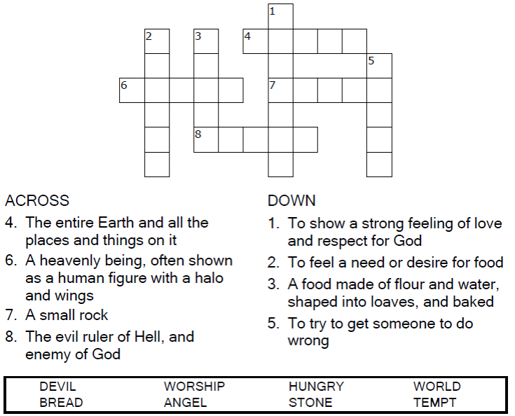

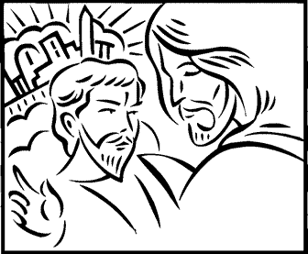

Copyright © Sermons4Kids, Inc.

May be reproduced for Ministry Use

Children’s Worship Bulletin



Luke 4:1-13

Word Search

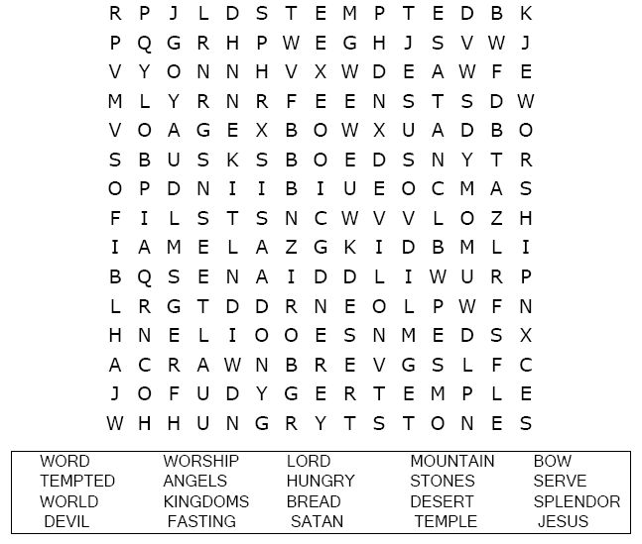

Your Church Name  
City or Town

Multiple Choice Quiz

Choose the word that best matches the definition  
.  
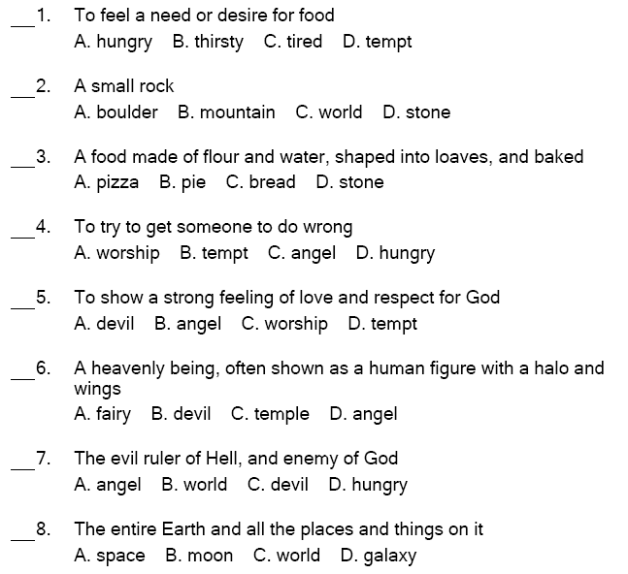

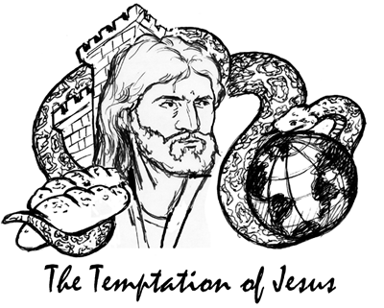

Coloring Page

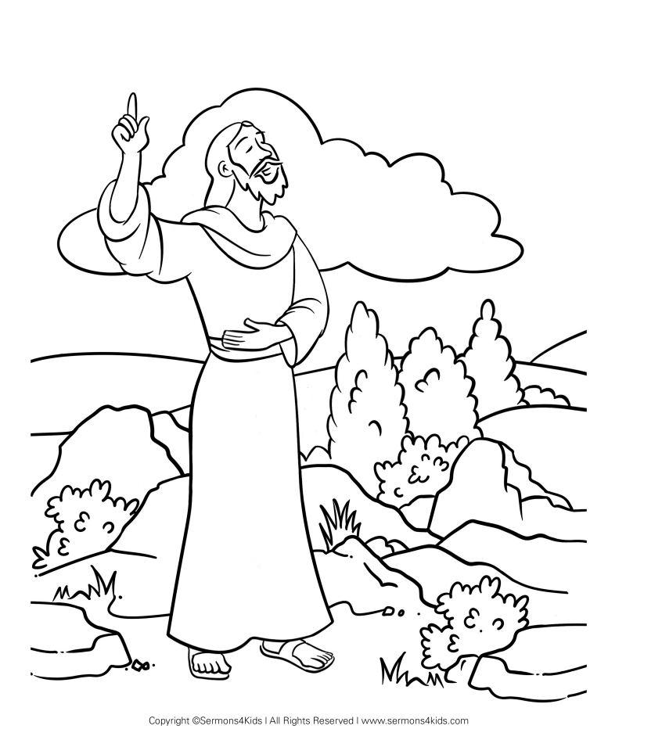

The Temptation of Jesus