Looking at his disciples, he said: "Blessed are you who are poor, for yours is the kingdom of God.  
Luke 6:20 (NIV)

Crossword Puzzle

The Beatitudes

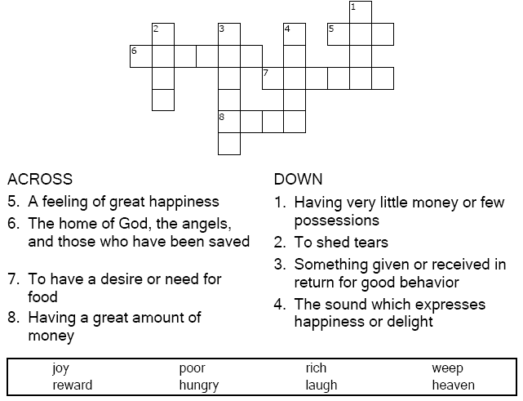



Copyright © Sermons4Kids, Inc.

May be reproduced for Ministry Use

Children’s Worship Bulletin



Luke 6:17-26

Word Search

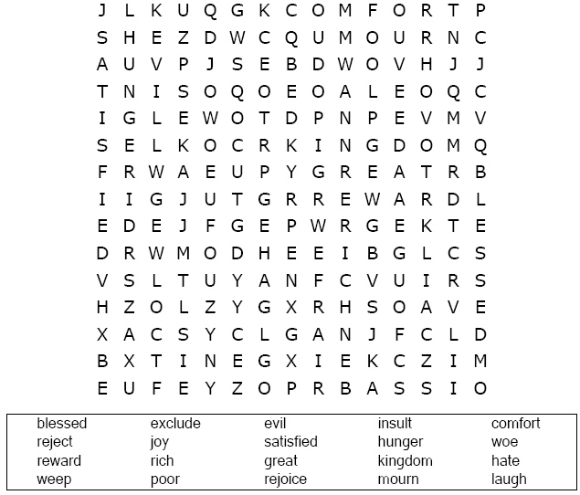

**Your Church Name Here**Anytown, USA

Fill in the Blanks Quiz

Look up Luke 6:20-23 in the Bible. Answers are  
also in the box below the fill-in-the-blanks quiz.

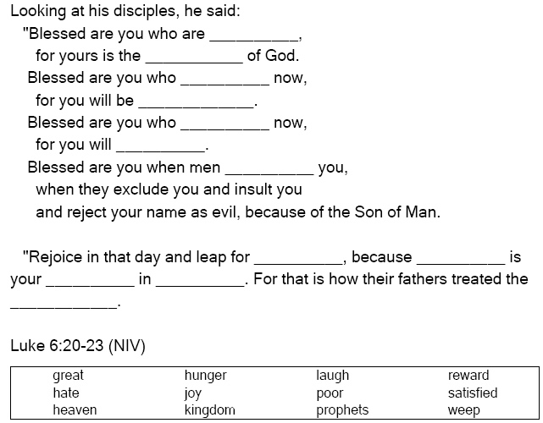

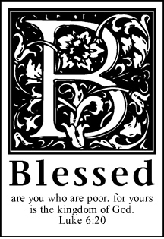

COLOR ME!

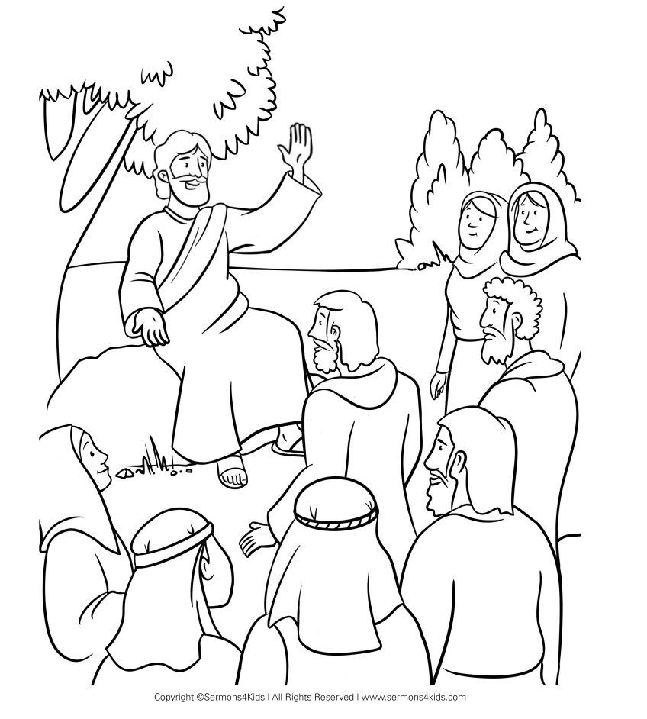

He went down with them and stood on a level place. A large  
crowd of his disciples was there and a great number of  
people from all over Judea, from Jerusalem, and  
from the coast of Tyre and Sidon, who had  
come to hear him and to be healed   
of their diseases.

Luke 6:17-18 (NIV)