Crossword Puzzle

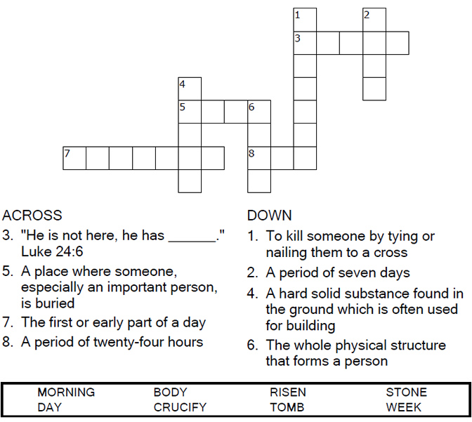



Copyright © Sermons4Kids, Inc.

May be reproduced for Ministry Use

Children’s Worship Bulletin



Luke 24:1-12

Word Search

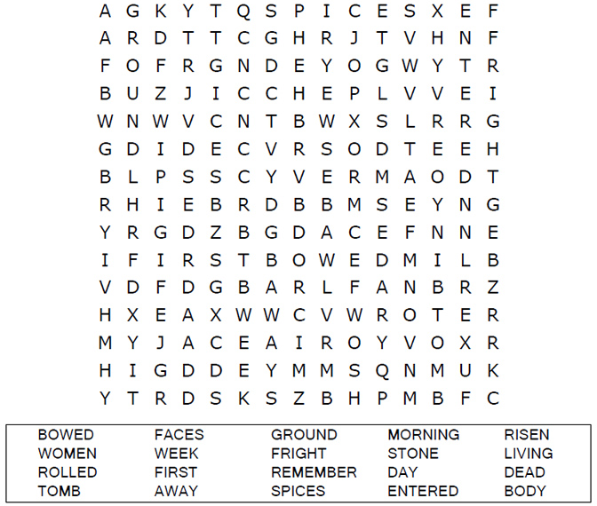

**Your Church Name Here**Anytown, Anywhere

Maze Puzzle

Can you find your way to the empty grave?

  
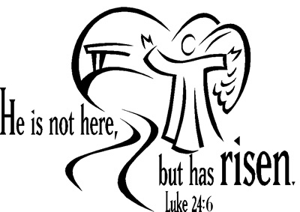

Color Me!

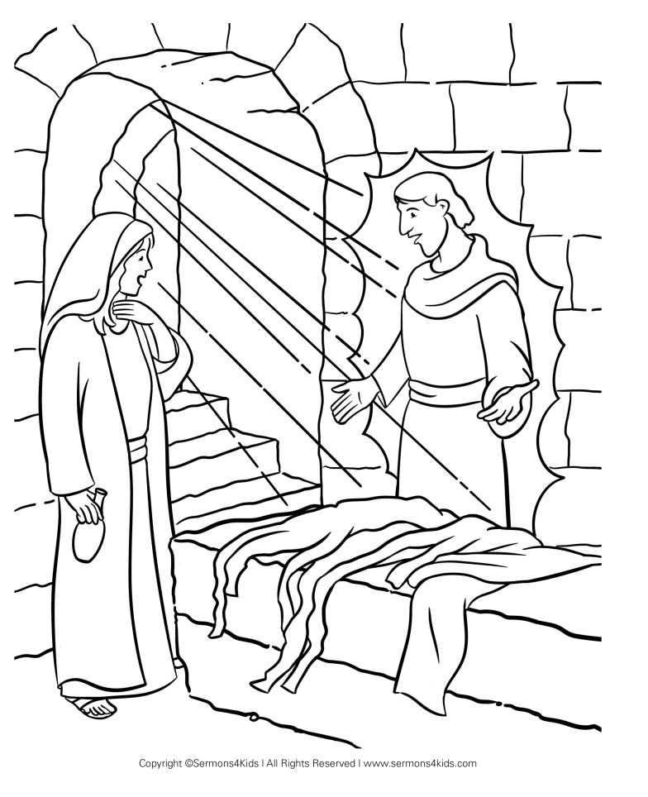

He is not here! He has risen!

easter_border_2.jpeg