Crossword Puzzle

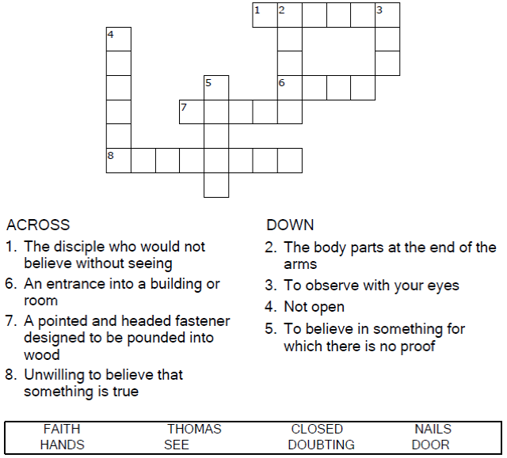

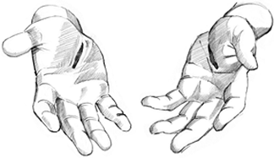

Copyright © Sermons4Kids, Inc.

May be reproduced for Ministry Use

Children’s Worship Bulletin



John 20:19-31

Word Search Puzzle

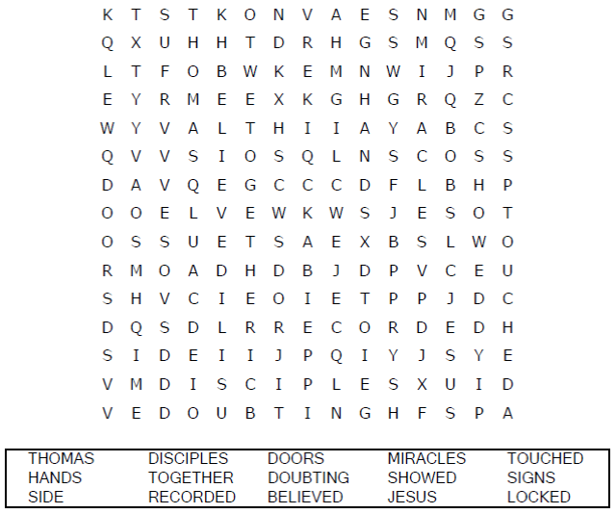

**Your Church Name Here**

Anytown, Anywhere

Coloring Page

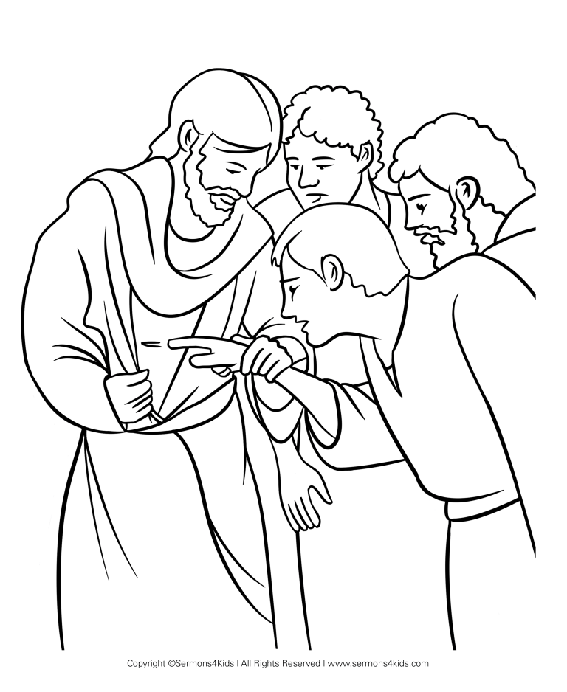

Jesus Appears!

Decoder Puzzle

