Crossword Puzzle

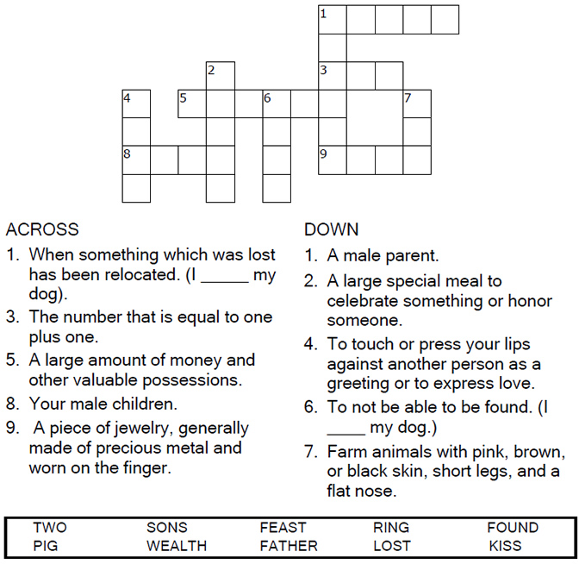



Copyright © Sermons4Kids, Inc.

May be reproduced for Ministry Use

Children’s Worship Bulletin



Luke 15:11-32

Word Search

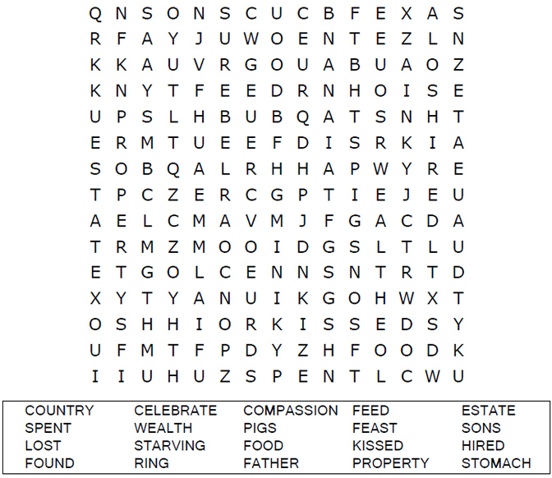

**Your Church Name Here**Anytown, USA

Color Me!

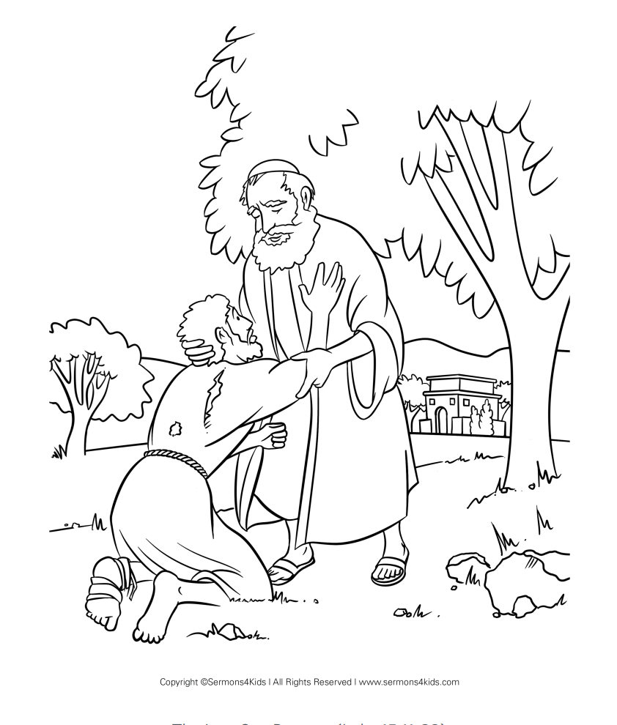

**Jesus told the parable of the prodigal son.  
Luke 15:11-32**

Dot to Dot Puzzle

Connect the dots to complete the picture.

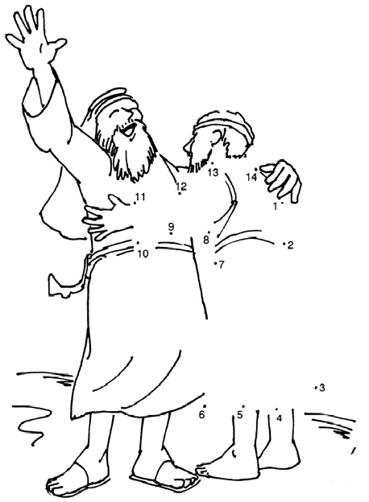

Copyright © Church of God International  
Used by Permission