Crossword Puzzle

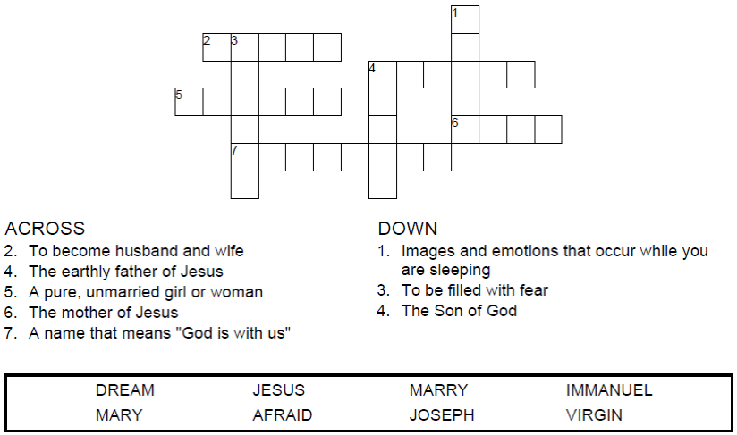

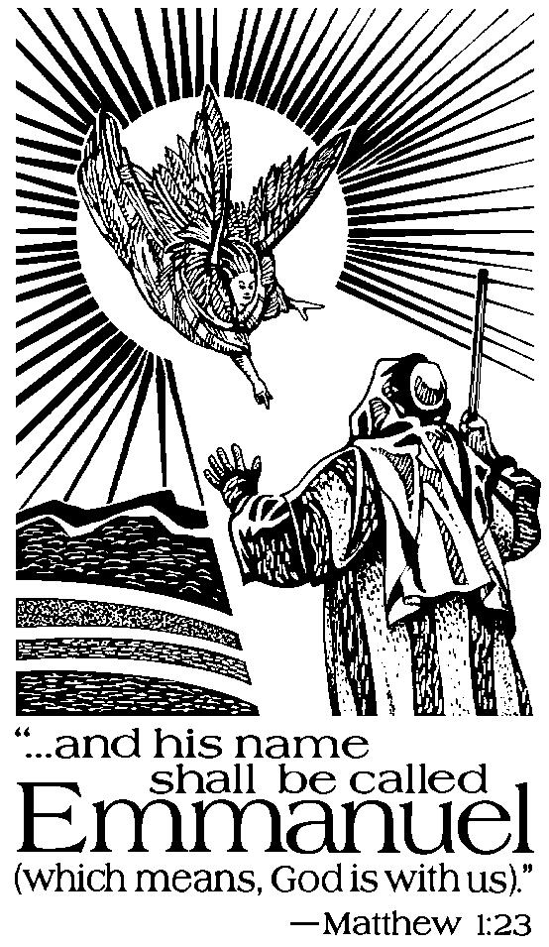

Copyright © Sermons4Kids, Inc.

May be reproduced for Ministry Use

**Children’s Worship Bulletin**



Matthew 1:18-25

Word Search Puzzle

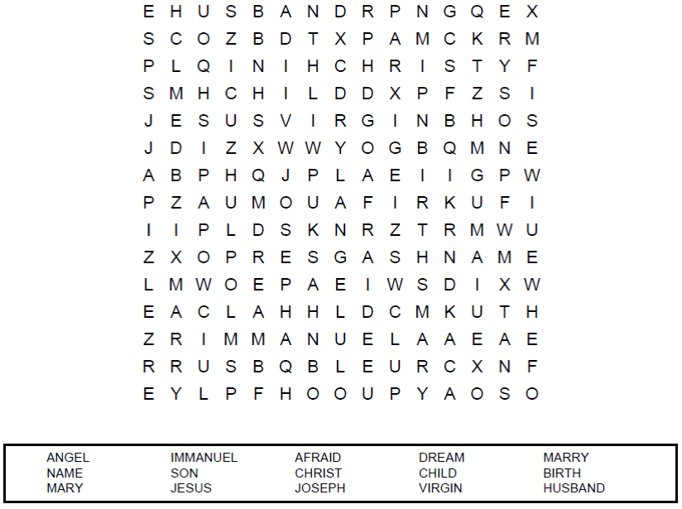

**Your Church Name  
Address  
City**

Coloring Page

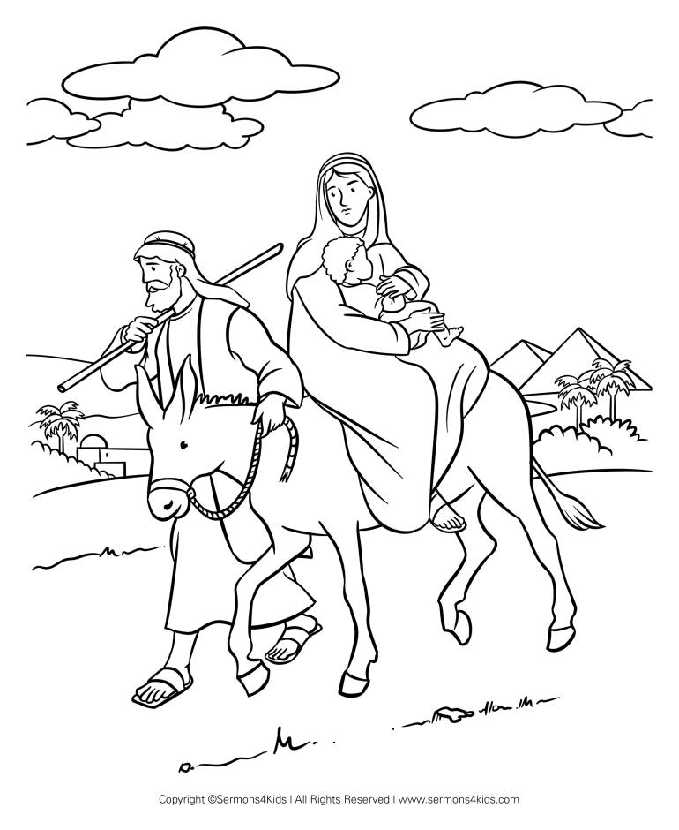

Decoder Puzzle

Each number represents a letter of the alphabet. Substitute  
the correct letter for the numbers to reveal the coded words.

