Crossword Puzzle

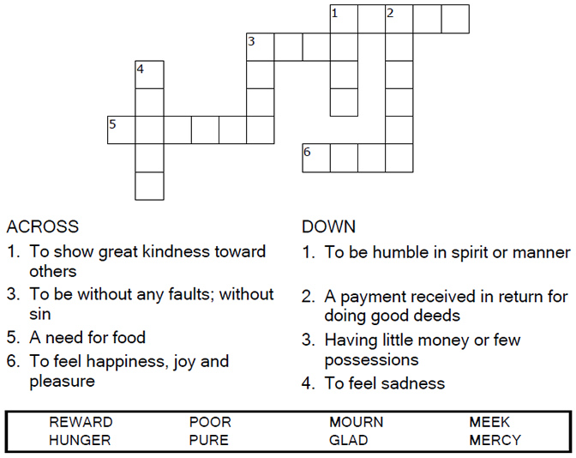

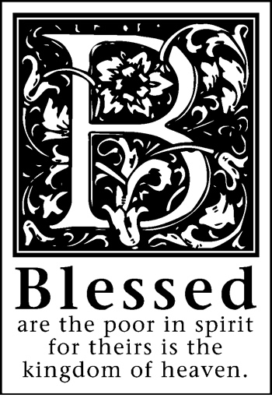

Copyright © Sermons4Kids, Inc.

May be reproduced for Ministry Use

Children’s Worship Bulletin



Matthew 5:1-12

Word Search

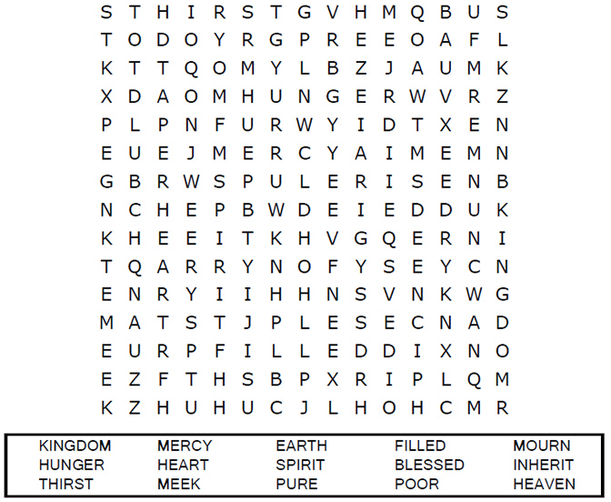

Your Church Name  
City or Town

Connect the Dots

Connect the dots in ABC order to complete the picture.

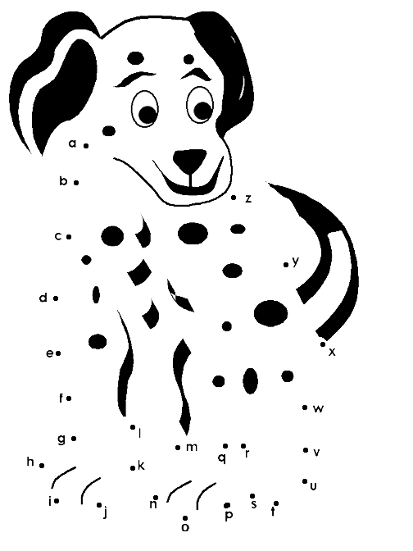

“Rejoice and be glad, because great is your reward in heaven.”  
Matthew 5:12a (NIV)

Coloring Page

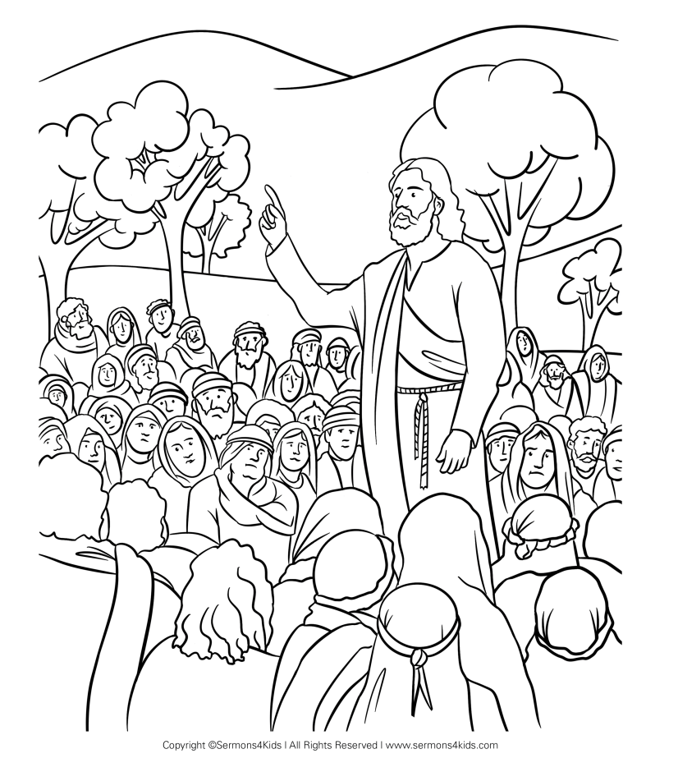

The Sermon on the Mount

Matthew 5:1-12