Crossword Puzzle

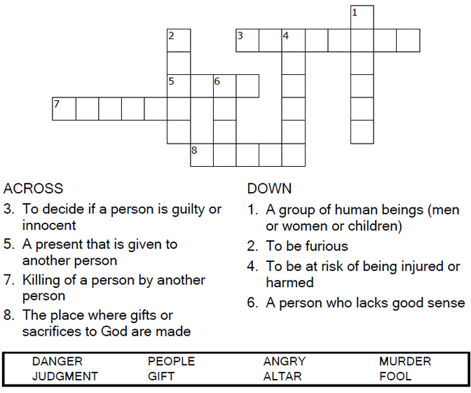



Copyright © Sermons4Kids, Inc.

May be reproduced for Ministry Use

**Children’s Worship Bulletin**



Matthew 5:21-25

Word Search Puzzle

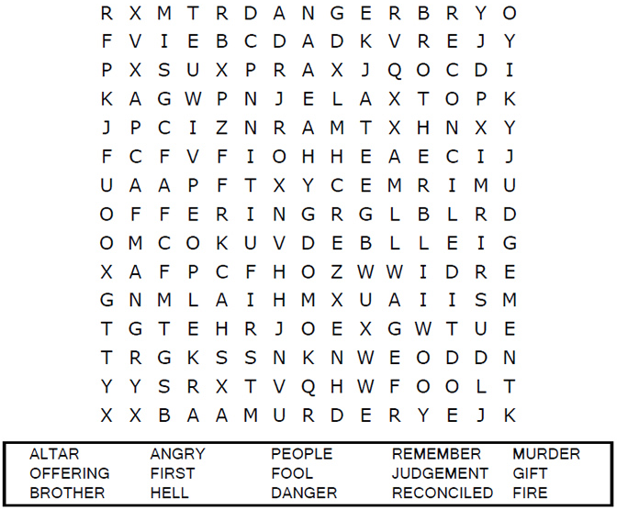



Coloring Page

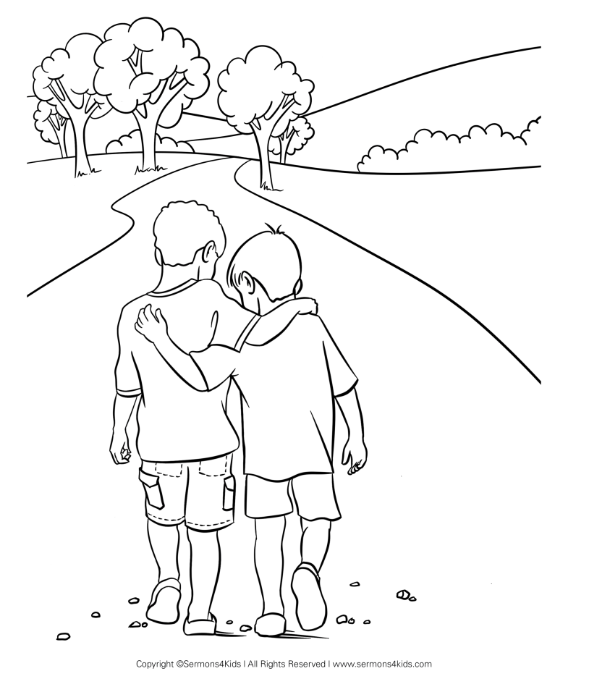

Multiple Choice

From the words provided for each clue, enter the letter   
of the word which best matches the definition.  
  
