Crossword Puzzle

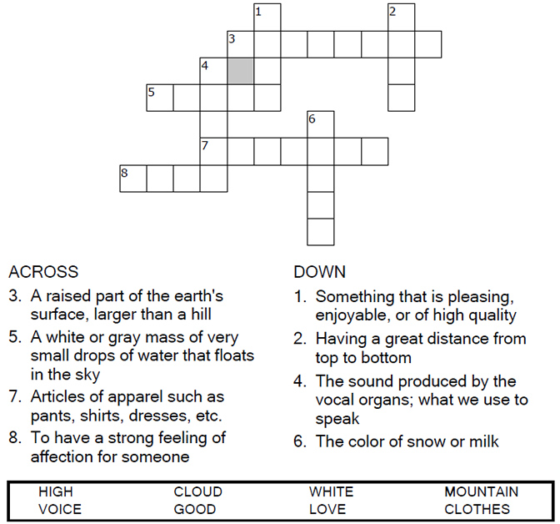

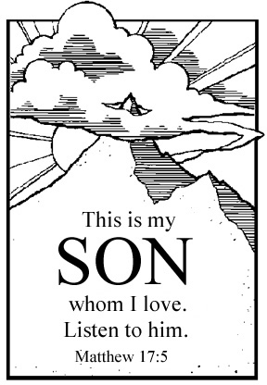

Copyright © Sermons4Kids, Inc.

May be reproduced for Ministry Use

**Children’s Worship Bulletin**



Matthew 17:1-9

Word Search Puzzle

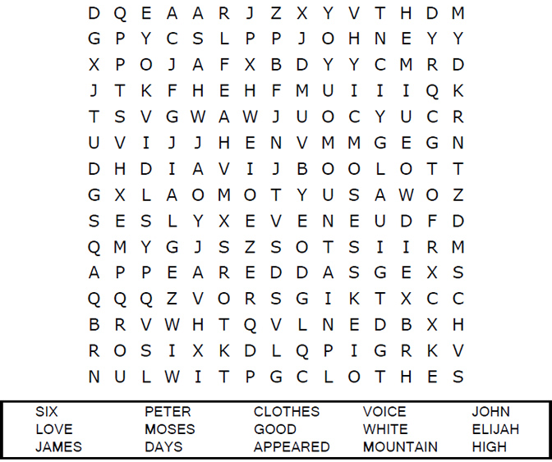



Coloring Page

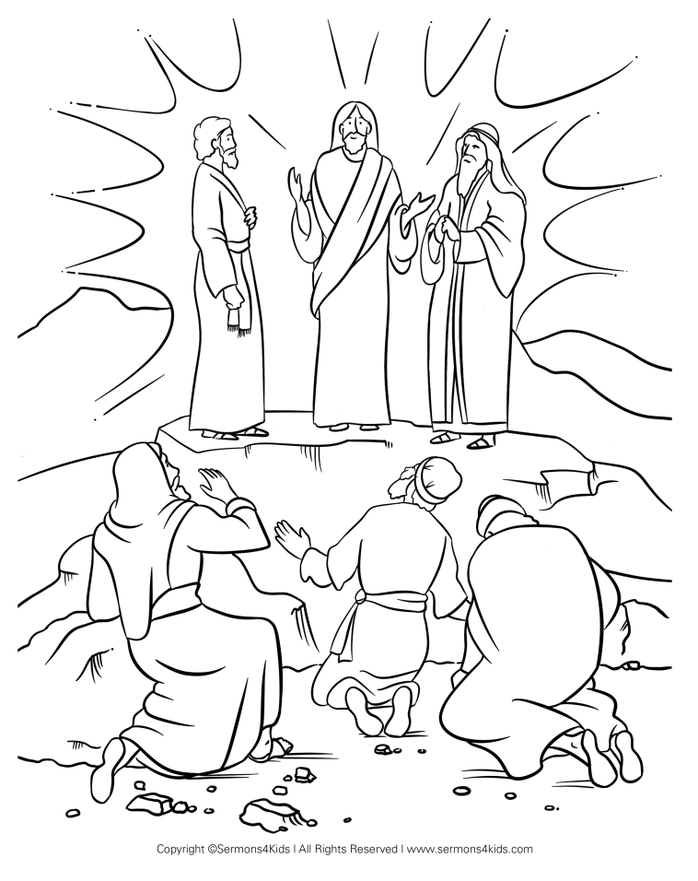  
  
"This is my Son, whom I love; with him I am well pleased.  
Listen to him!"  
Matthew 17:5b (NIV)

Maze Puzzle

Can you find the way to Jesus, Moses, and Elijah on the mountain?   
  
