Crossword Puzzle

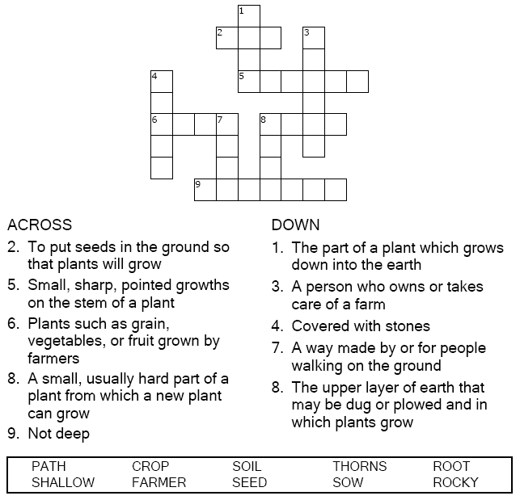

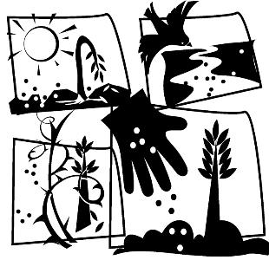

Copyright © Sermons4Kids, Inc.

May be reproduced for Ministry Use

**Children’s Worship Bulletin**



Matthew 13:1-9, 18-23

Word Search Puzzle

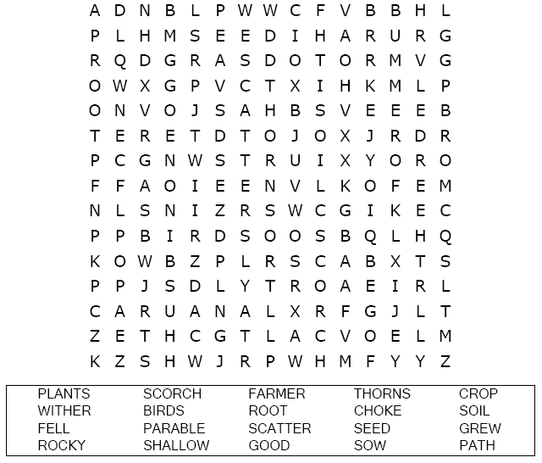  
  


Coloring Page

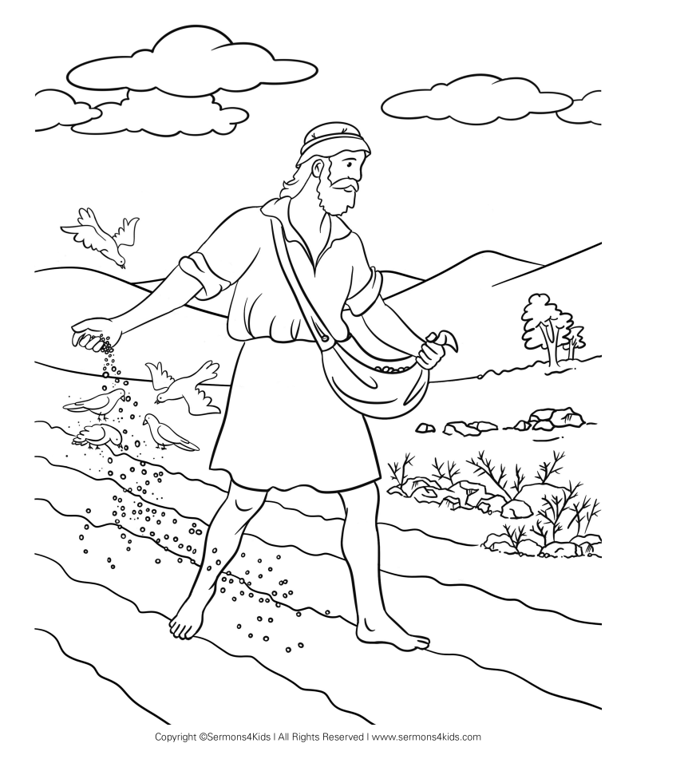  
  
The Parable of the Sower

Copyright © CalvaryCurriculum.com  
Used by Permission

Multiple Choice Quiz

Choose the word that best matches the definition.

