Crossword Puzzle

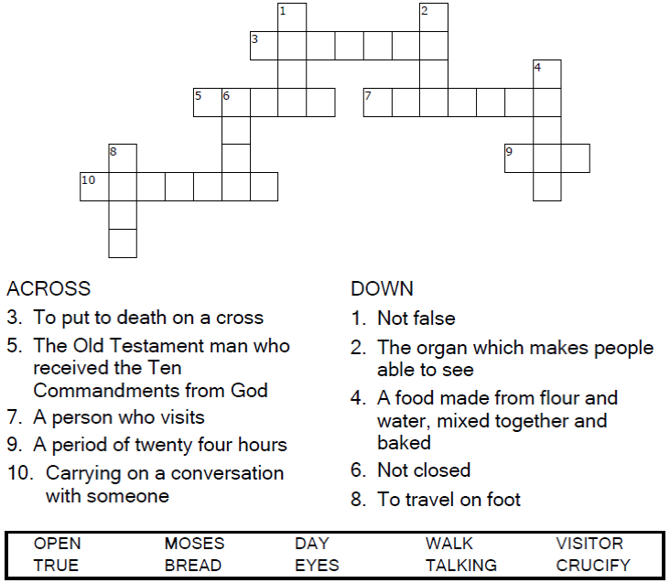

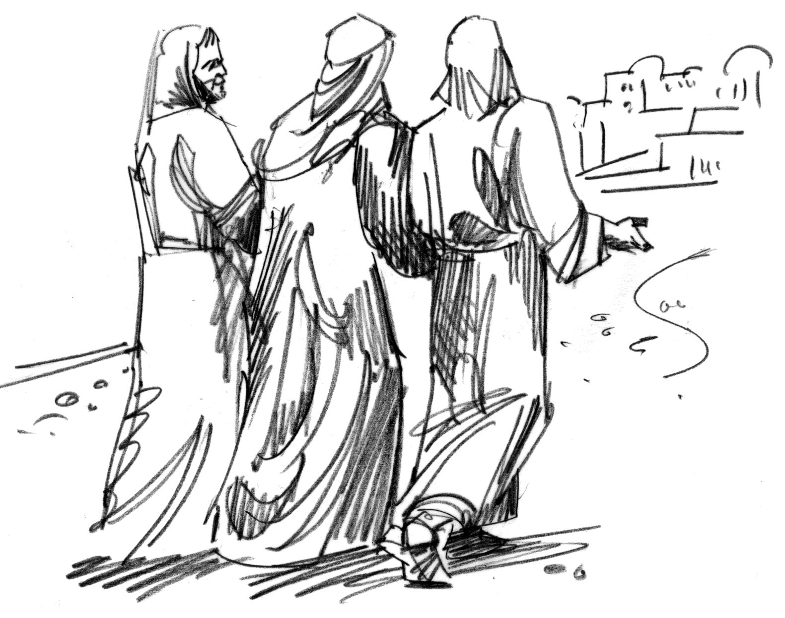

Copyright © Sermons4Kids, Inc.

May be reproduced for Ministry Use

Children’s Worship Bulletin



Luke 24:13-35

Word Search

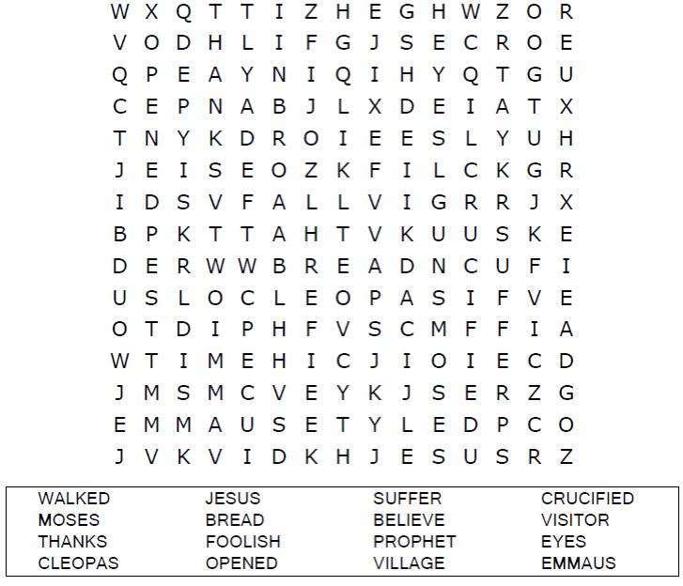



Maze Puzzle

Follow Jesus on the road to Emmaus

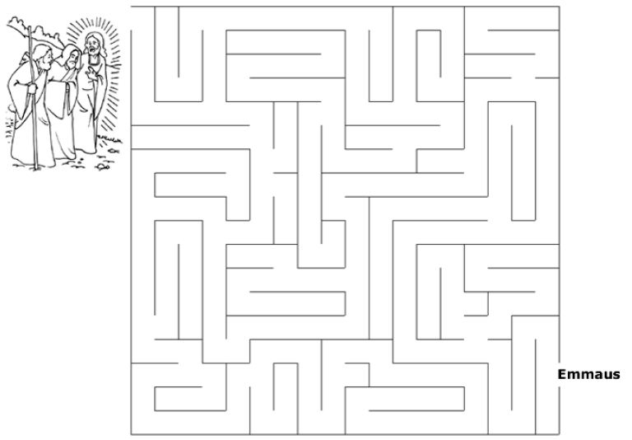



Coloring Page

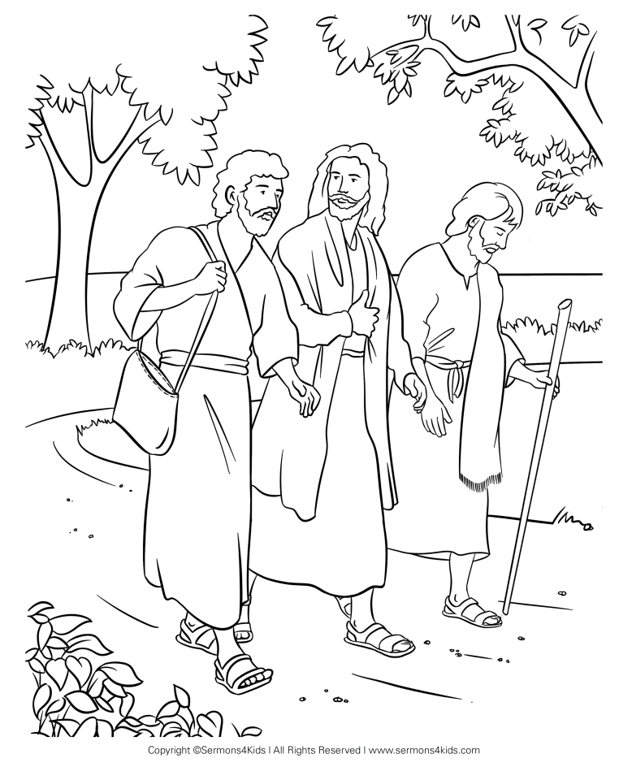

The Road to Emmaus