Crossword Puzzle

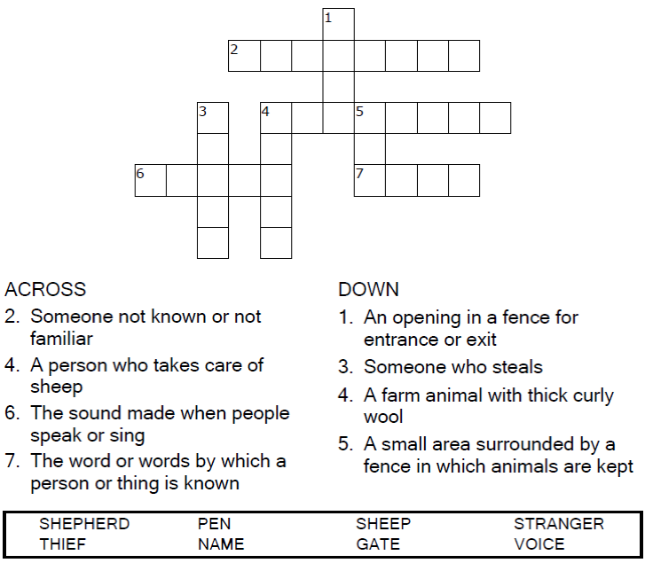

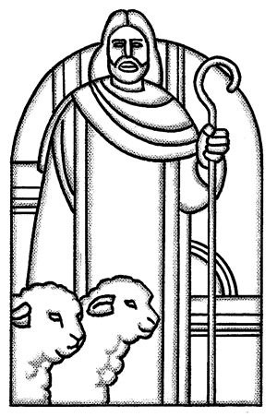

Copyright © Sermons4Kids, Inc.

May be reproduced for Ministry Use

**Children’s Worship Bulletin**



John 10:1-10

Word Search Puzzle

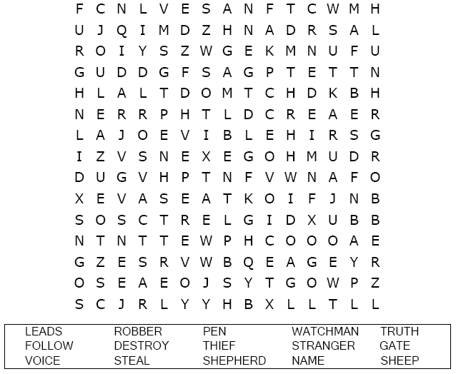



Coloring Page

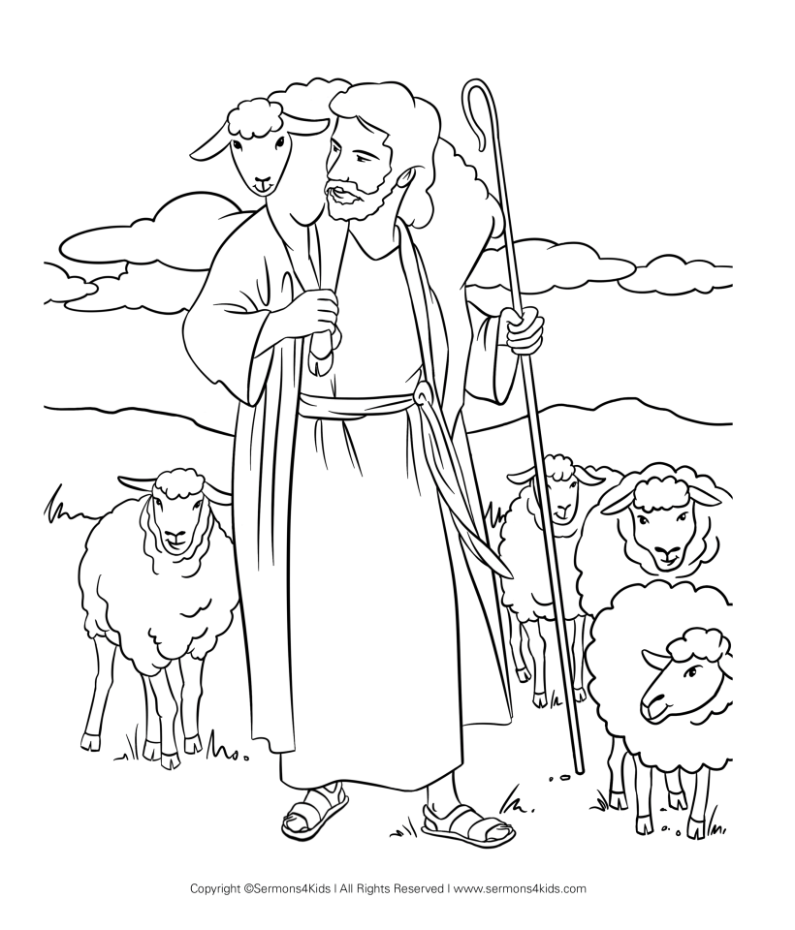

**He calls his own sheep by name and leads them out.  
John 10:3**

Maze Puzzle

Help the lost sheep find his way back to the shepherd.  
  
  
