Crossword Puzzle

Look at the numbered clues. Choose the correct word and write  
it in the puzzle. Each numbered square starts a new word.

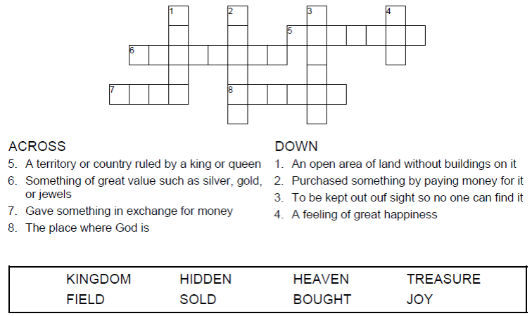

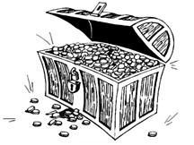

Copyright © Sermons4Kids, Inc.

May be reproduced for Ministry Use

**Children’s Worship Bulletin**



Matthew 13:44

Word Search Puzzle

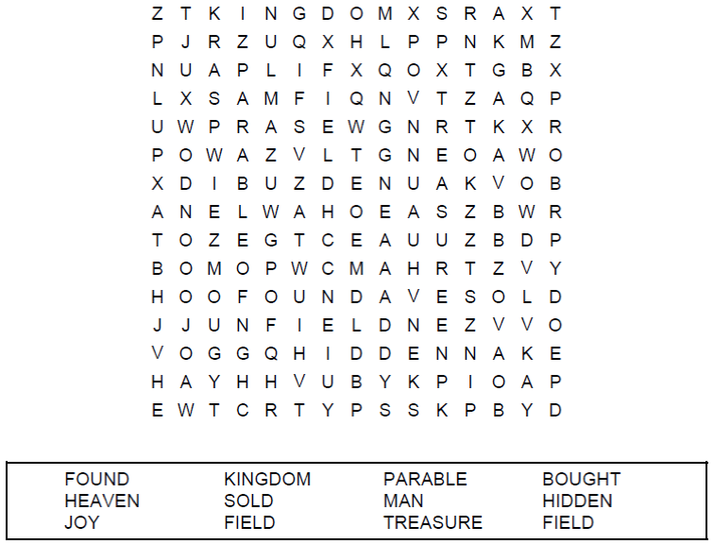

**Your Church Name Here  
Church Address  
City**

Coloring Page

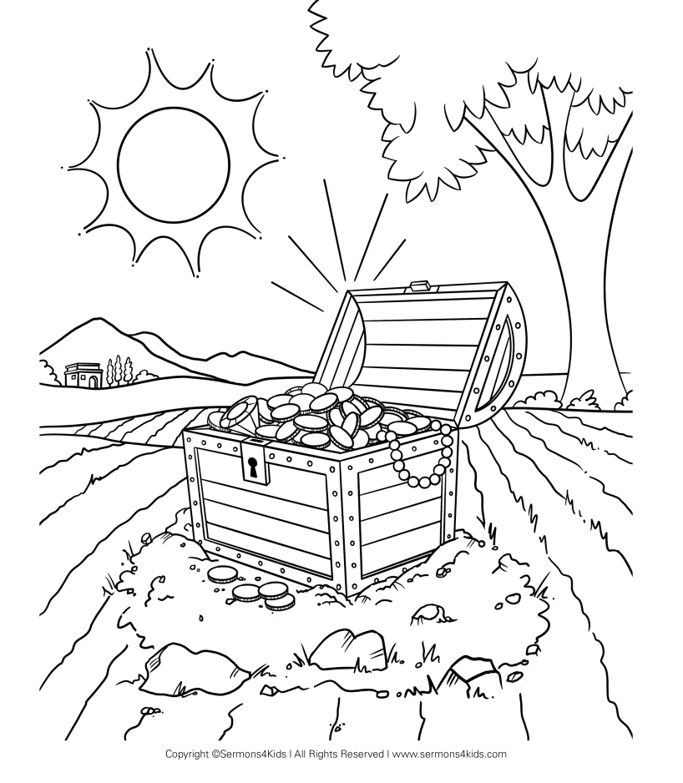

The Treasure in the Field

The kingdom of heaven is like a treasure hidden in a field, which someone found and hid; then in his joy he goes and sells all that he has and buys that field.

Matthew 13:44

Maze Puzzle

Can you find the way to the hidden treasure?

