Crossword Puzzle

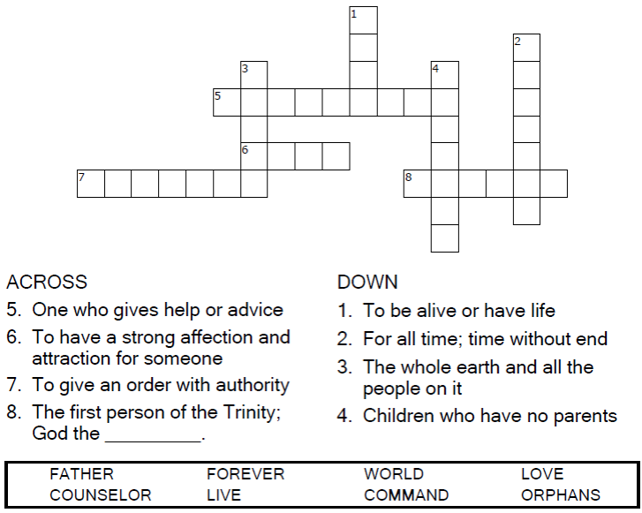



Copyright © Sermons4Kids, Inc.

May be reproduced for Ministry Use

**Children’s Worship Bulletin**



John 14:15-21

Word Search Puzzle

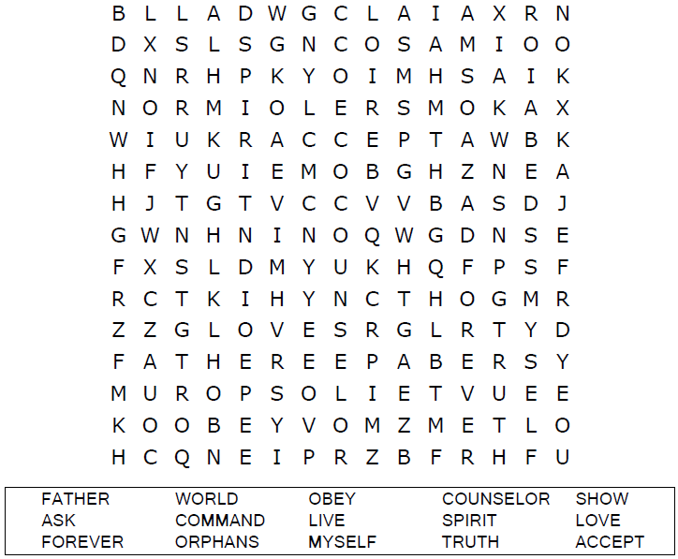  
  
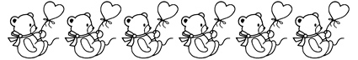

Coloring Page

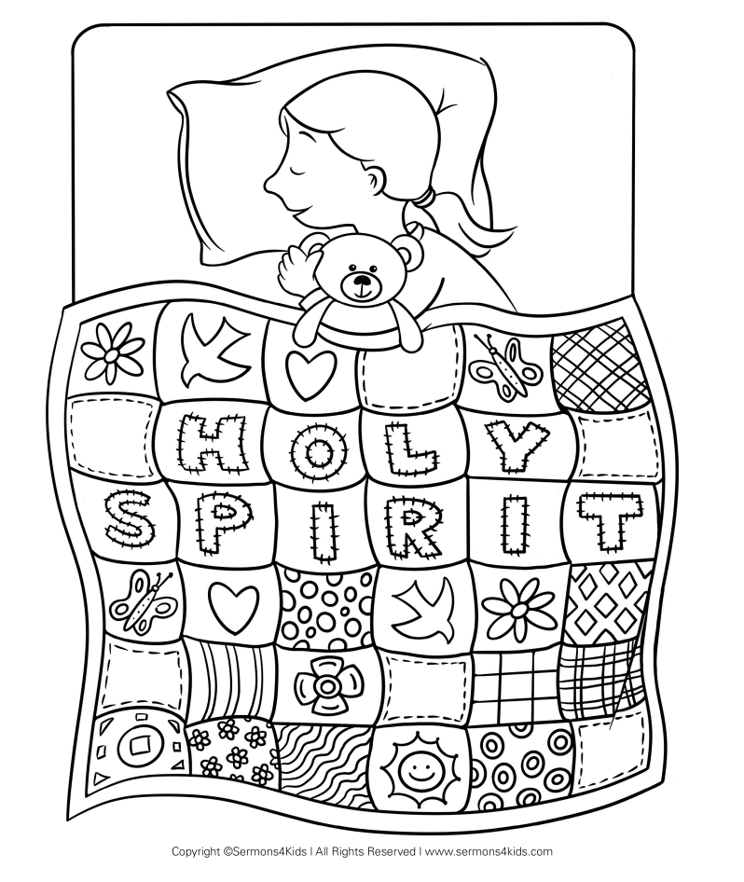

Word Jumble Puzzle

Unscramble the letters and write the word correctly in the space provided.

