Crossword Puzzle

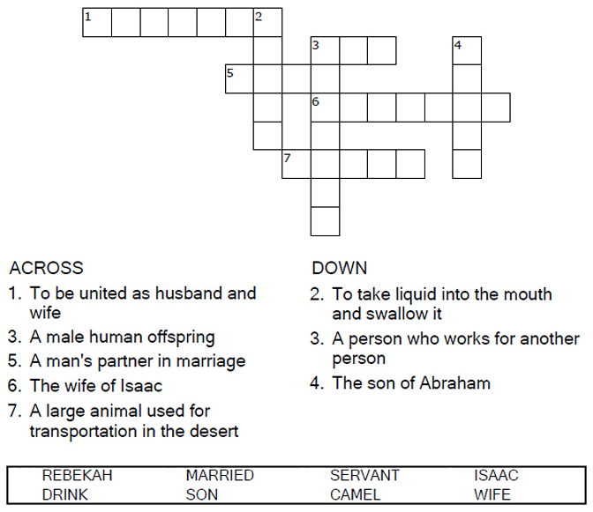

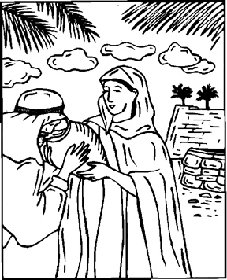

Copyright © Sermons4Kids, Inc.

May be reproduced for Ministry Use

**Children’s Worship Bulletin**



Genesis 24:1-67

Word Search Puzzle

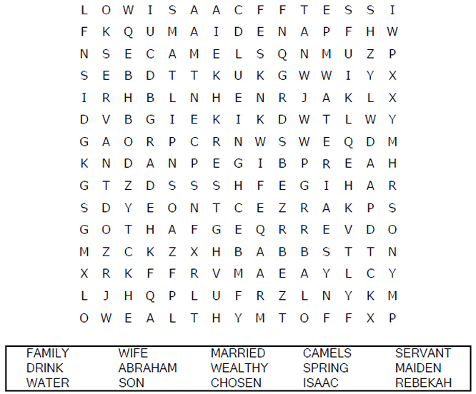  
**Your Church Name  
Church Address  
City**

Coloring Page

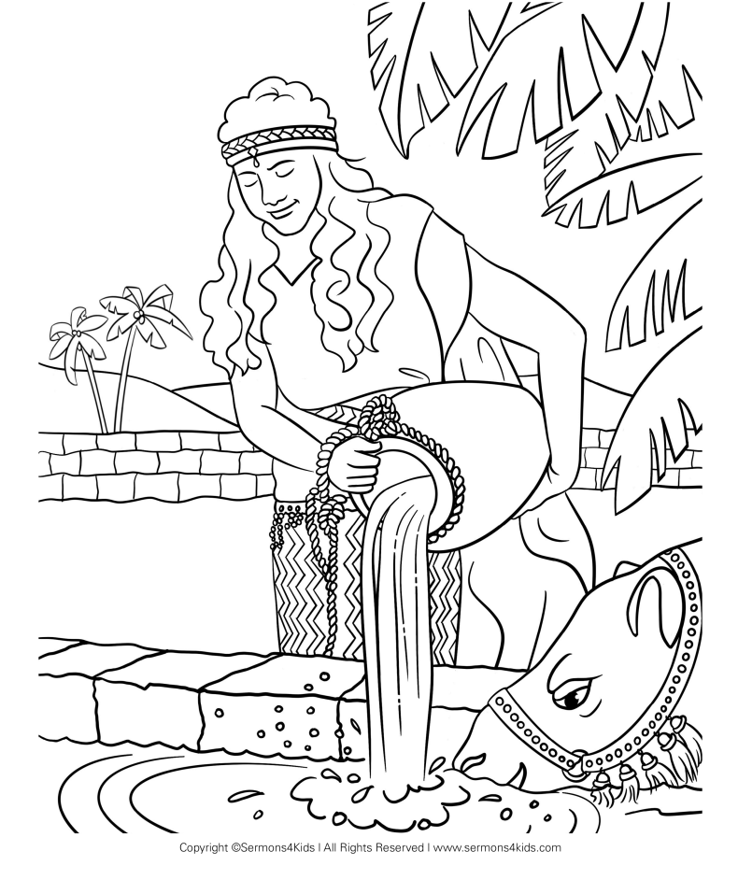  
A Bride for Isaac  
Genesis 24:1-67

Decoder Puzzle

Each number represents a letter of the alphabet. Substitute  
the correct letter for the numbers to reveal the coded words.

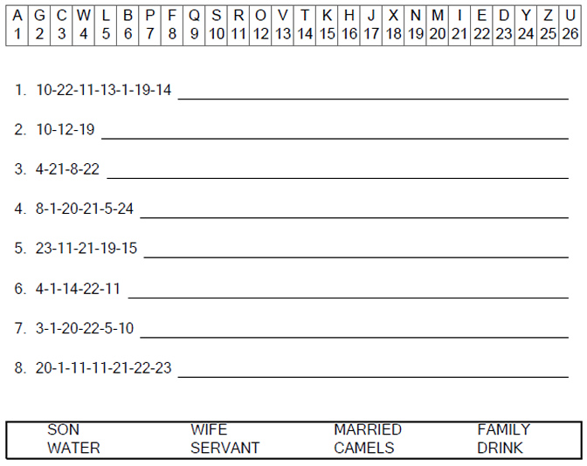

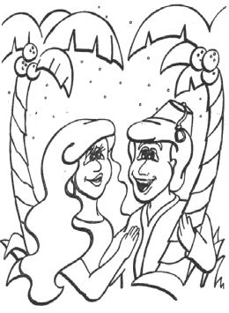  
Isaac and Rebekah