Crossword Puzzle

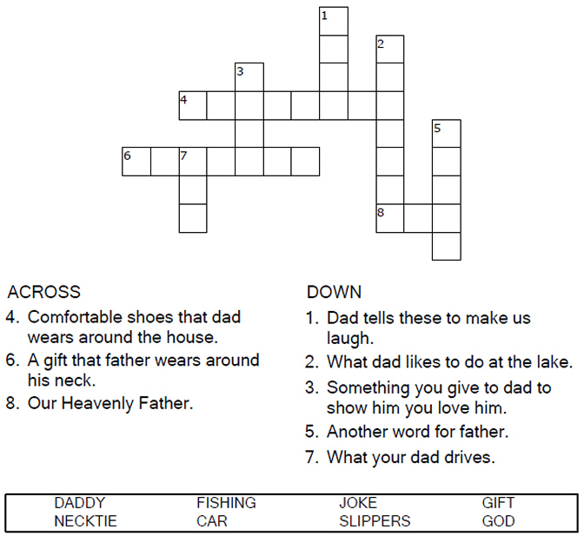



Copyright © Sermons4Kids, Inc.

May be reproduced for Ministry Use

**Children’s Worship Bulletin**



Listen, my sons, to a father's instruction;  
pay attention and gain understanding.  
Proverbs 4:1

Word Search Puzzle

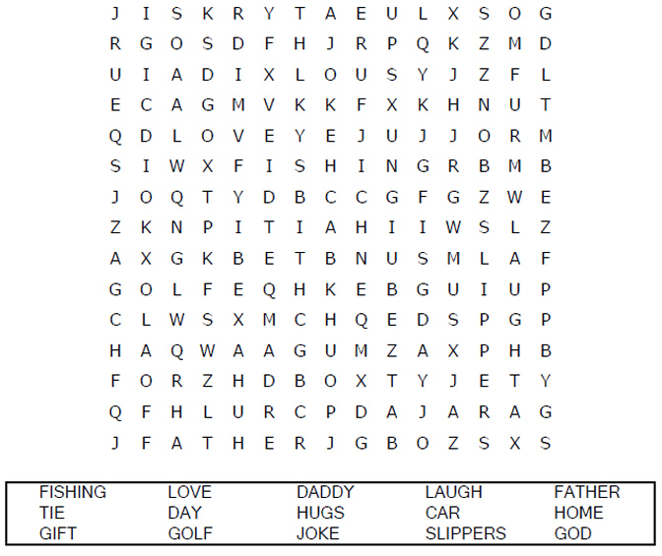

**Your Church Name  
Church Address**

Coloring Page

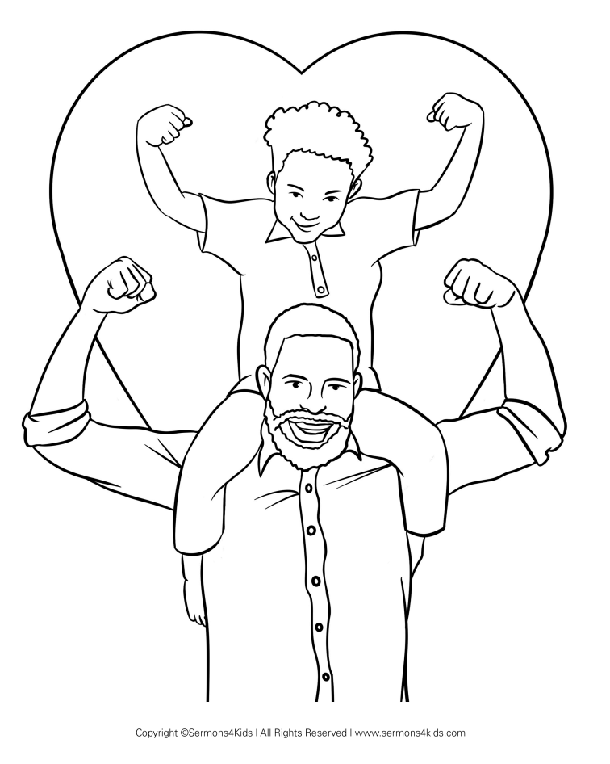

I can do right by obeying God’s laws.

Decoder Puzzle

