Crossword Puzzle

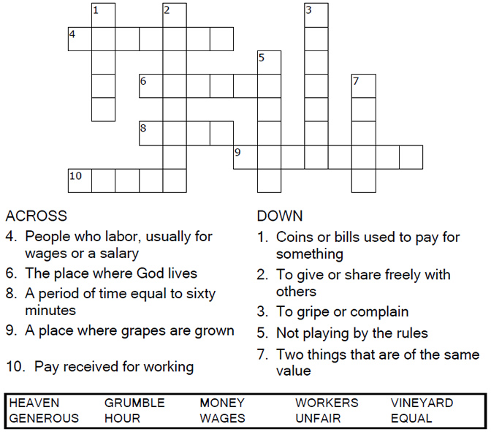

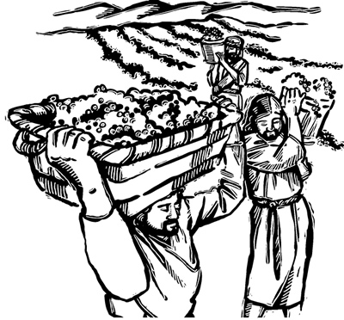

Copyright © Sermons4Kids, Inc.

May be reproduced for Ministry Use

**Children’s Worship Bulletin**



Matthew 20:1-16

Word Search Puzzle

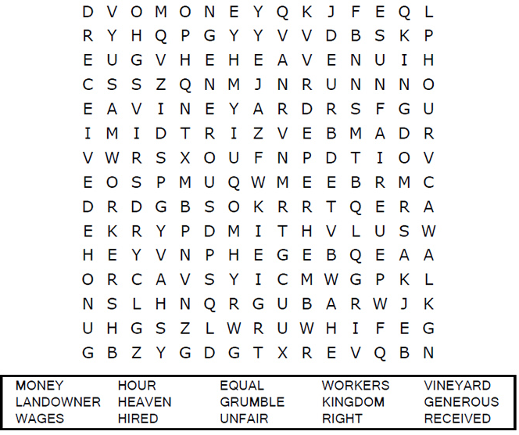

**Your Church Name  
Address  
City**

Coloring Page

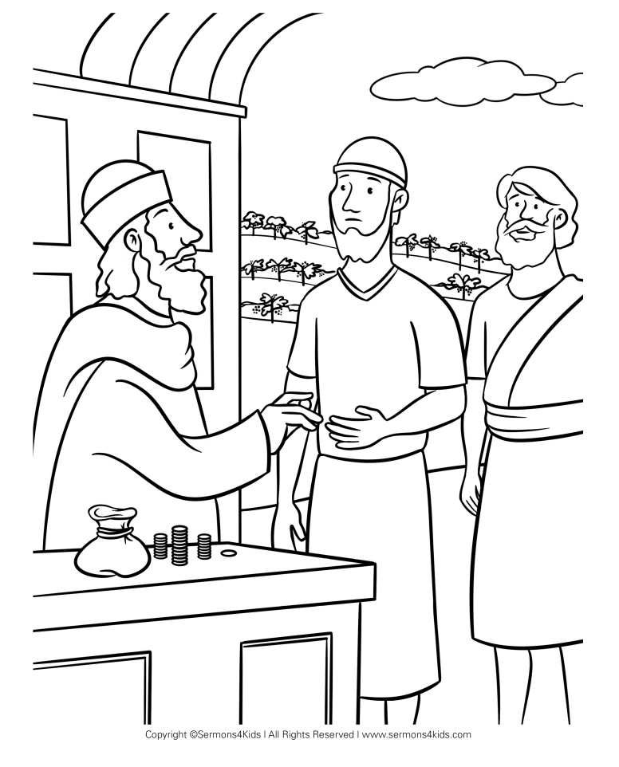

'These men who were hired last worked only one hour,' they said, '  
and you have made them equal to us who have borne the   
burden of the work and the heat of the day.'  
Matthew 20:12

Decoder Puzzle

Each number represents a letter of the alphabet. Substitute  
the correct letter for the numbers to reveal the coded words.

