Crossword Puzzle

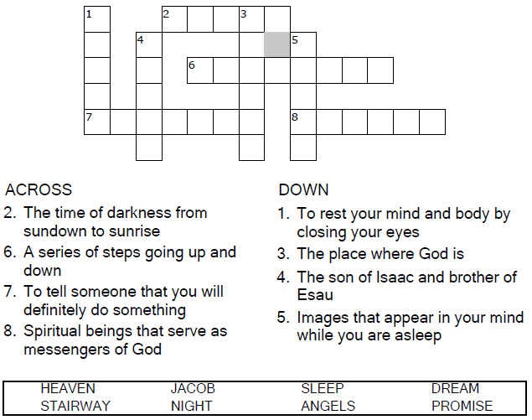

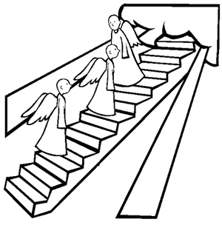

Copyright © Sermons4Kids, Inc.

May be reproduced for Ministry Use

**Children’s Worship Bulletin**



Genesis 28:10-19

Word Search Puzzle

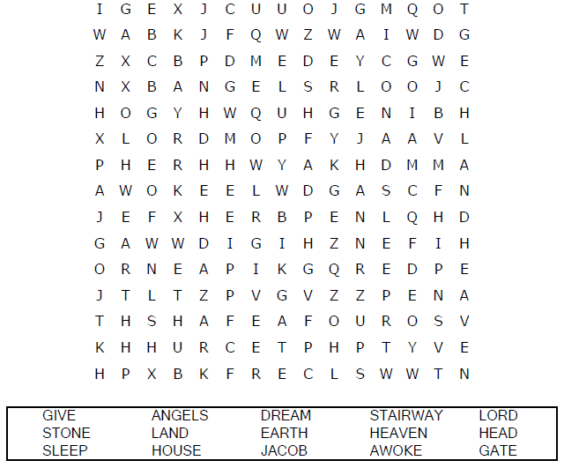  
**Church Name  
Address  
City**

Coloring Page

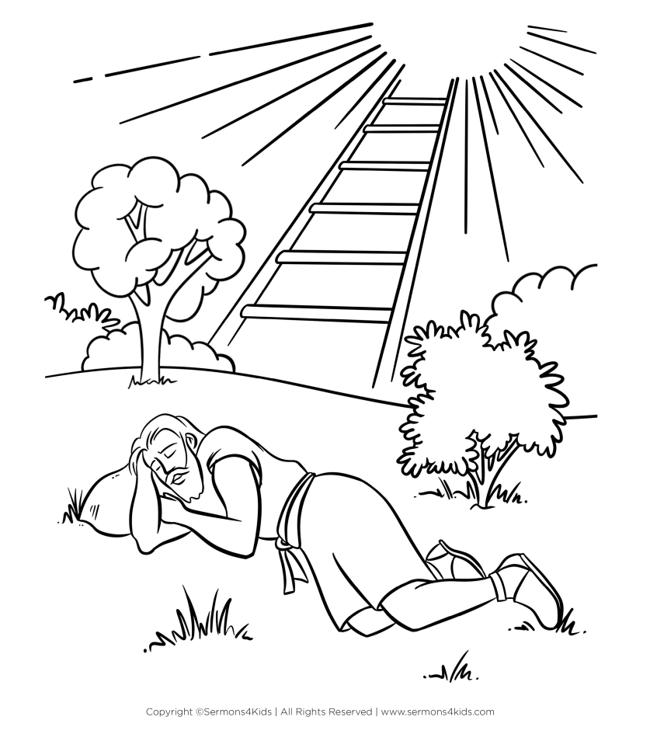  
  
God Cares for Jacob

Maze Puzzle

Can you find your way through the "maze of clouds"

to Jacob's stairway to heaven?

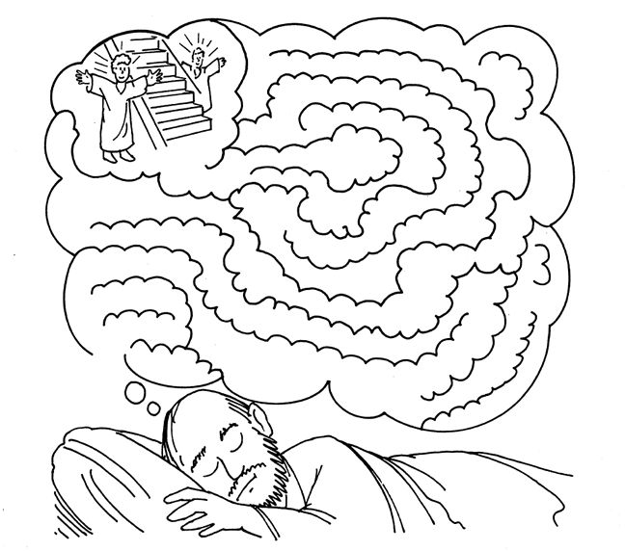

Jacob had a dream. In his dream, the LORD said,

"I will give to you and your family the land  
on which you are now sleeping."

Copyright © 1999 Church of God International  
Used by Permission