Crossword Puzzle

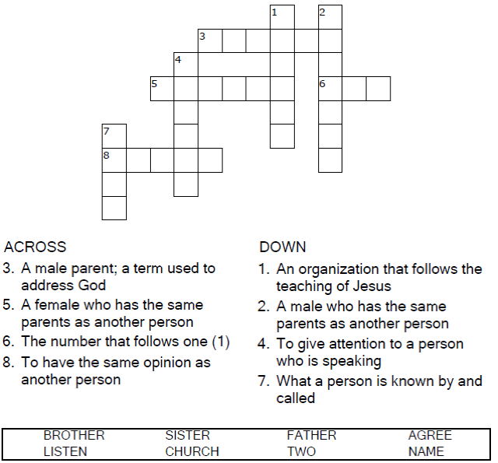



Copyright © Sermons4Kids, Inc.

May be reproduced for Ministry Use

**Children’s Worship Bulletin**



Matthew 18:15-20

Word Search Puzzle

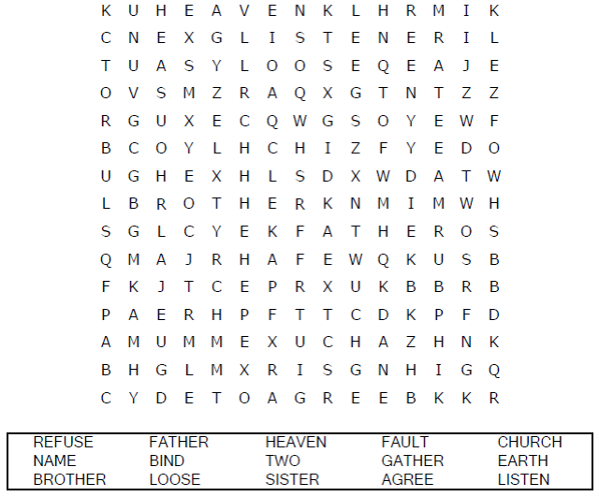  
**Your Church’s Name  
Address  
City, State**

Coloring Page

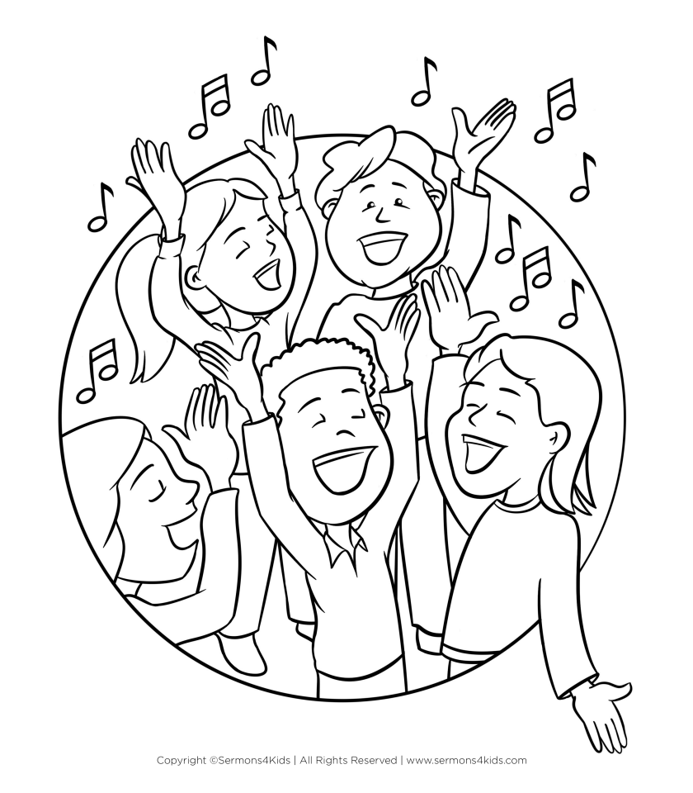

Decoder Puzzle

Each number represents a letter of the alphabet. Substitute  
the correct letter for each number to solve the coded word.

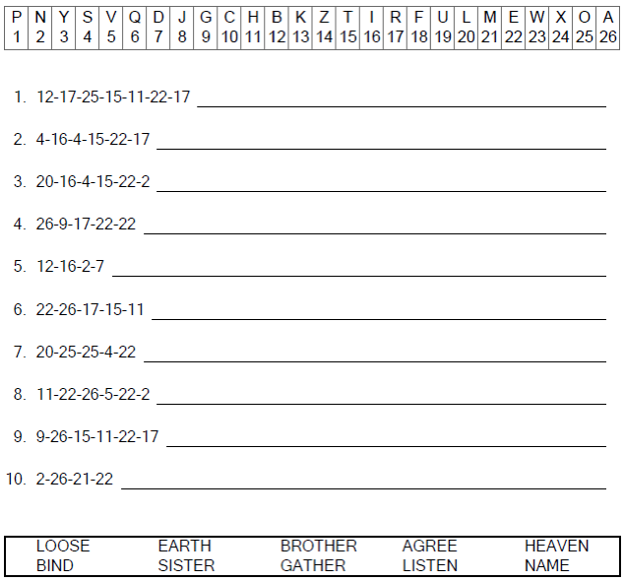  


For where two or three come together in my name,  
there am I with them.".

Matthew 18:20 (NIV)