Crossword Puzzle

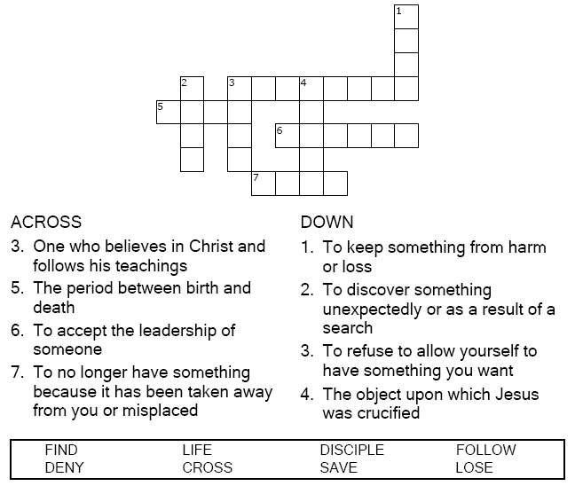

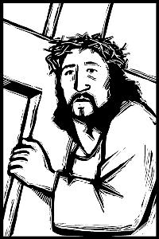

Copyright © Sermons4Kids, Inc.

May be reproduced for Ministry Use

**Children’s Worship Bulletin**



Matthew 16:21-28

Word Search Puzzle

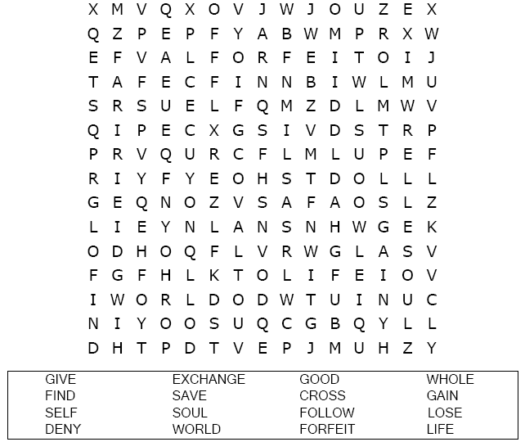  
**Your Church’s Name  
Address  
City, State**

Coloring Page

  
  
I will follow Jesus, our leader.

Connect the Dots

Connect the dots in ABC order to complete the picture.

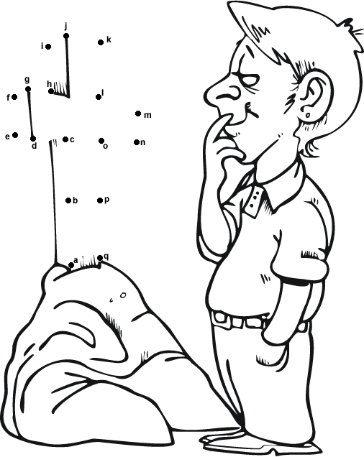

Then Jesus said to his disciples, "If anyone would come after me,

he must deny himself and take up his cross and follow me.

Matthew 16:24 (NIV)