Crossword Puzzle

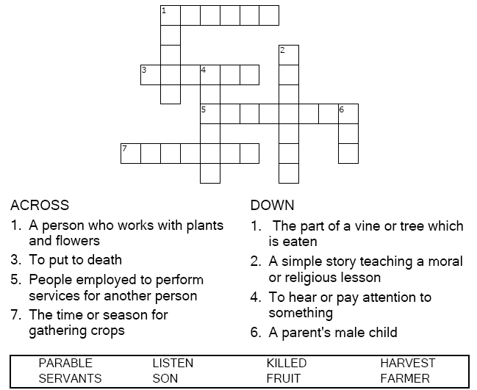

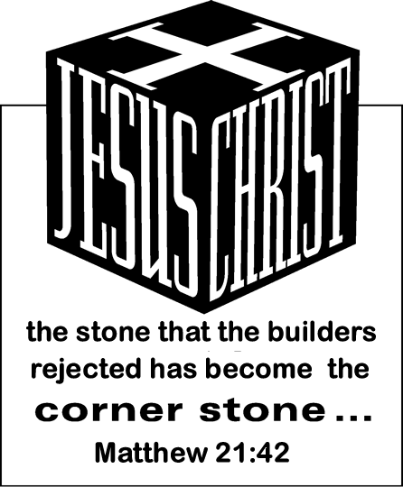

Copyright © Sermons4Kids, Inc.

May be reproduced for Ministry Use

**Children’s Worship Bulletin**



Matthew 21:36-46

Word Search Puzzle

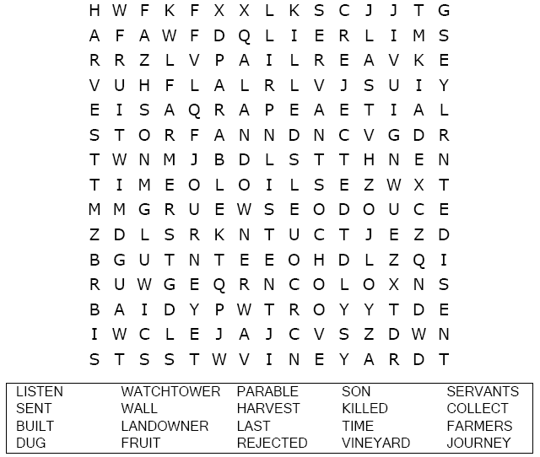

**heartcross_border.jpeg**

Coloring Page

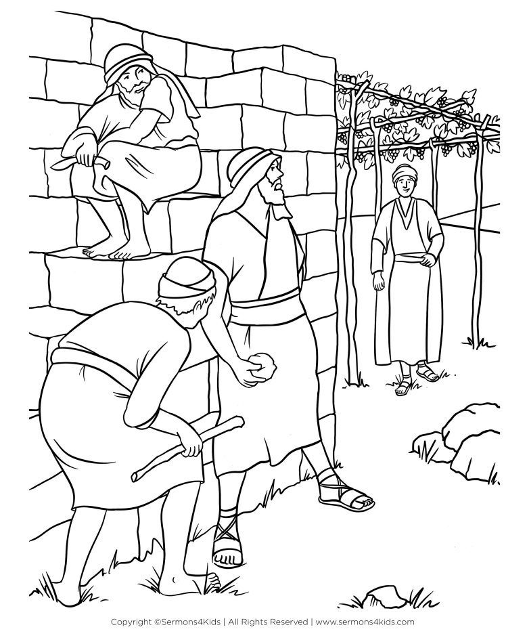

**The Parable of the Tenants  
Matthew 21:33-46**

Decoder Puzzle

Each number represents a letter of the alphabet. Substitute  
the correct letter for the numbers to reveal the coded words.

