Crossword Puzzle

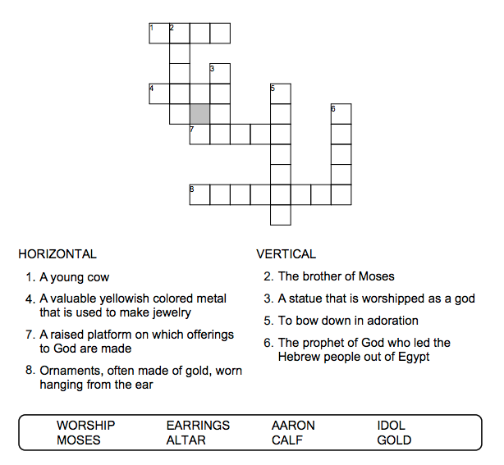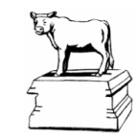

Copyright © Sermons4Kids, Inc.

May be reproduced for Ministry Use

**Children’s Worship Bulletin**



Exodus 32:1-14

Word Search Puzzle

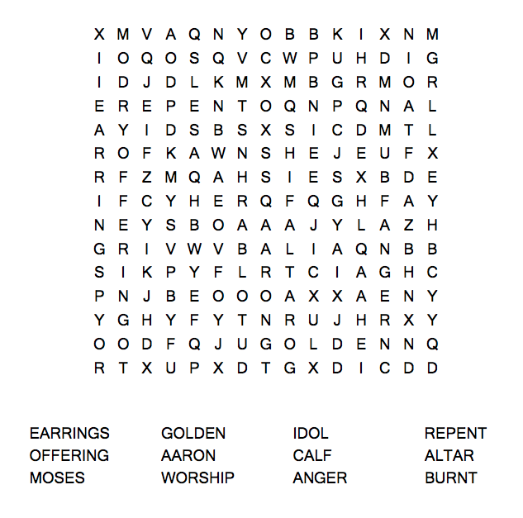  
  
**Church Name  
Address  
City**

Coloring Page

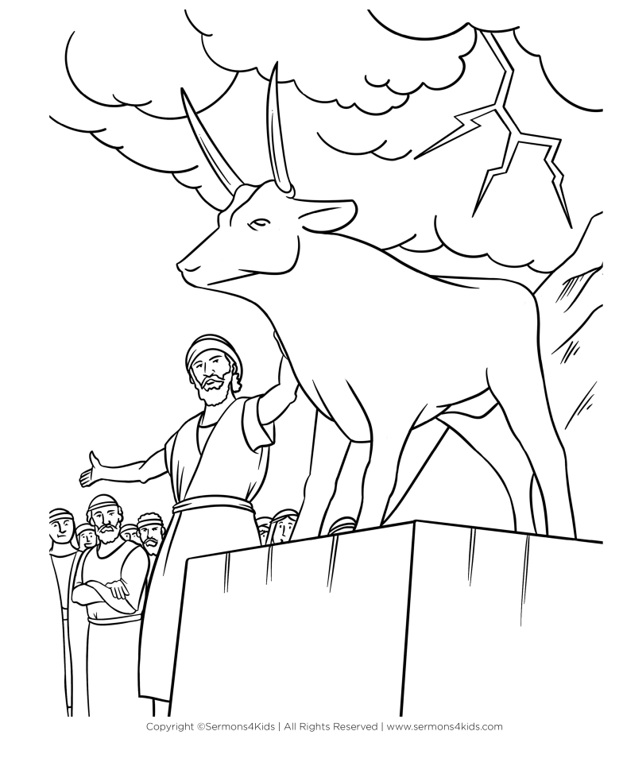

Decoder Puzzle

Each number represents a letter of the alphabet.  
Substitute the correct letter for the numbers to  
reveal the coded words.

