Crossword Puzzle

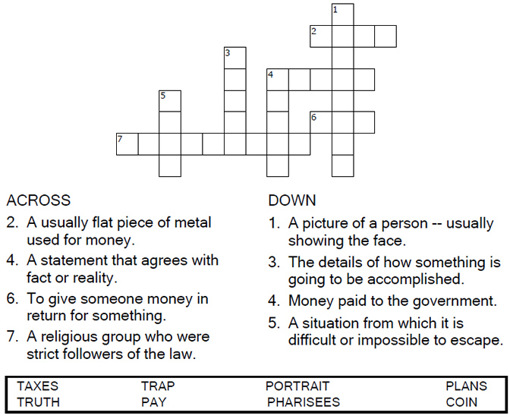



Copyright © Sermons4Kids, Inc.

May be reproduced for Ministry Use

**Children’s Worship Bulletin**



Matthew 22:15-22

Word Search Puzzle

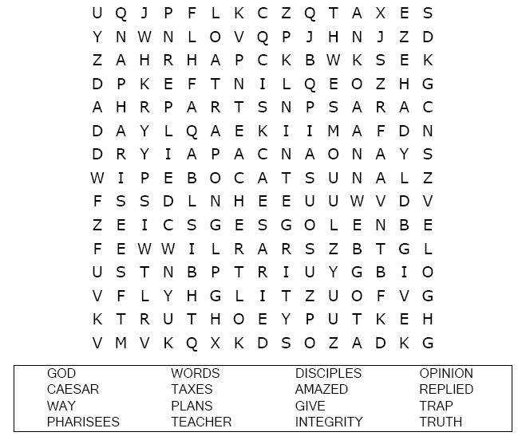  
**Your Church Name  
Address  
City**

Coloring Page

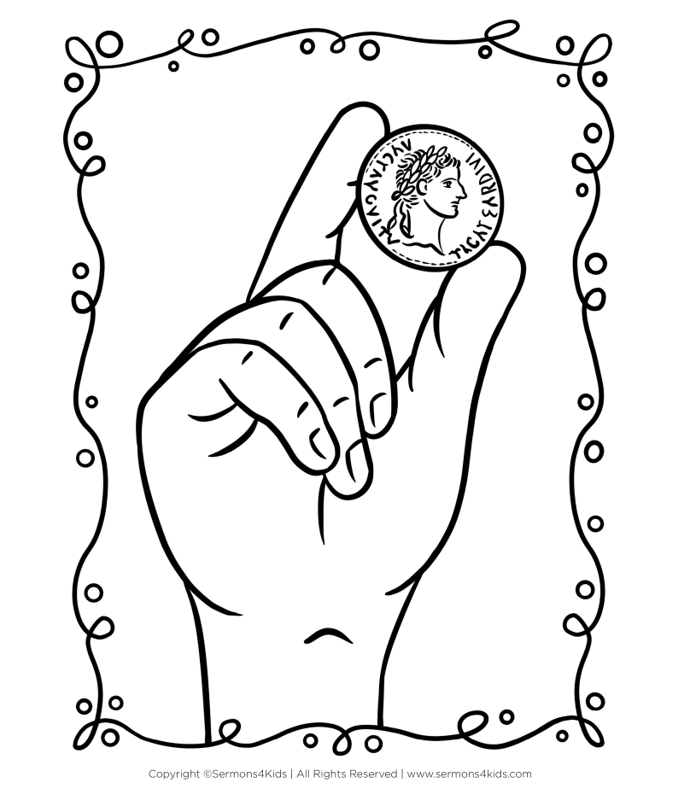

**“Give to Caesar what is Caesar’s, and to God what is God’s”  
Matthew 22:21.**

Multiple Choice Quiz

Choose the word that best matches the definition.

