Crossword Puzzle

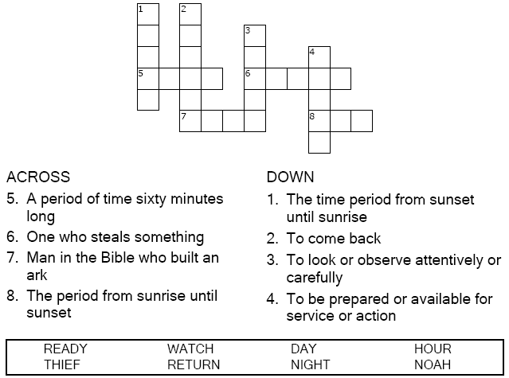

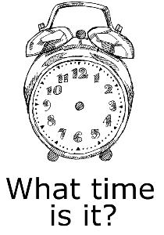

Copyright © Sermons4Kids, Inc.

May be reproduced for Ministry Use

Children’s Worship Bulletin



Matthew 25:31-46

Word Search Puzzle

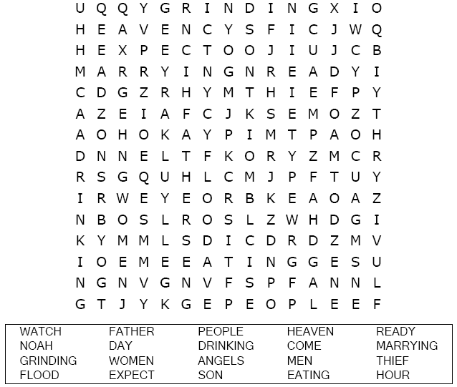  
Your Church Name  
Church Address  
City

Coloring Page

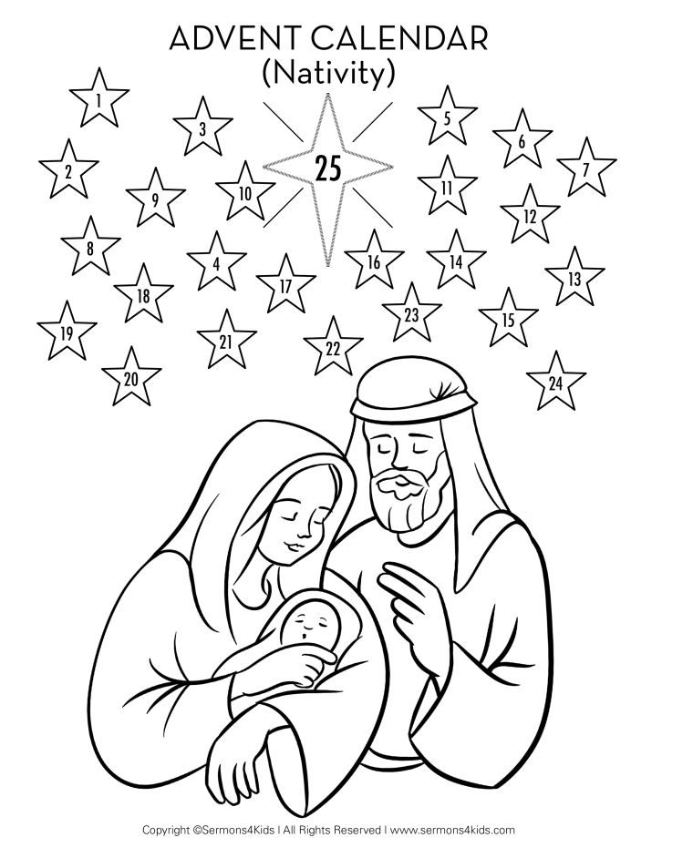

Color the picture, then each day color one star beginning with number one.

Decoder Puzzle

Each number represents a letter of the alphabet. Substitute  
the correct letter for the number to reveal the coded word.

