Elisha sent a messenger to say to him, "Go, wash yourself seven times in the Jordan, and your flesh  
will be restored and you will be cleansed."  
2 Kings 5:10 (NIV)

Crossword Puzzle

Naaman Healed of Leprosy

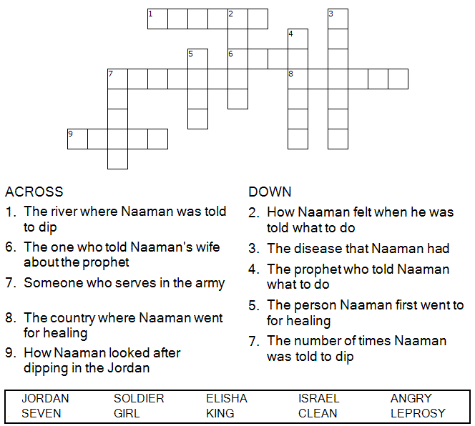

Copyright © Sermons4Kids, Inc.

May be reproduced for Ministry Use

Children’s Worship Bulletin



2 Kings 5:1-14

Word Search

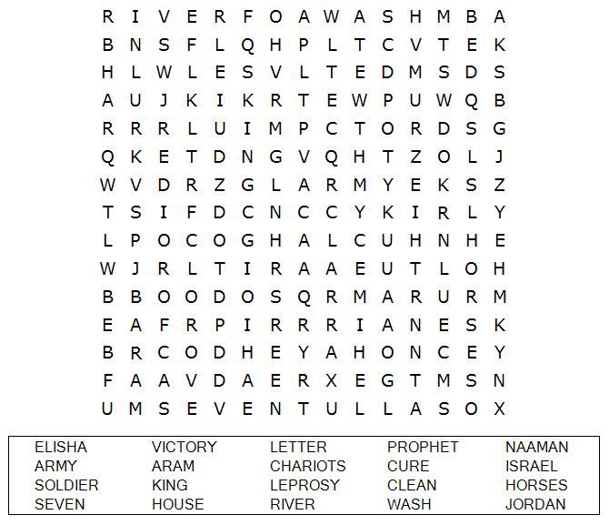

**Your Church Name Here**Anytown, USA

Multiple Choice Quiz

Choose the word that best matches the definition.  
You can find the answers in 2 Kings 5:1-14.

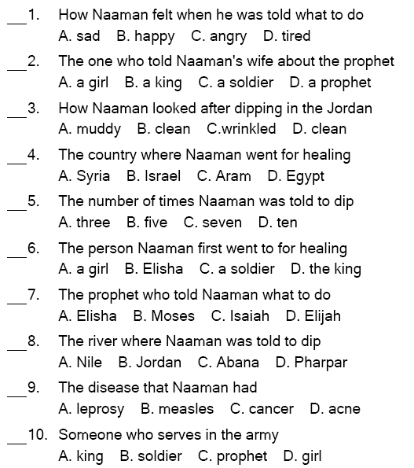

So he went down and dipped himself in the Jordan seven times, as the man of God had told him, and his flesh was restored and became clean like that of a young boy. 1 Kings 5:14 (NIV)

Fill in the Blanks

Complete the sentences by filling in the blanks with the correct words from the word bank below the story.

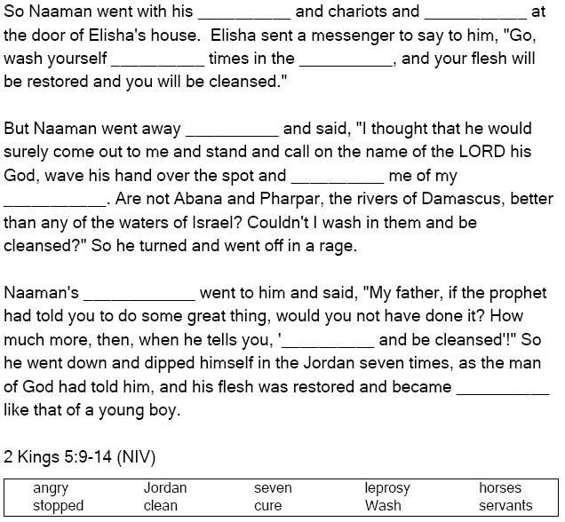

Follow God's Directions!