Crossword Puzzle

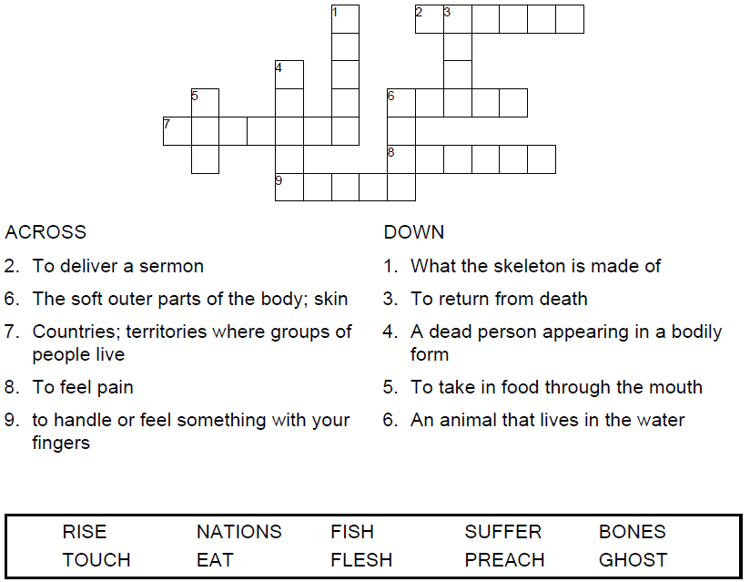

**

Copyright © Sermons4Kids, Inc.

May be reproduced for Ministry Use

Children’s Worship Bulletin



Luke 24:36-48

Word Search Puzzle

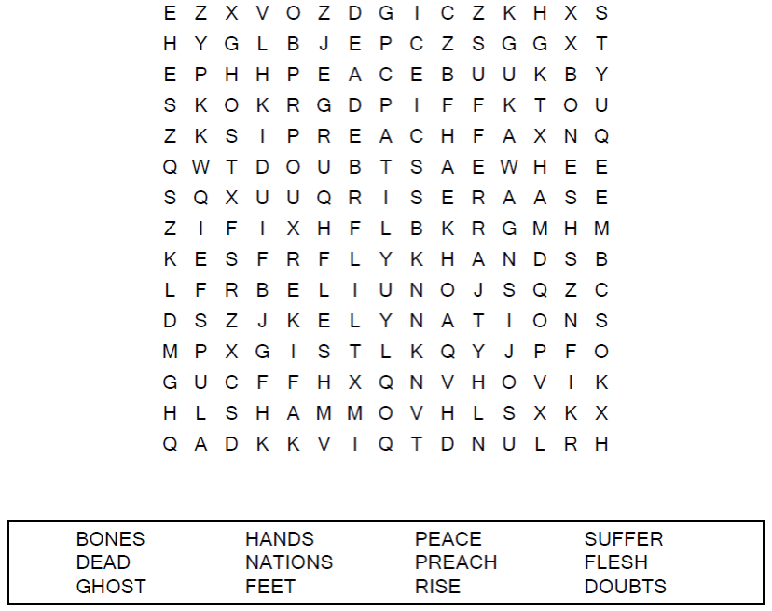

**Your Church Name Here**

Anytown, Anywhere

Coloring Page

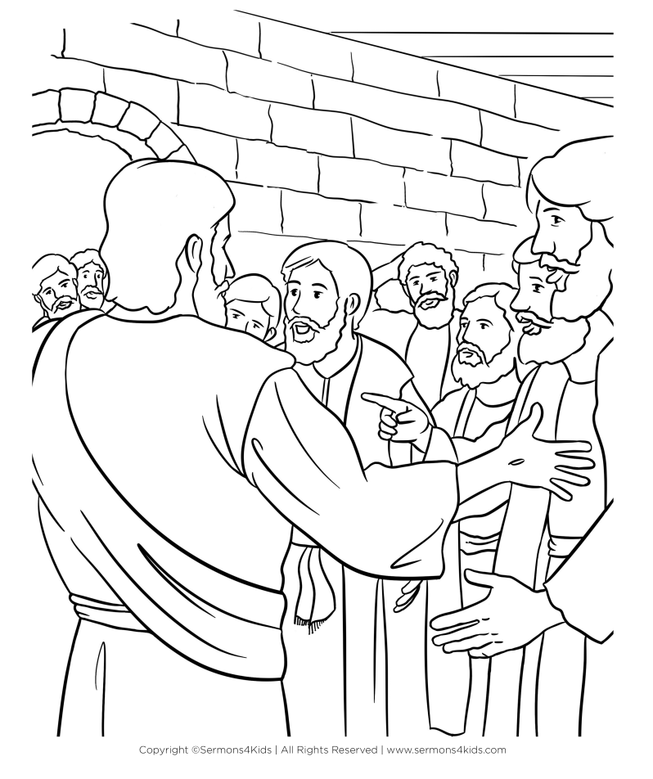

Jesus Appears to the Disciples

Decoder Puzzle

Each number represents a letter of the alphabet. Substitute   
the correct letter for the numbers to reveal the coded words.

