Crossword Puzzle

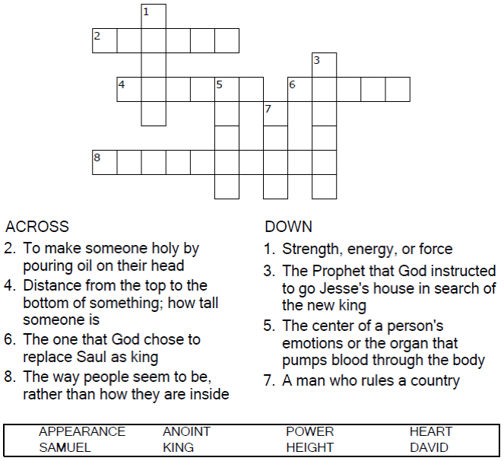



Copyright © Sermons4Kids, Inc.

May be reproduced for Ministry Use

Children’s Worship Bulletin



1 Samuel 16:1-13

Word Search

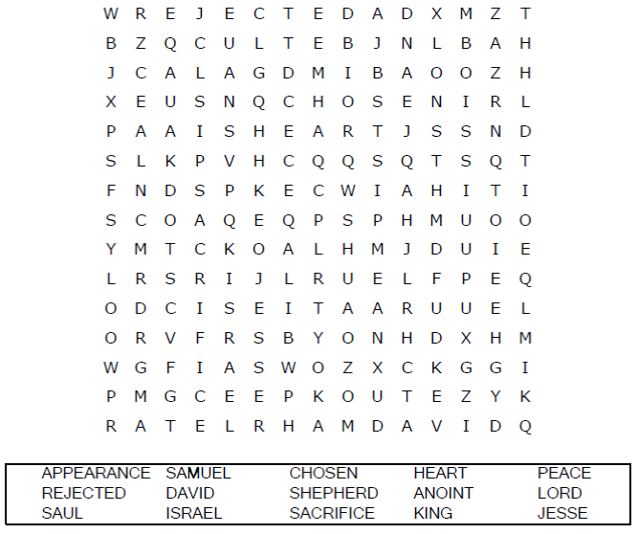

Your Church Name  
City or Town

Multiple Choice

From the words provided for each clue, write the  
 letter of the word which best matches the clue.

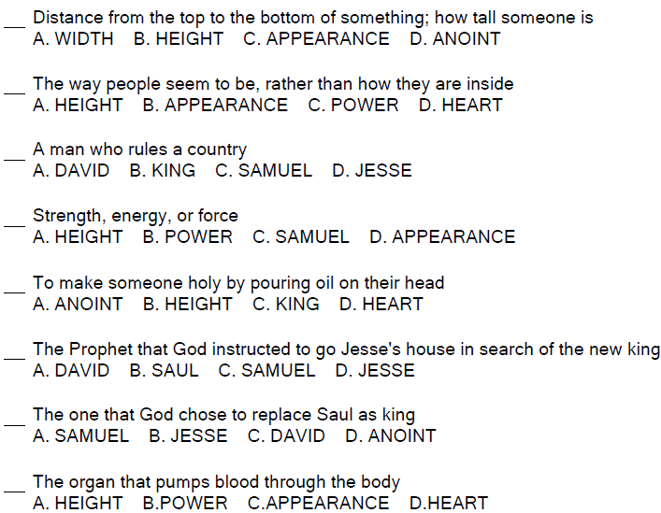

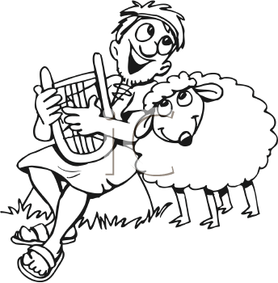

Coloring Page

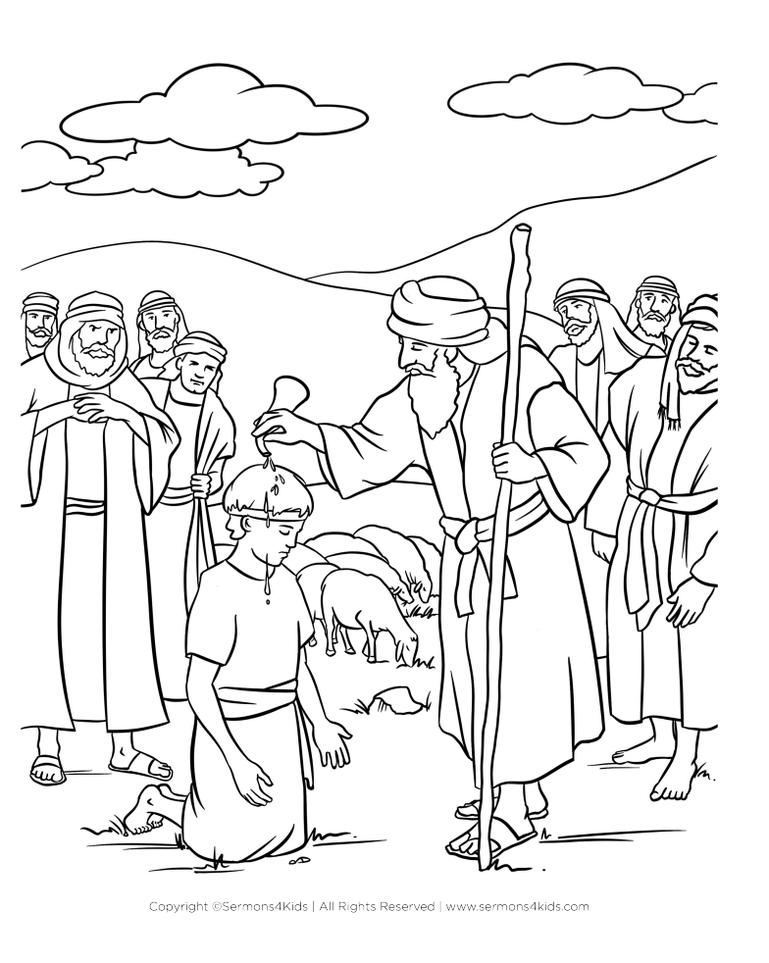

The LORD does not look at the things man looks at.  
Man looks at the outward appearance,   
but the LORD looks at the heart."

1 Samuel 16:7 (NIV)