Fill In The Blanks

A word has been removed from each sentence and is  
listed below the sentences. Use the listed words to fill  
 the blanks in the sentence.

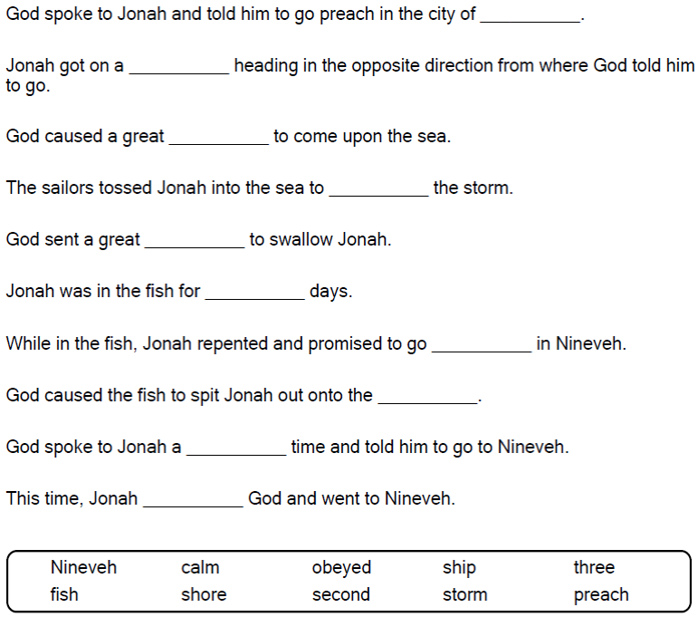



Copyright © Sermons4Kids, Inc.

May be reproduced for Ministry Use

**Children’s Worship Bulletin**



Jonah 1:1-3:3

Word Search Puzzle

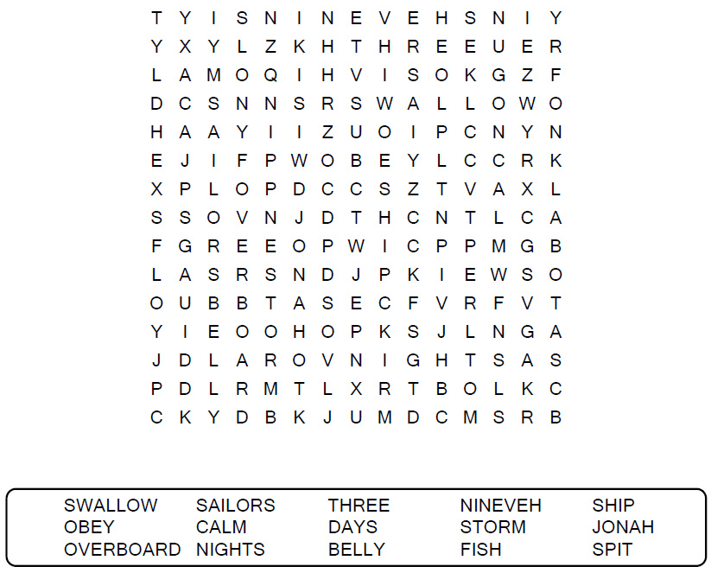  
  
**Church Name  
Address  
City**

Coloring Page

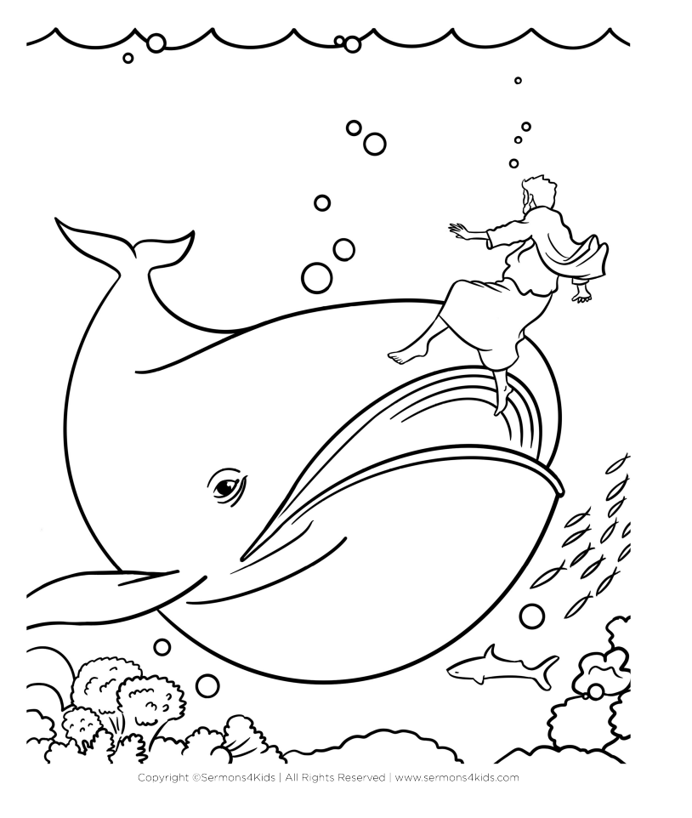

Decoder Puzzle

Each number represents a letter of the alphabet.  
Substitute the correct letter for the numbers to  
reveal the coded words.

