Crossword Puzzle

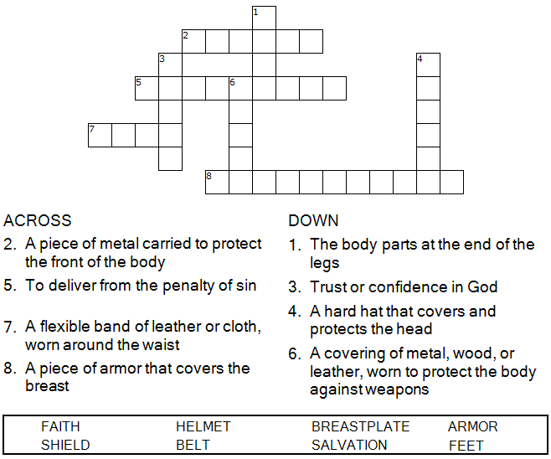

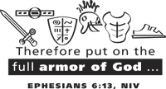

Copyright © Sermons4Kids, Inc.

May be reproduced for Ministry Use

Children’s Worship Bulletin



Ephesians 6:11-17

Word Search Puzzle

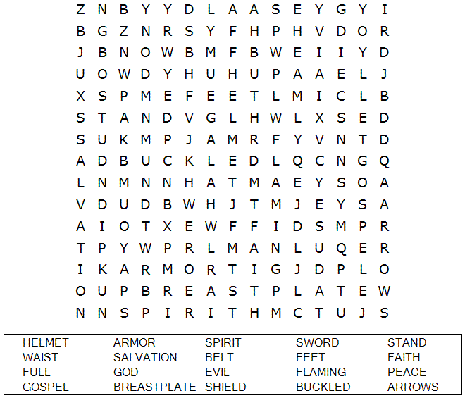

**Your Church Name Here**

Anytown, USA

Fill in the Blanks

Complete the sentences by filling in the blanks with the correct words from the word bank at the bottom of the page.

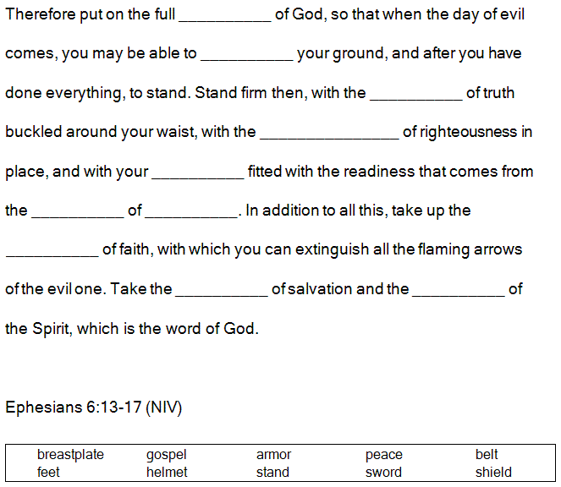

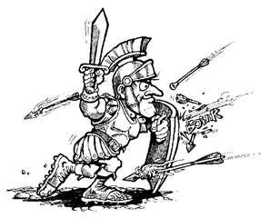

Decoder Puzzle

Each number represents a letter of the alphabet. Substitute the correct letter for the numbers to reveal the words.

