Dot to Dot Puzzle

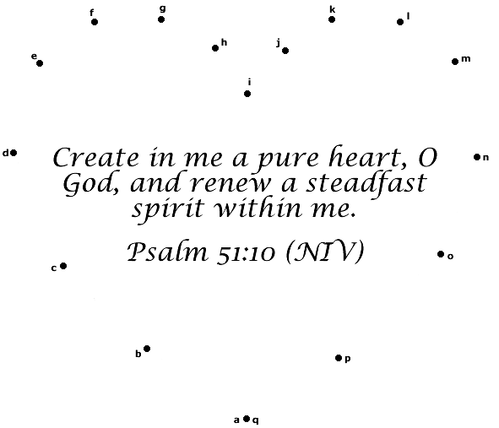

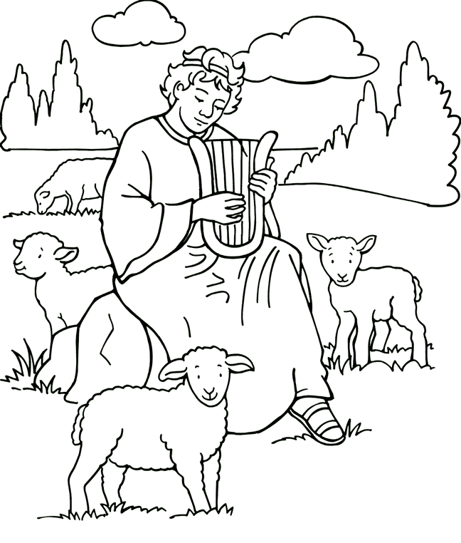

Copyright © Sermons4Kids, Inc.

May be reproduced for Ministry Use

**Children’s Worship Bulletin**



Psalm 51:1-13

Word Search Puzzle

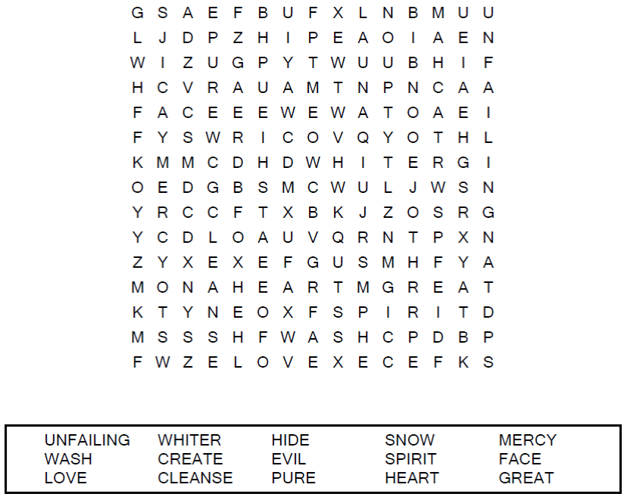

**Your Church Name  
Your City**

Coloring Page

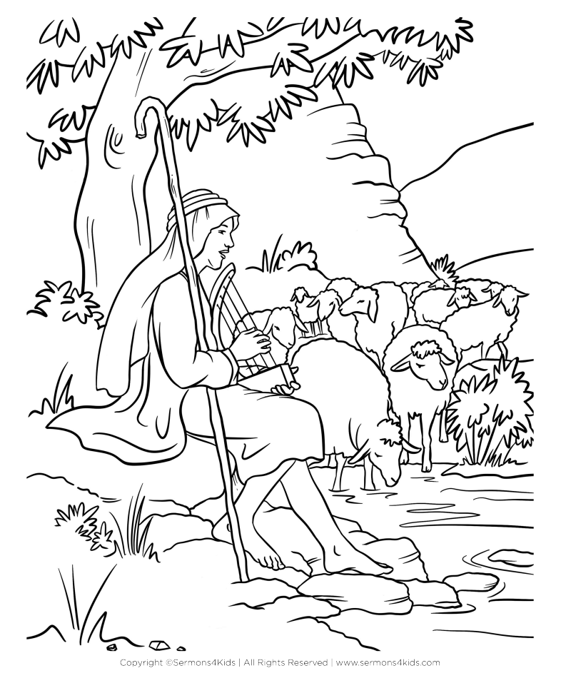

**David, King of Israel**

Decoder Puzzle

The words below have been written in code. Use the hints  
in the decoder at the top of the page to help break the code.



