Crossword Puzzle

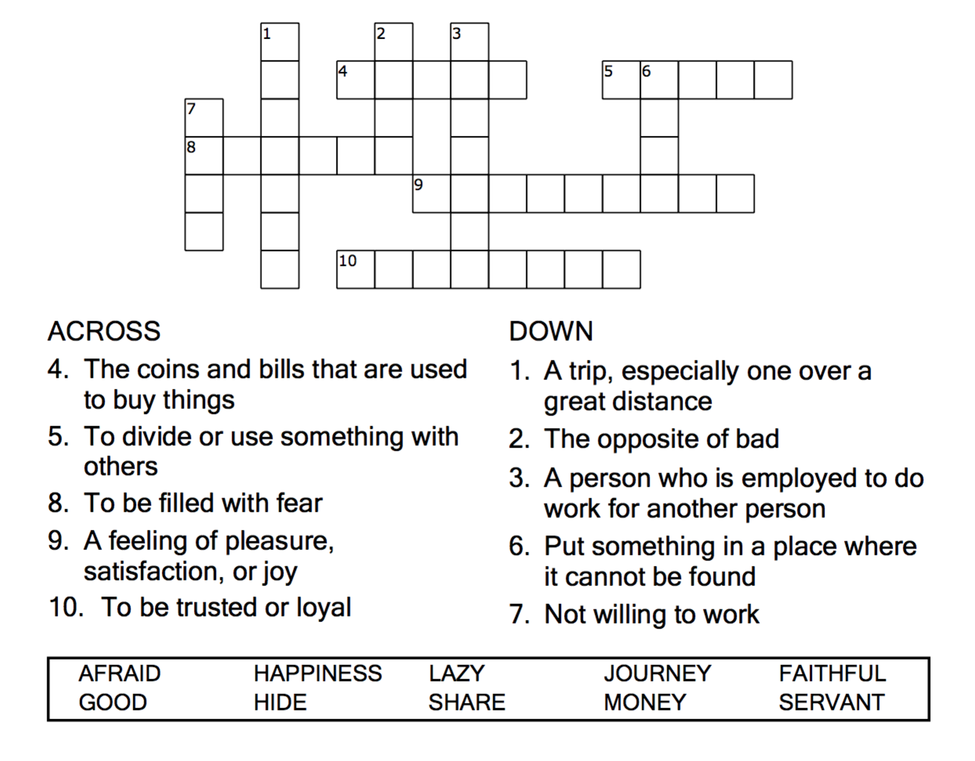



Copyright © Sermons4Kids, Inc.

May be reproduced for Ministry Use

Children’s Worship Bulletin



Matthew 25:14-30

Word Search Puzzle

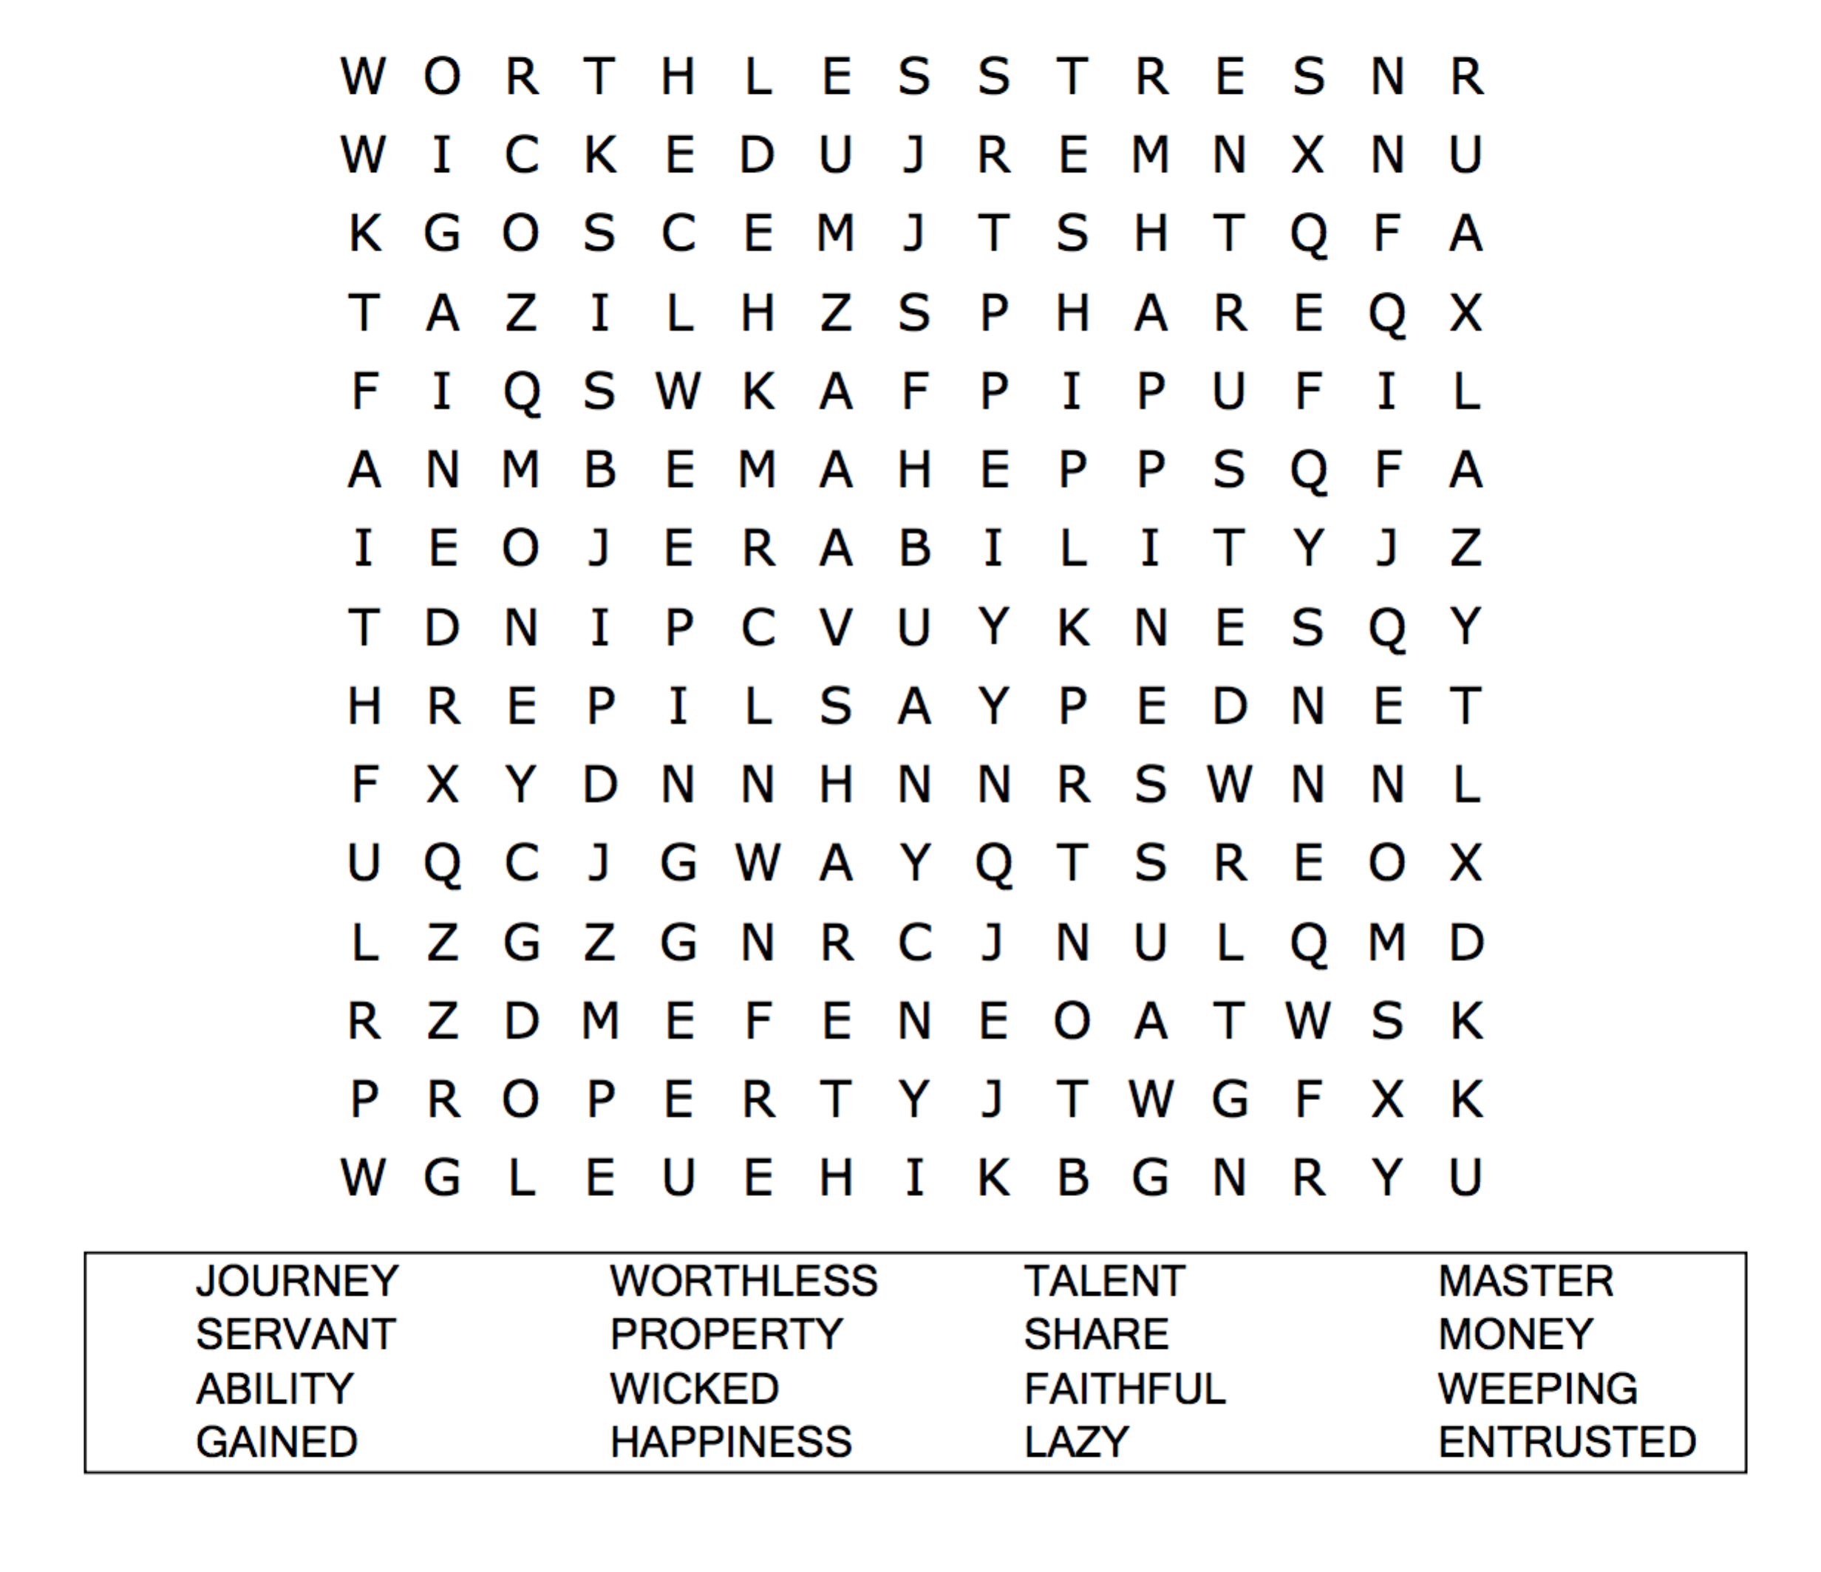

**Your Church Name Here**

Anytown, USA

Coloring Page

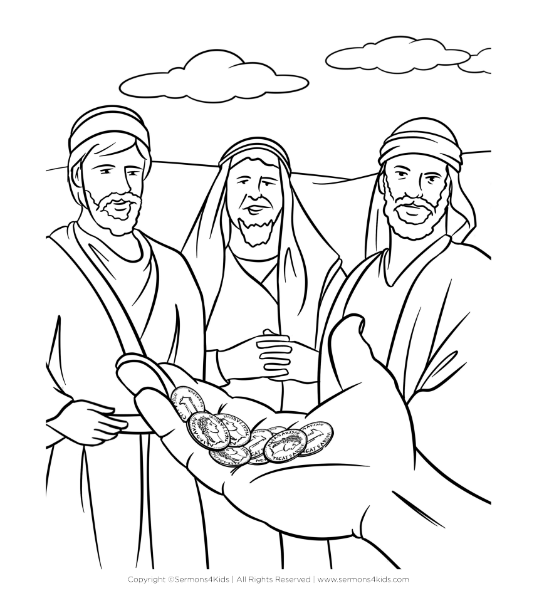

Multiple Choice Quiz

