“The time has come,” he said. “The kingdom of God is near. Repent and believe the good news!”   
Mark 1:15(NIV)

Crossword Puzzle

**Carrying the Message**

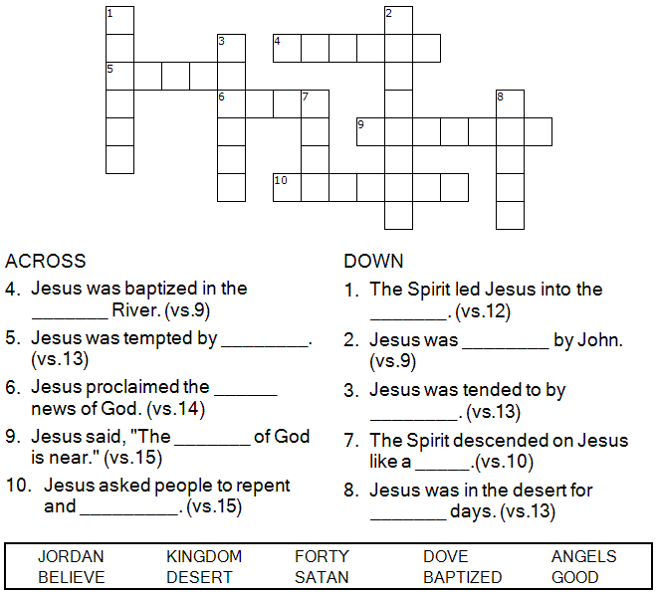

Copyright © Sermons4Kids, Inc.

May be reproduced for Ministry Use

Children’s Worship Bulletin



Mark 1:9-15

Word Search Puzzle

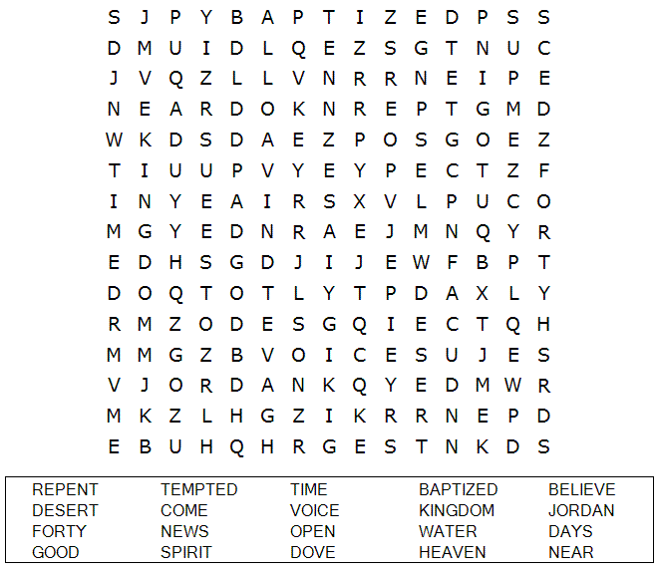

**Your Church Name Here**

Anytown, USA

Multiple Choice Quiz

Choose the word that best completes the sentence. You can find the answers in Mark 1:9-15 (NIV)

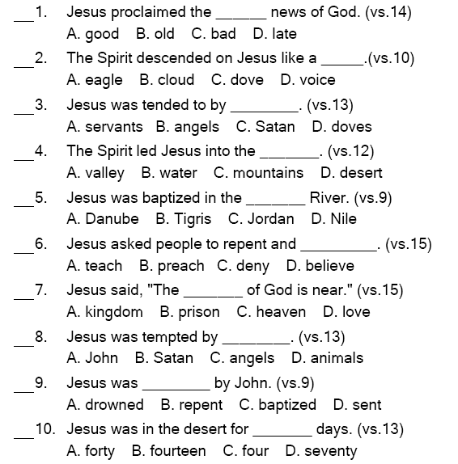

image.png

Decoder Puzzle

Each number represents a letter of the alphabet. Substitute the correct letter for the numbers to reveal the coded words.

