Crossword Puzzle

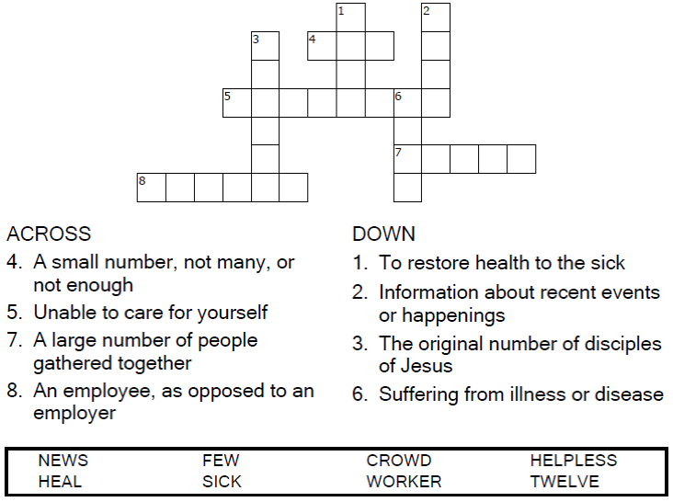

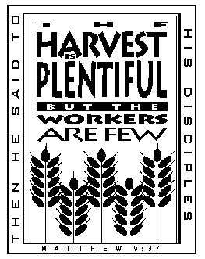

Copyright © Sermons4Kids, Inc.

May be reproduced for Ministry Use

**Children’s Worship Bulletin**



Matthew 9:35-10:8

Word Search Puzzle

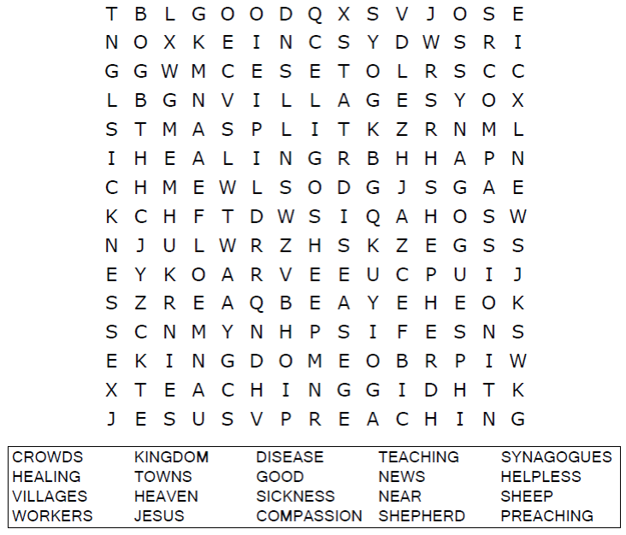  
  


Coloring Page

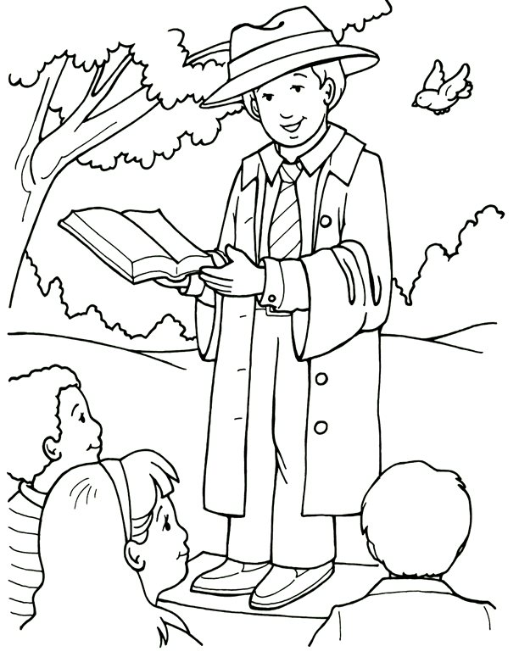  
  
Christ gave me the work of preaching the Good News.

From Thru-the-Bible Coloring Pages for Ages 4-8. © 1986,1988 Standard Publishing.

Used by permission. Reproducible Coloring Books may be purchased from

Standard Publishing, www.standardpub.com, 1-800-543-1301.

Multiple Choice Quiz

Choose the word that best matches the definition.  
Put the letter in the blank beside the number.

