CROSSWORD PUZZLE

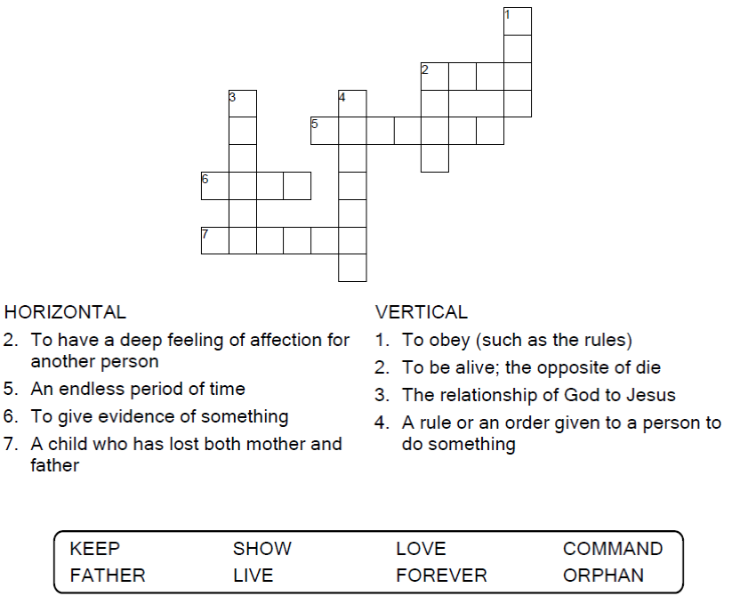



Copyright © Sermons4Kids, Inc.

Todos los derechos reservados

Children’s Bulletin



John 14:15-21

Word Search

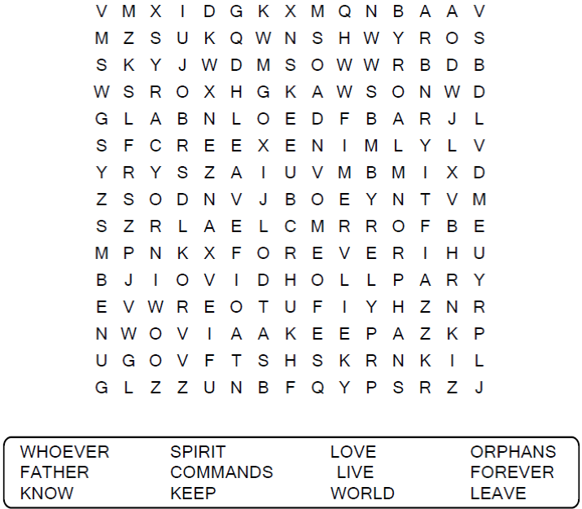

**Your Church Name  
Church Address**

Coloring Page

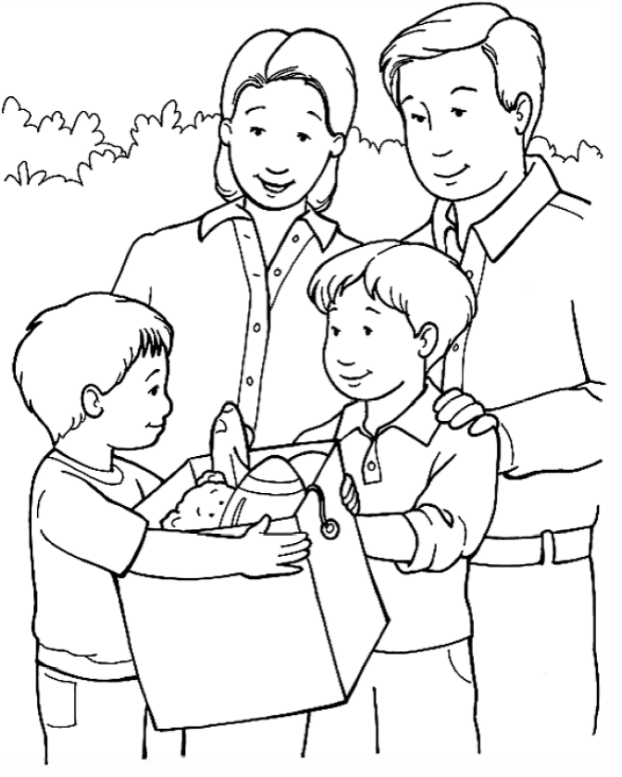

**"I can show my friends that Jesus loves them."**

From Thru-the-Bible Coloring Pages for Ages 4-8. © Standard Publishing.  
Used by permission. Reproducible Coloring Books may be purchased from  
Standard Publishing, www.standardpub.com, 1-800-323-7543.

Decoder Puzzle

Each number represents a letter of the alphabet. Substitute the

correct letter for the numbers to reveal the coded words.



