Crossword Puzzle

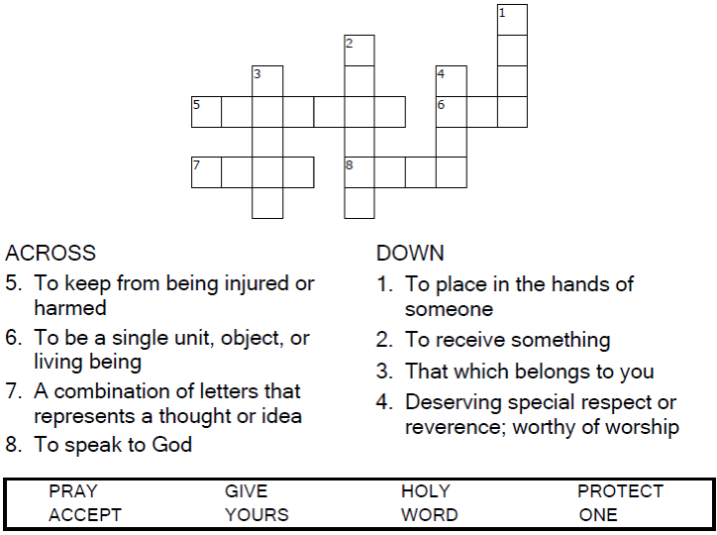



Copyright © Sermons4Kids, Inc.

May be reproduced for Ministry Use

**Children’s Worship Bulletin**



John 17:6-11

Word Search Puzzle

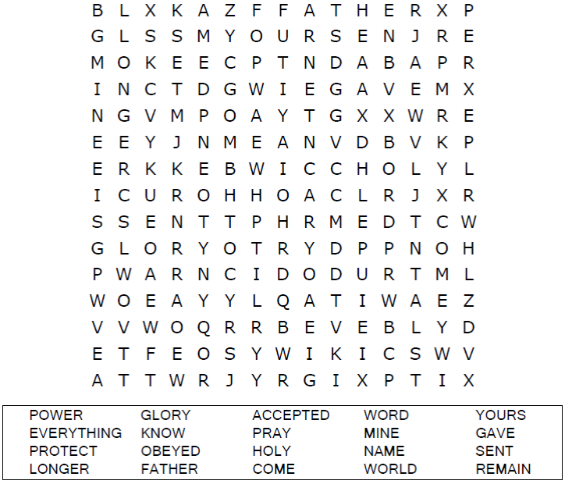

**heartcross_border.jpeg**

Coloring Page

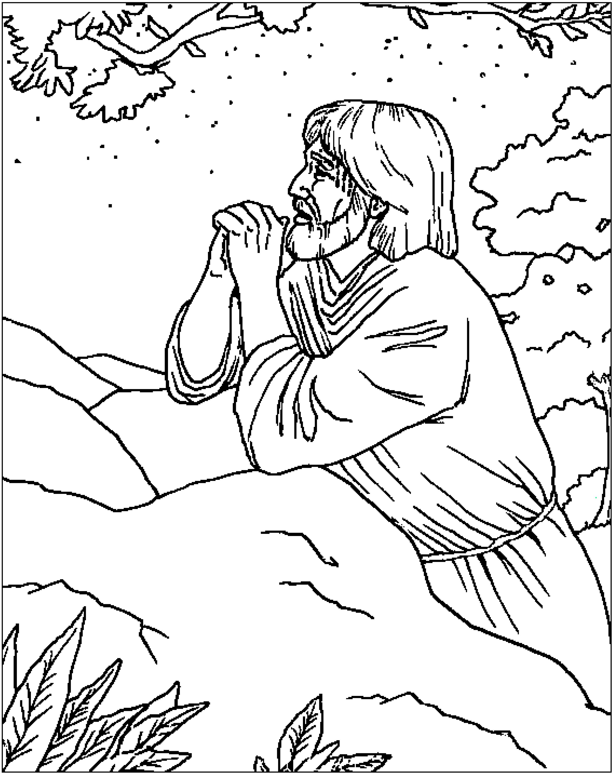

**Jesus Prays for His Disciples**

From BibleStoryCard Learning System'M Coloring Book© 1996 Wesleyan Publishing House

Used by permission. Additional resources available by calling 1-800-493-7539 or visiting on line.

https://wphstore.com/

Multiple Choice Quiz

Choose the word that best matches the definition.

