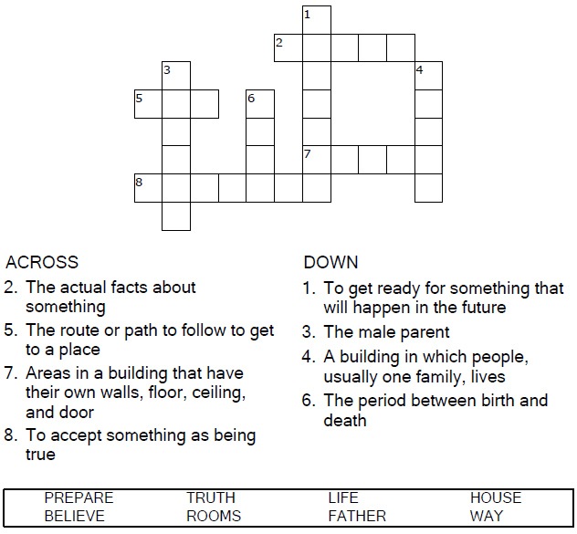
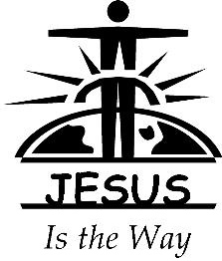

Copyright © Sermons4Kids, Inc.
May be reproduced for Ministry Use
Children’s Worship Bulletin

"I Am the Way"

John 14:1-14

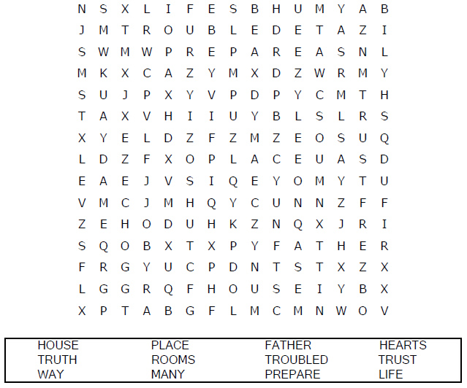
Your Church Name
Church Address

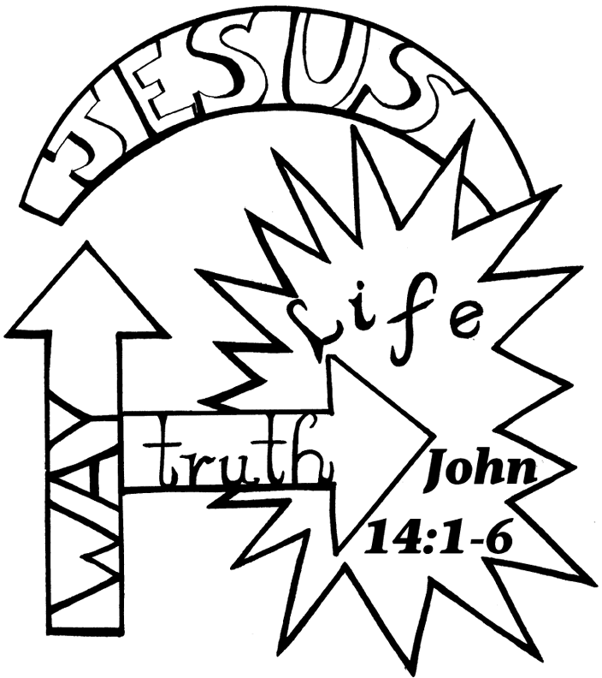

Copyright © CalvaryCurriculum.com
Used by Permission

