Crossword Puzzle

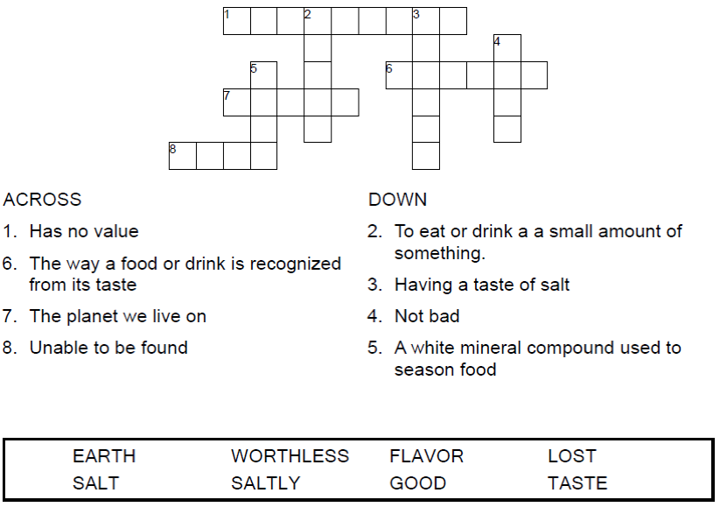

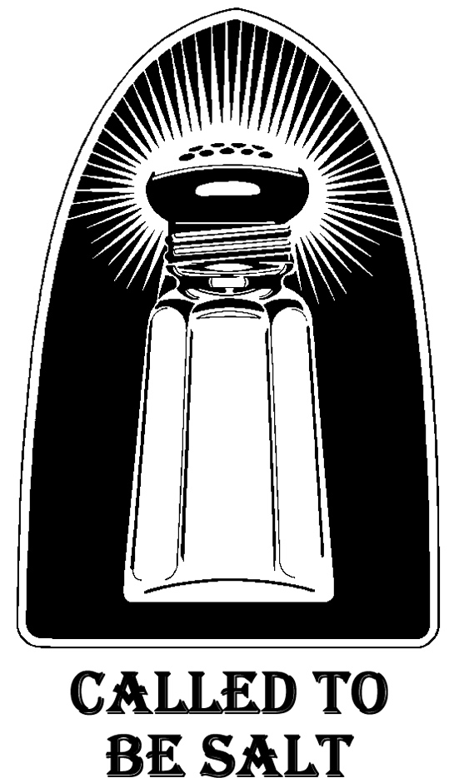

Copyright © Sermons4Kids, Inc.

May be reproduced for Ministry Use

Children’s Worship Bulletin



Matthew 5:13

Word Search Puzzle

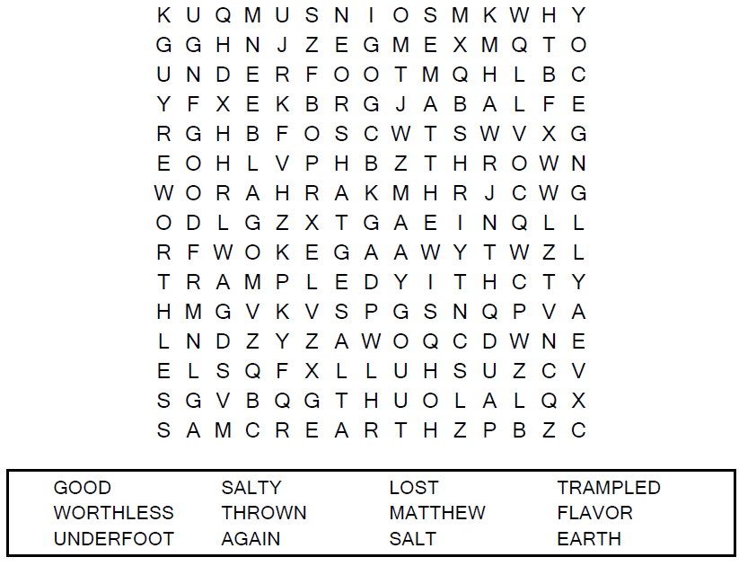

**Your Church Name Here**

Anytown, USA

Coloring Page

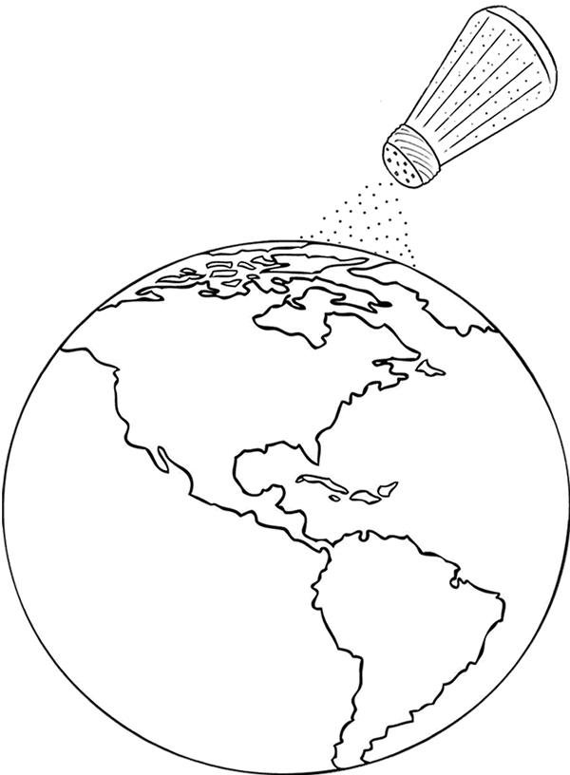

You are the salt of the earth.  
Matthew 5:13

Decoder Puzzle

Each number represents a letter of the alphabet. Substitute the correct letter for the numbers  
to reveal the coded words.

