Crossword Puzzle

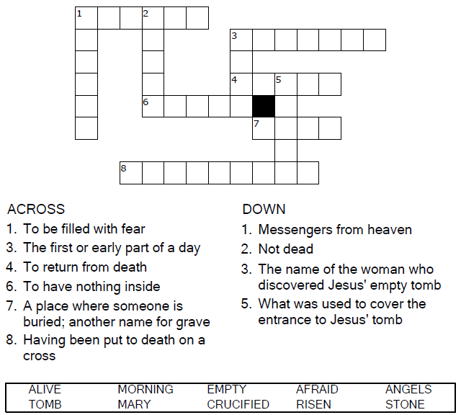

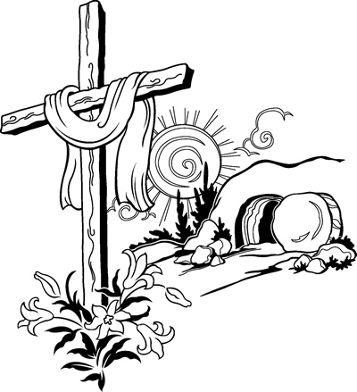

Copyright © Sermons4Kids, Inc.

May be reproduced for Ministry Use

Children’s Worship Bulletin



Mark 16:1-8  
John 20:1-19

Word Search Puzzle

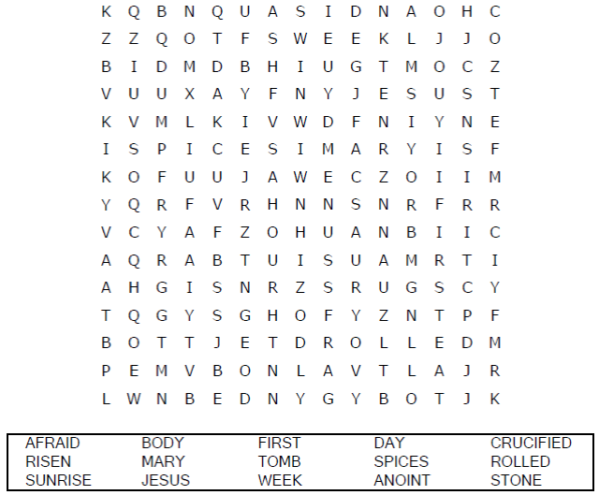

**Your Church Name Here**

Anytown, Anywhere

Coloring Page

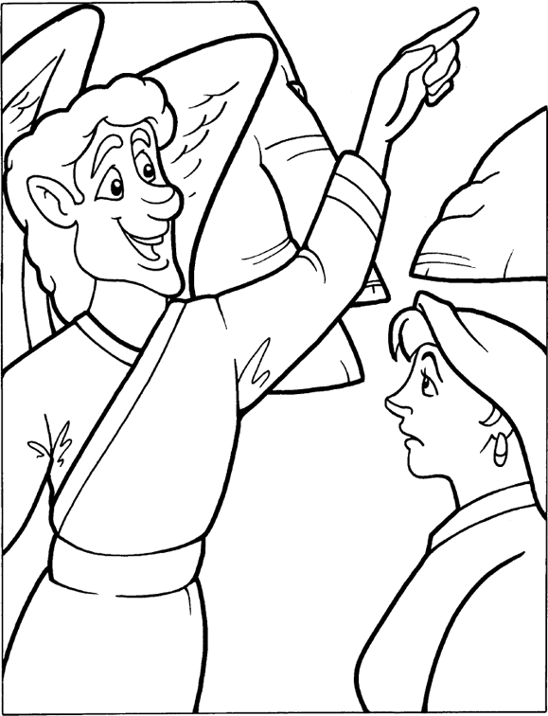

Jesus Is Alive!

Copyright CalvaryCurriculum.com  
Used by Permission

Decoder Puzzle



