Crossword Puzzle

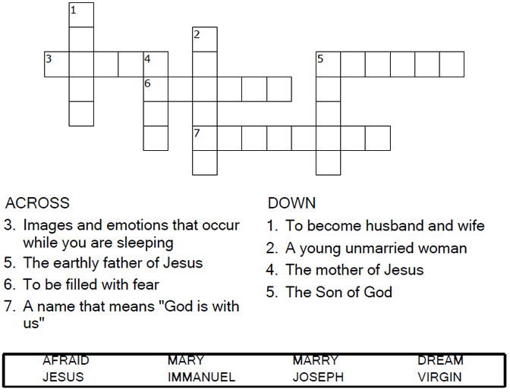

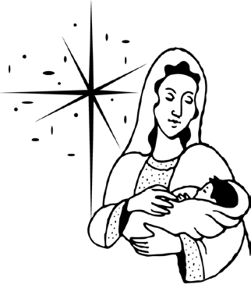

Copyright © Sermons4Kids, Inc.

May be reproduced for Ministry Use

**Children’s Worship Bulletin**



Matthew 1:18-25

Word Search Puzzle

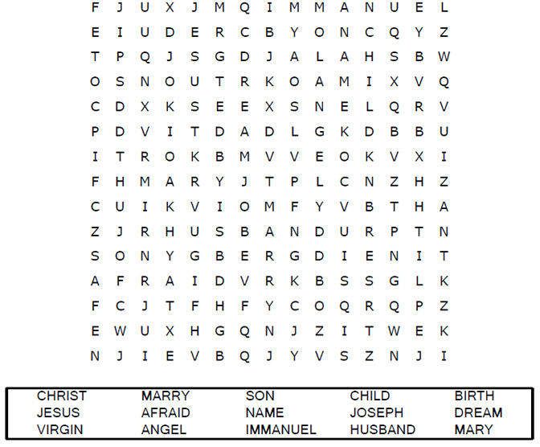  
  
**Your Church’s Name  
Address  
City, State**

Coloring Page

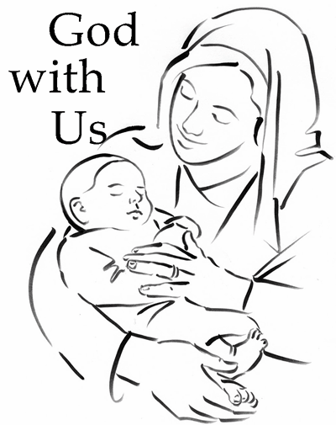  
  
"She will give birth to a son, and you are to give  
him the name Jesus, because he will save  
his people from their sins."  
Matthew 18:21 (NIV)

Decoder Puzzle

Each number represents a letter of the alphabet. Substitute  
the correct letter for the numbers to reveal the coded words.

