Crossword Puzzle

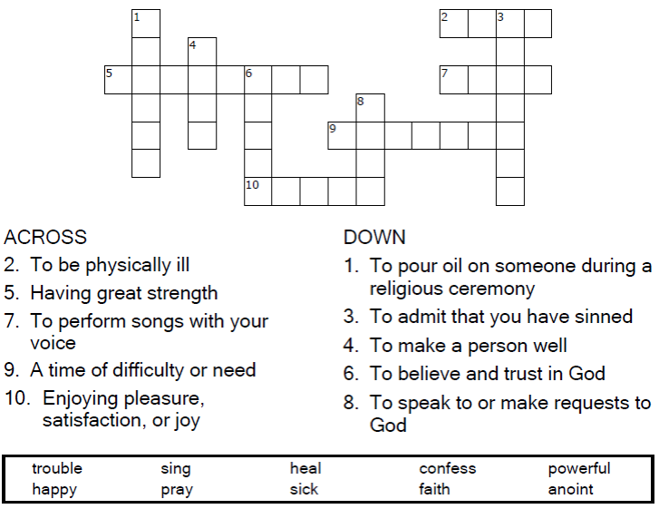



Copyright © Sermons4Kids, Inc.

May be reproduced for Ministry Use

**Children’s Worship Bulletin**



James 5:13-16

Word Search Puzzle

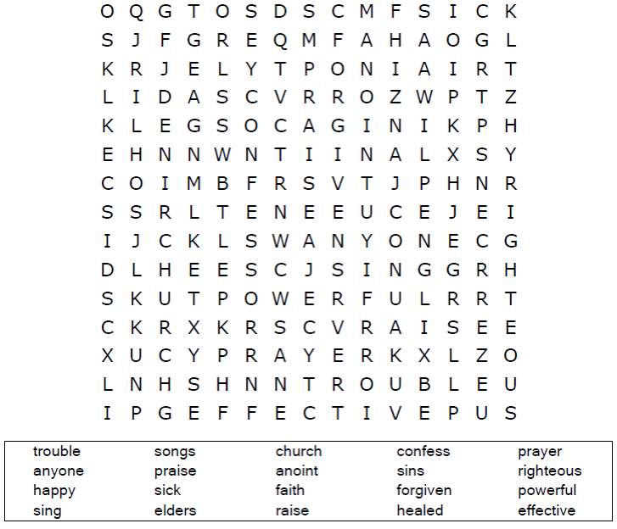

**Your Church Name  
Address  
City**

Coloring Page

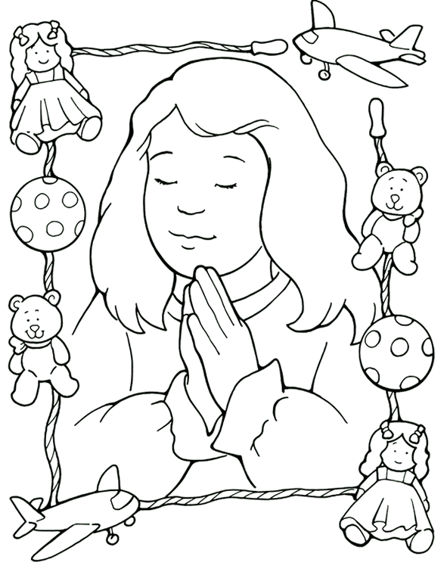

**Keep on Praying**

From Thru-the-Bible Coloring Pages © 1986,1988 Standard Publishing.

Used by permission. Reproducible Coloring Books may be purchased from

Standard Publishing, www.standardpub.com, 1-800-323-5473.

Decoder Puzzle

Each number represents a letter of the alphabet. Substitute  
the correct letter for the numbers to reveal the coded words.

