Crossword Puzzle

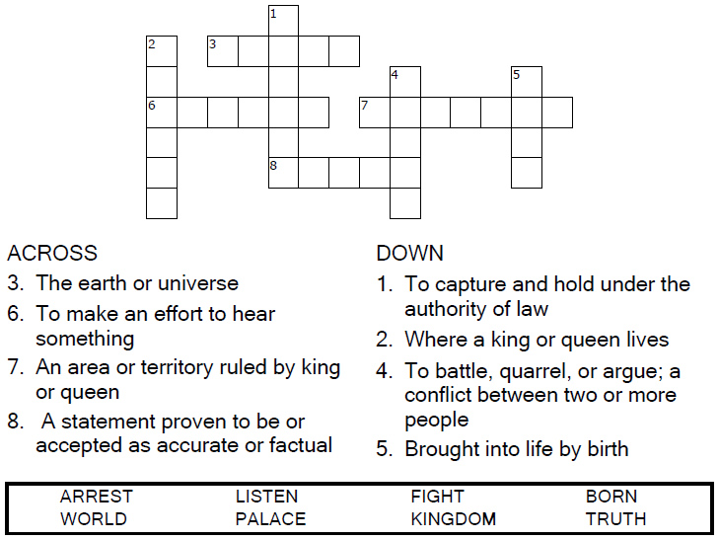



Copyright © Sermons4Kids, Inc.

May be reproduced for Ministry Use

Children’s Worship Bulletin



John 18:33-37

Word Search Puzzle

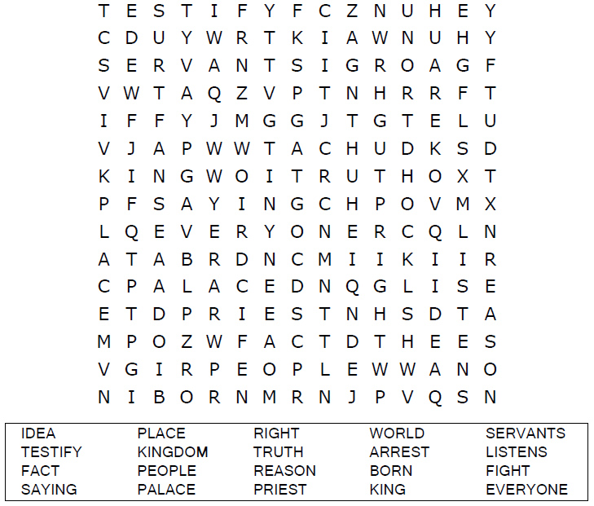

**Your Church Name Here**

Anytown, Anywhere

Coloring Page

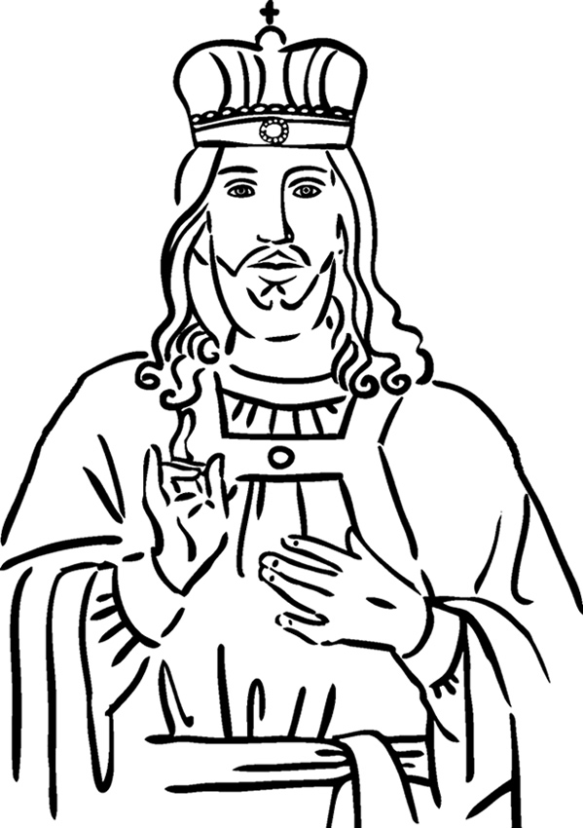

**Christ the King**John 18:33-37

Decoder Puzzle

Each number represents a letter of the alphabet. Substitute the  
correct letter for the numbers to reveal the coded words.

