Crossword Puzzle

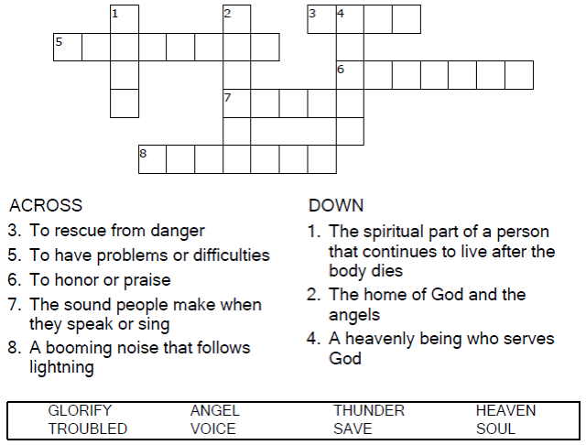

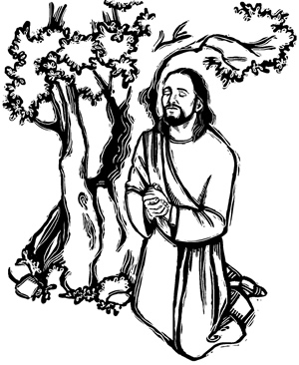

Copyright © Sermons4Kids, Inc.

May be reproduced for Ministry Use

Children’s Worship Bulletin



John 12:27-29

Word Search Puzzle

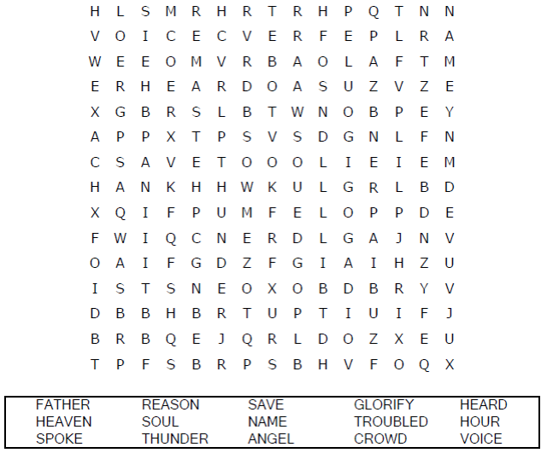

**Your Church Name Here**

Anytown, Anywhere

Coloring Page

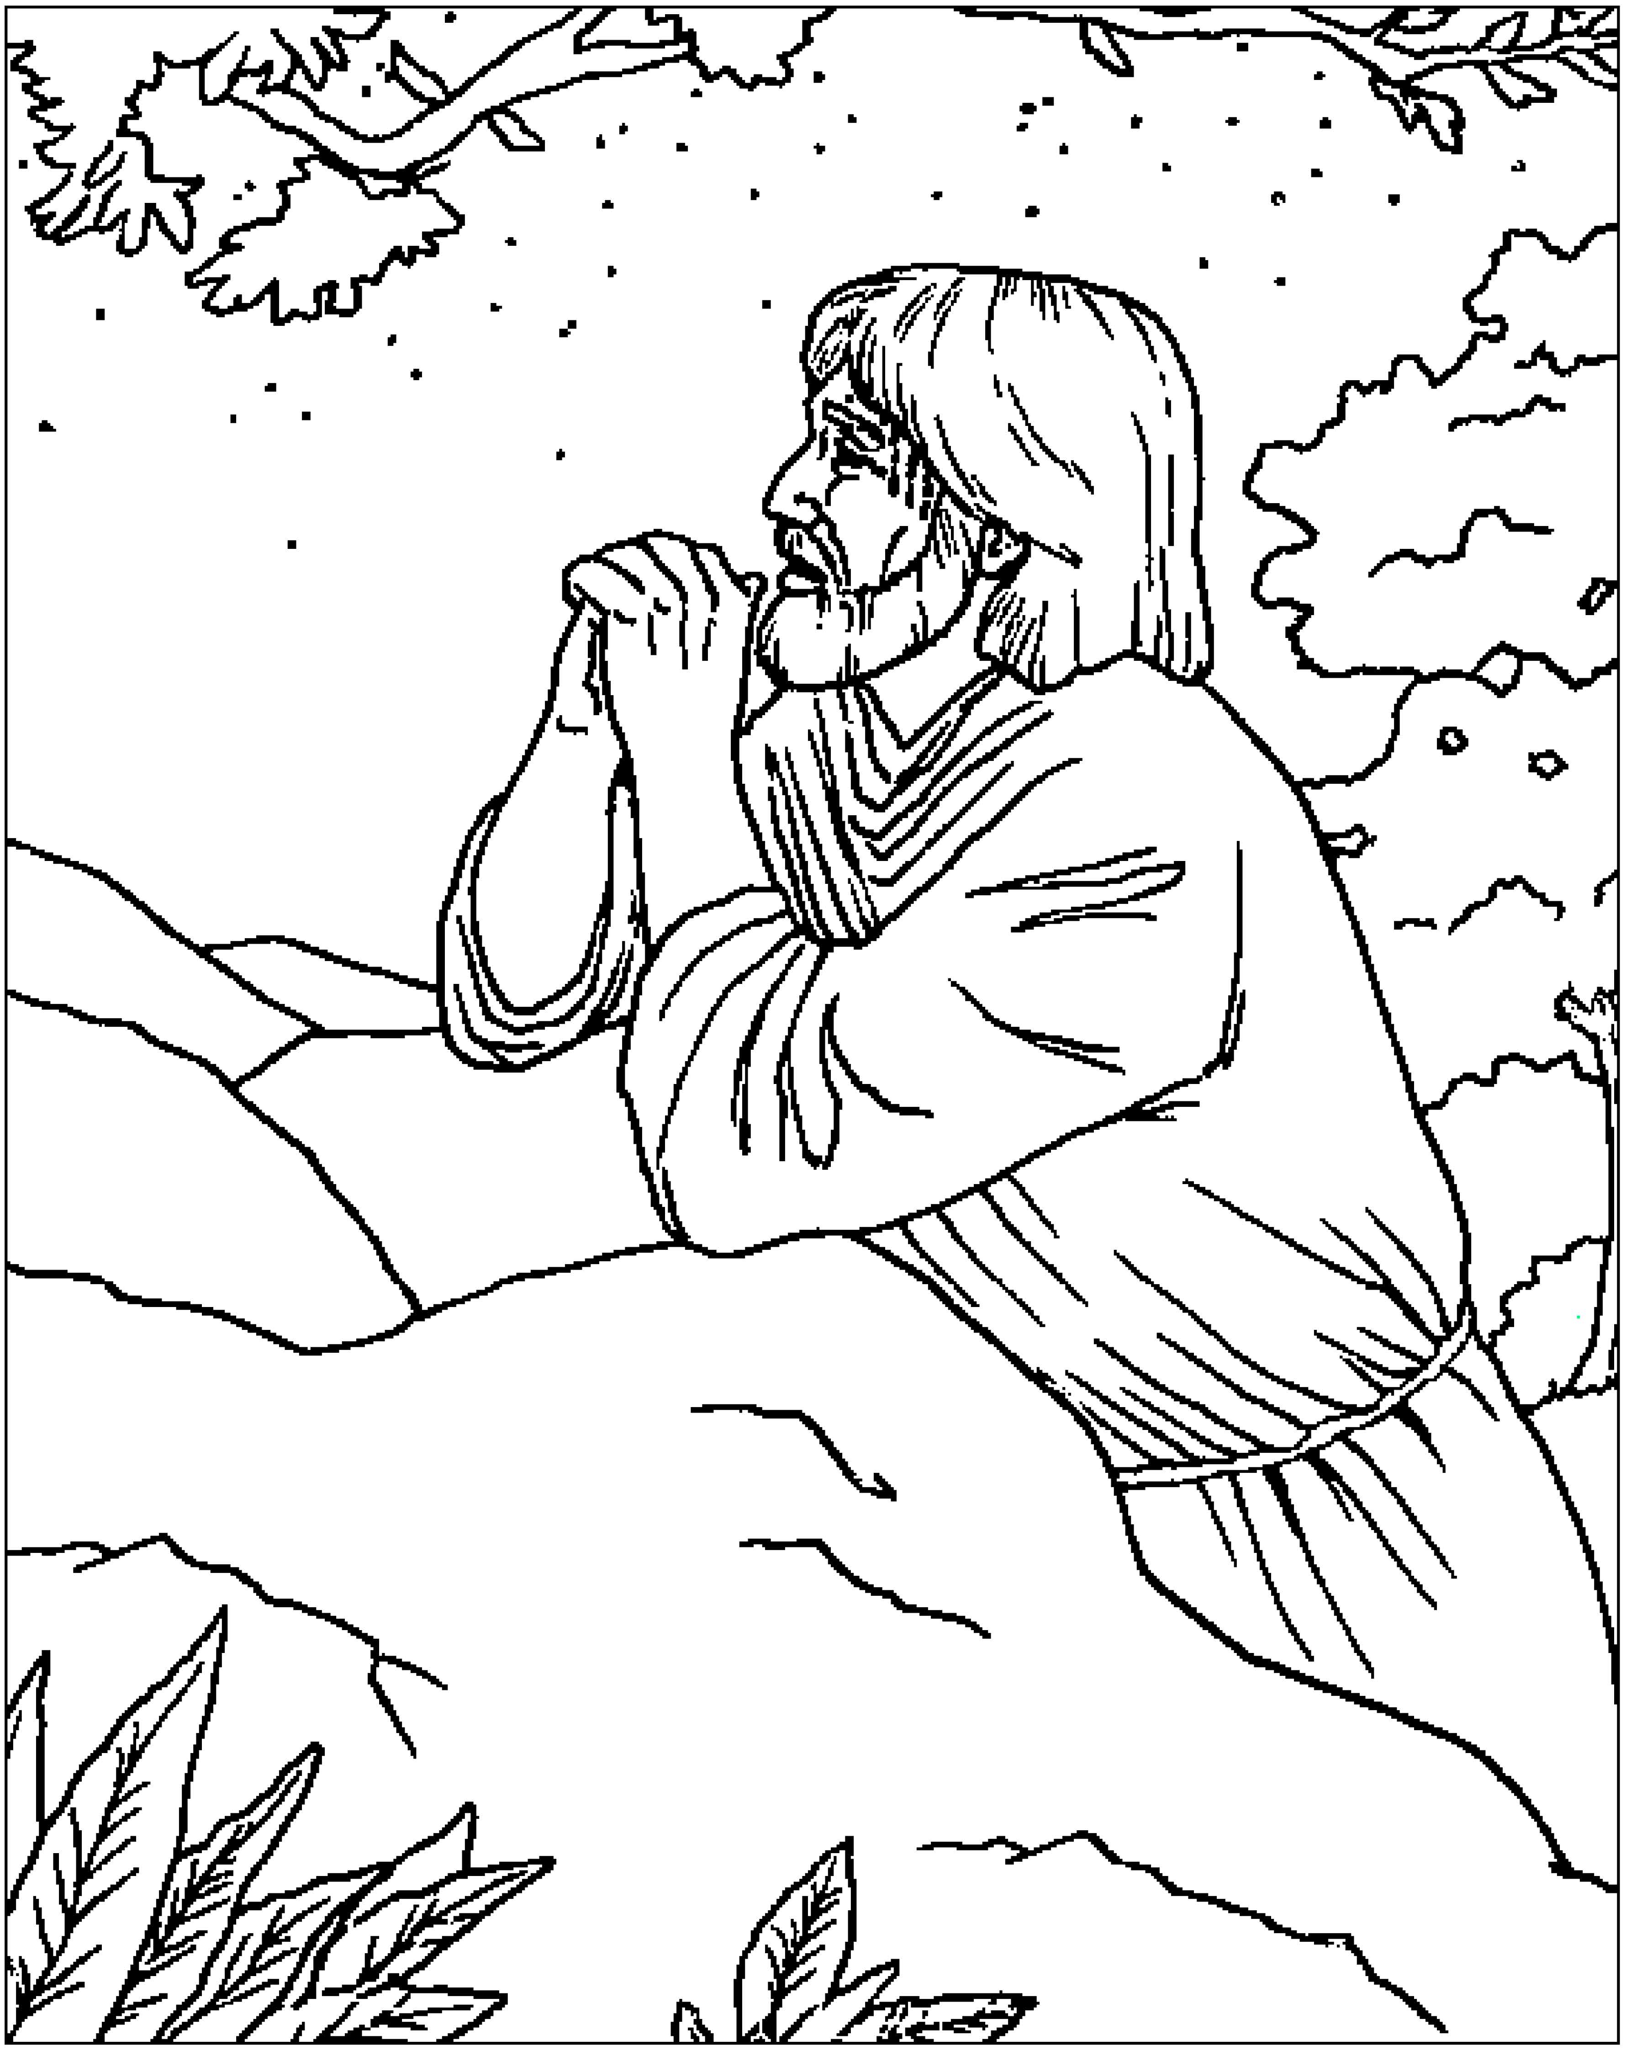

“Now my heart is troubled, and what shall I say?

‘Father, save me from this hour?’ No it was  
for this very reason I came to this hour.”

John 12:27 (NIV)

From BibleStoryCard Learning System'M Coloring Book© 1996 Wesleyan Publishing  
House. Used by permission. Additional resources available by calling 1-800-493-7539  
or visiting on line. https://wphstore.com/

Decoder Puzzle



