Crossword Puzzle

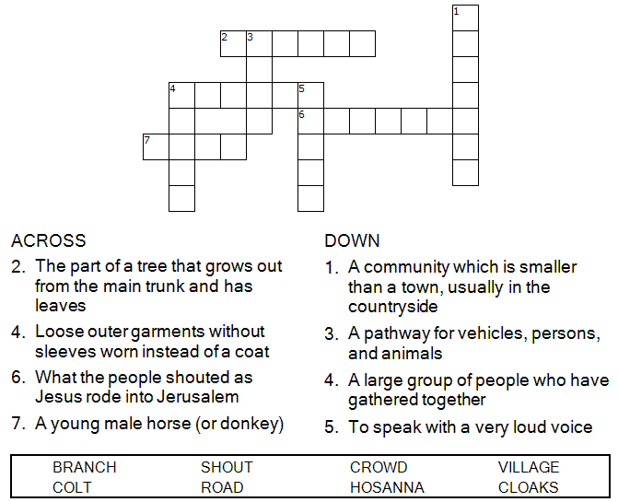

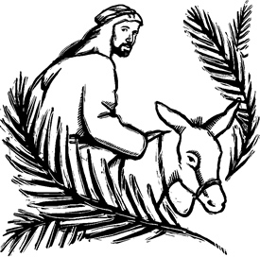

Copyright © Sermons4Kids, Inc.

May be reproduced for Ministry Use

Children’s Worship Bulletin



Mark 11:1-11

Word Search Puzzle

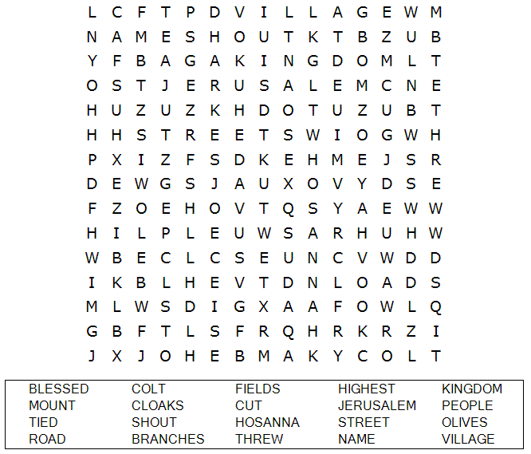

**Your Church Name Here**

Anytown, USA

Coloring Page

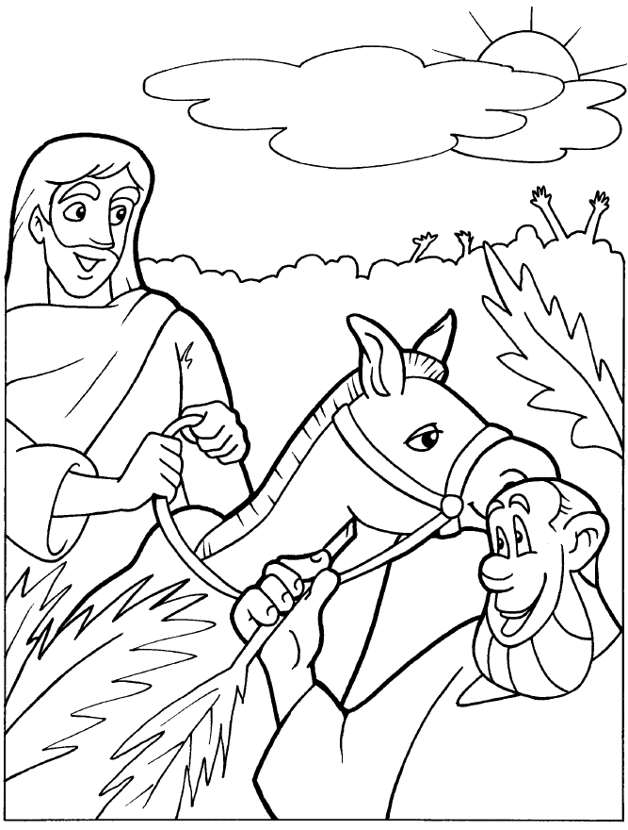

The Triumphal Entry

Copyright © CalvaryCurriculum.com  
Used by Permission

Maze Puzzle

Can you help Jesus find the way through the streets  
of Jerusalem to the temple?

