Crossword Puzzle

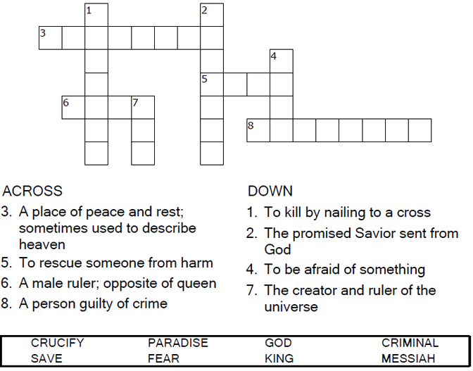



Copyright © Sermons4Kids, Inc.

May be reproduced for Ministry Use

**Children’s Worship Bulletin**



Luke 23:33-43

Word Search Puzzle

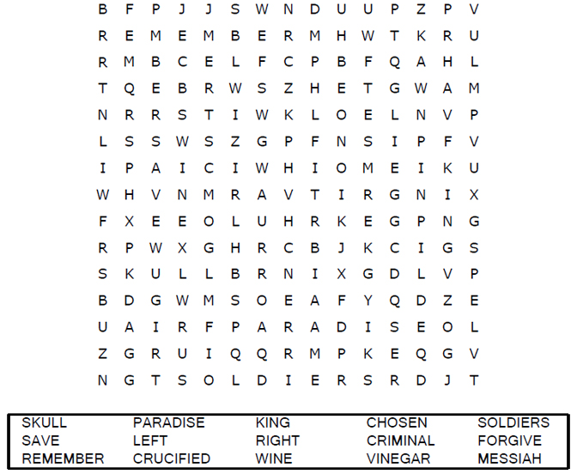

**Your Church Name  
Address  
City**

Coloring Page

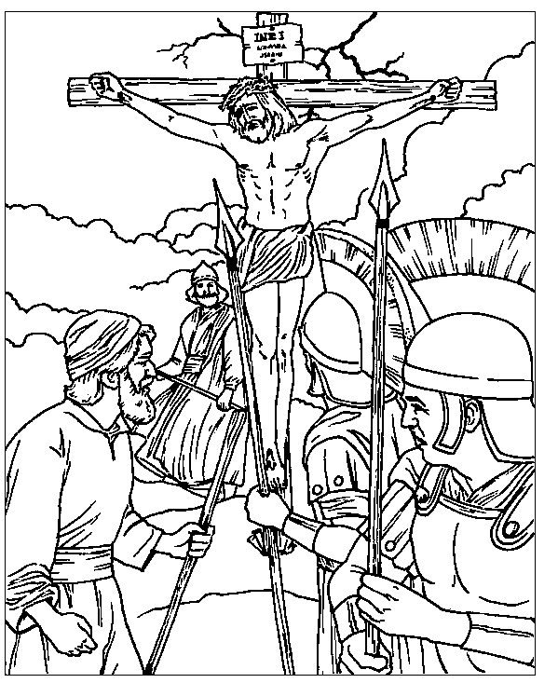

From BibleStoryCard Learning System(TM) Coloring Book © 1996  
 Wesleyan Publishing House. Used by permission. Additional  
BibleStoryCard resources are available by calling 1-800-493-7539   
or by visiting the Wesleyan Publishing House website.

http://www.parable.com/wph/group_1052.htm

Decoder Puzzle

Each number represents a letter of the alphabet. Substitute  
the correct letter for the numbers to reveal the coded words.

