Crossword Puzzle

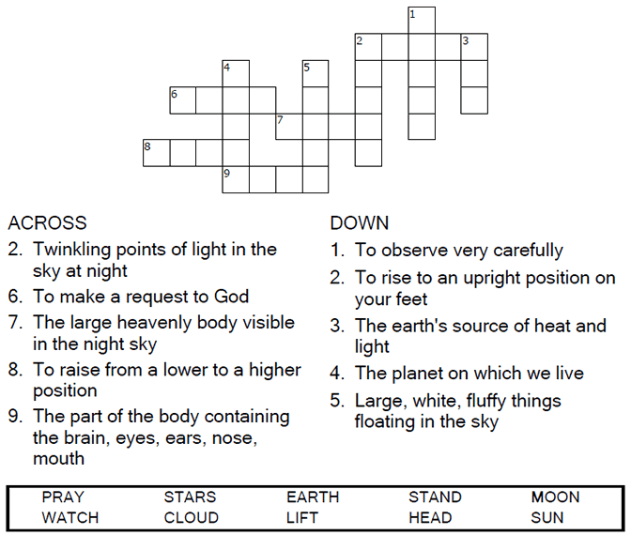



Copyright © Sermons4Kids, Inc.

May be reproduced for Ministry Use

Children’s Worship Bulletin



Luke 21:25-36

Word Search Puzzle

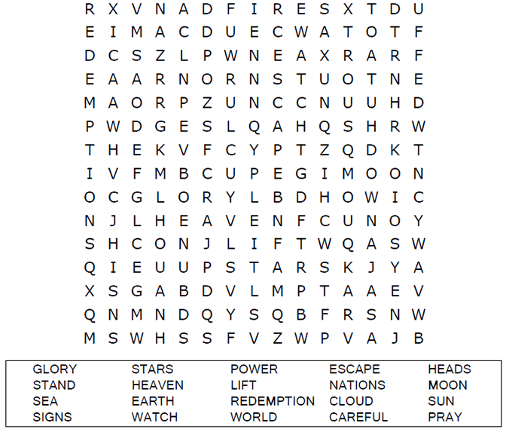

**Your Church Name Here**

Anytown, Anywhere

Coloring Page

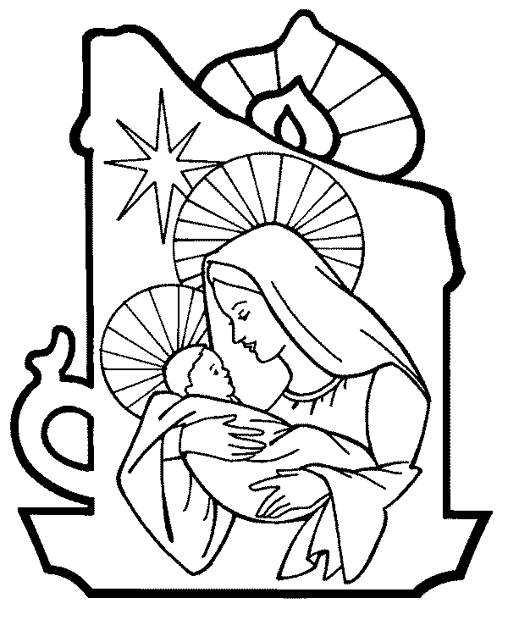



Decoder Puzzle

Each number represents a letter of the alphabet. Substitute the  
correct letter for the numbers to reveal the coded words.

