Crossword Puzzle

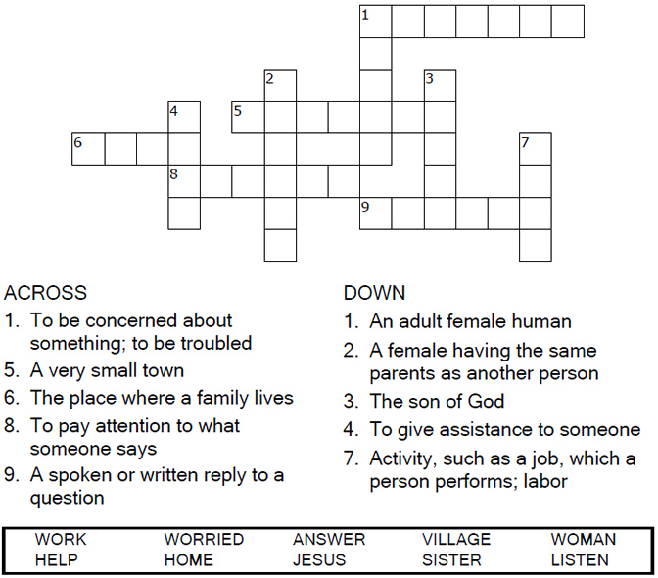

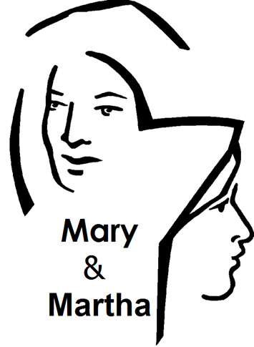

Copyright © Sermons4Kids, Inc.

May be reproduced for Ministry Use

Children’s Worship Bulletin



Luke 10:38-42

Word Search

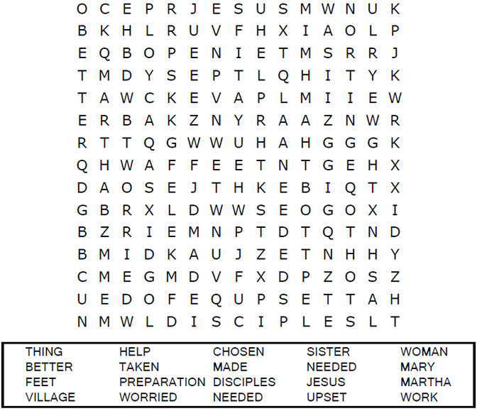



Decoder Puzzle

Each number represents a letter of the alphabet. Substitute  
the correct letter for the numbers to reveal the coded words.

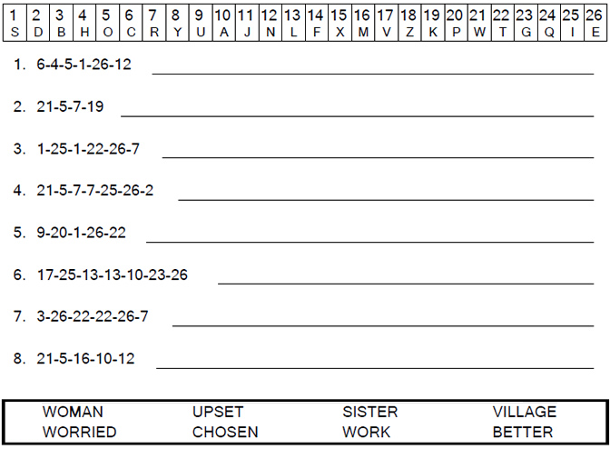



Coloring Page

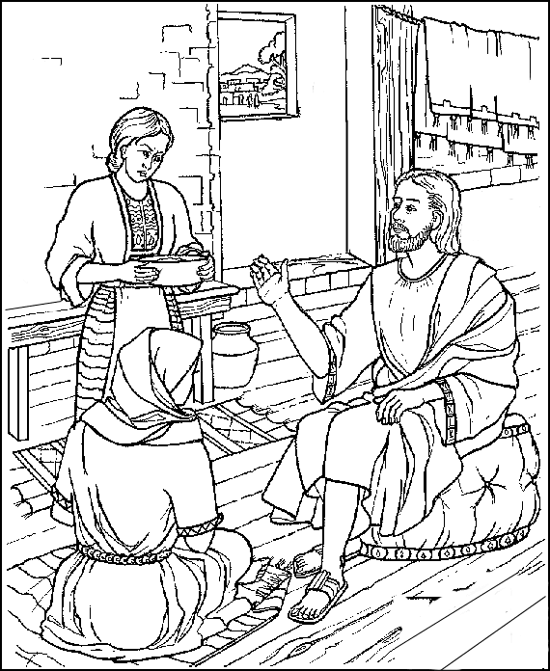

Jesus visits the home of Mary and Martha.  
Luke 10:38:42

Copyright © ABDA ACTS Art & Publishing

Used by permission.