Crossword Puzzle

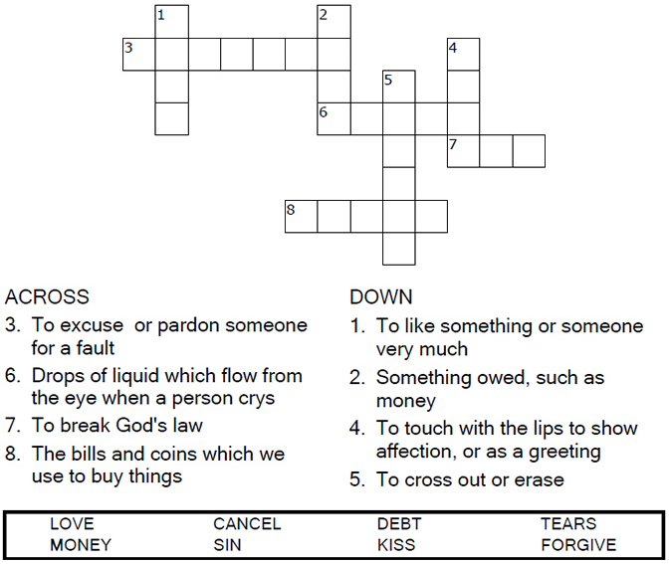



Copyright © Sermons4Kids, Inc.

May be reproduced for Ministry Use

Children’s Worship Bulletin



Luke 7:41-47

Word Search

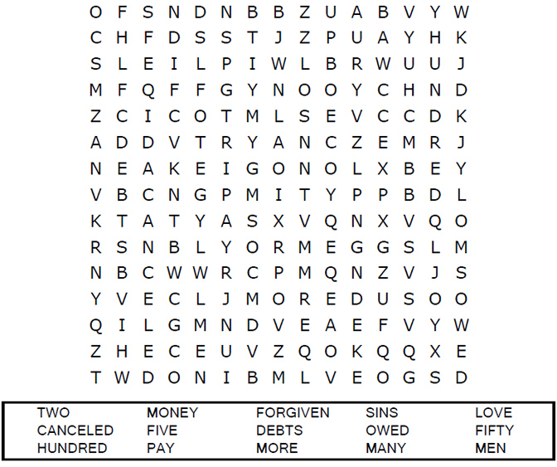

**Your Church Name Here**Anytown, USA

Word Links

Draw a line to connect the first part of the word in  
column one to the correct second part of the word  
in column two. Then complete the word by writing  
the correct word ending in the space provided.

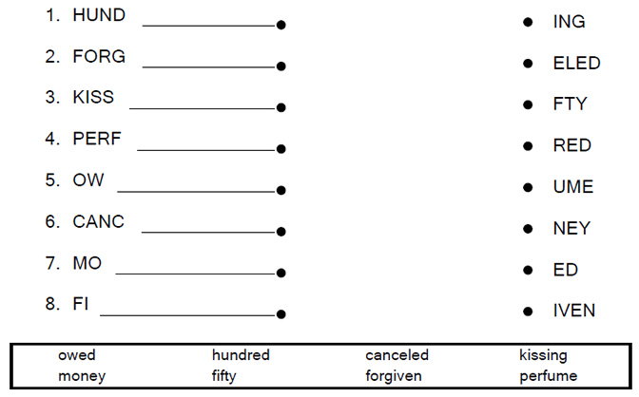



Coloring Page

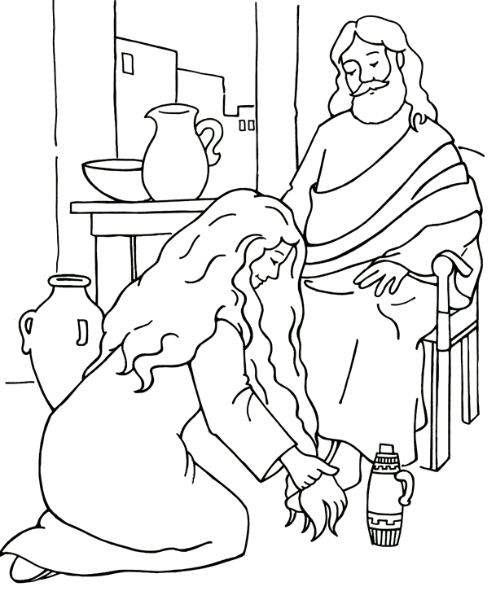

**Jesus Forgives a Woman  
Luke 7**

From Thru-the-Bible Coloring Pages for Ages 4-8. © 1986,1988 Standard Publishing.  
Used by permission. Reproducible Coloring Books may be purchased from  
Standard Publishing, www.standardpub.com, 1-800-543-1301.