Crossword Puzzle

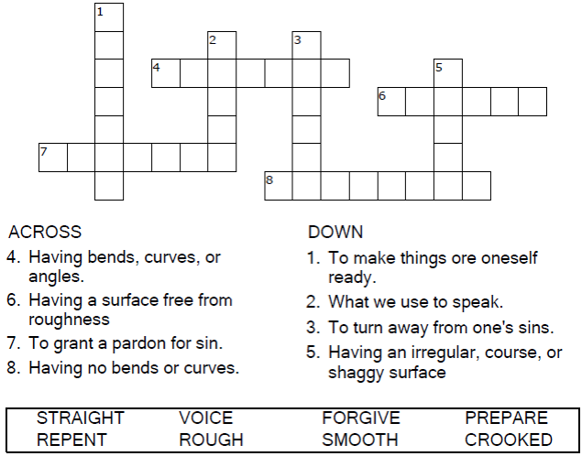

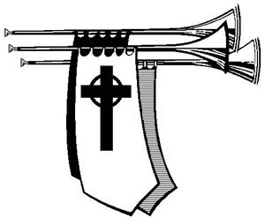

Copyright © Sermons4Kids, Inc.

May be reproduced for Ministry Use

Children’s Worship Bulletin



Luke 3:1-6

Word Search Puzzle

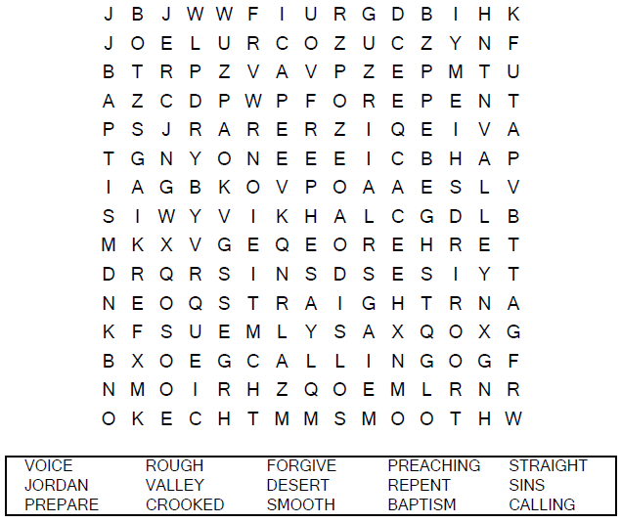

**Your Church Name Here**

Anytown, Anywhere

Coloring Page

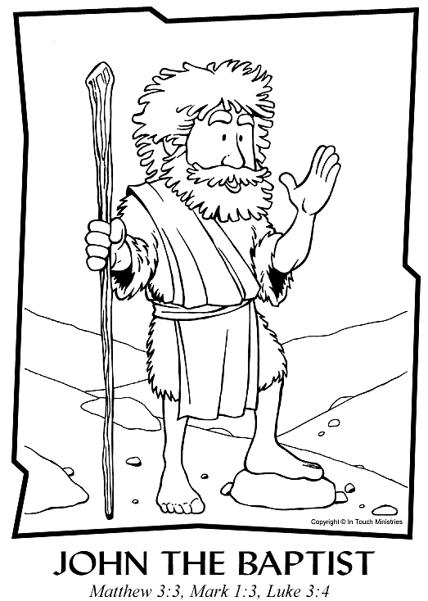

Copyright © In Touch Ministries  
Used by Permission

Decoder Puzzle

Each number represents a letter of the alphabet. Substitute the  
correct letter for the numbers to reveal the coded words.

