Crossword Puzzle

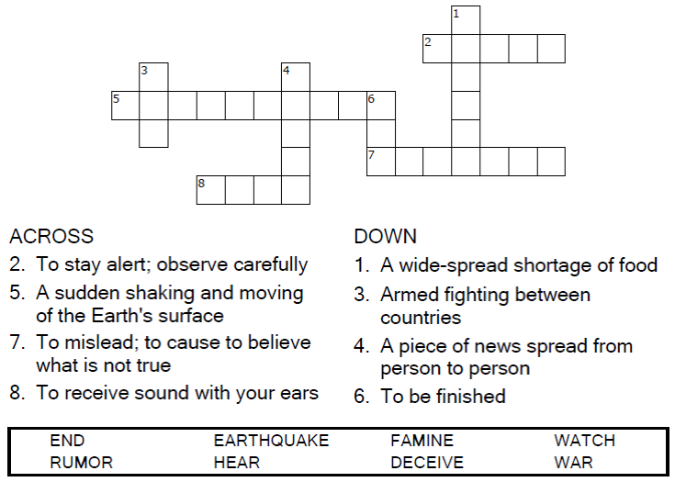

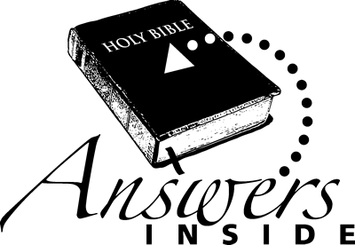

Copyright © Sermons4Kids, Inc.

May be reproduced for Ministry Use

Children’s Worship Bulletin



Mark 13:1-8

Word Search Puzzle

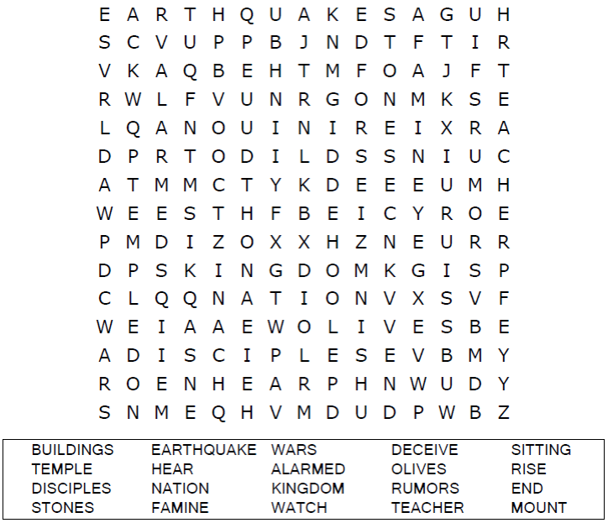

**Your Church Name Here**

Anytown, USA

Coloring Page

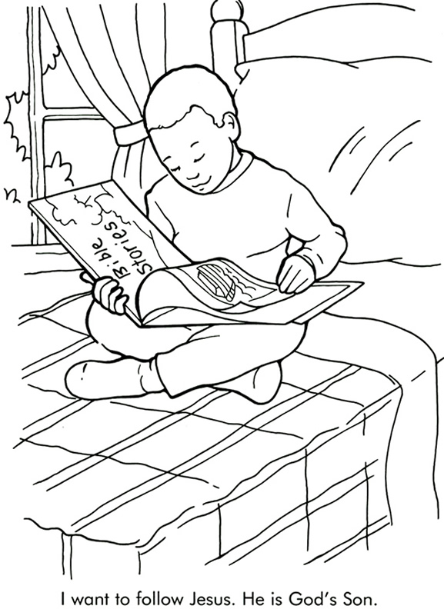

From Thru-the-Bible Coloring Pages for Ages 4-8. © 1986,1988 Standard Publishing.  
Used by permission. Reproducible Coloring Books may be purchased from  
Standard Publishing, [www.standardpub.com](http://www.standardpub.com/), 1-800-543-1301.

Decoder Puzzle

Each number represents a letter of the alphabet. Substitute the  
correct letter for the numbers to reveal the coded words.

