Crossword Puzzle

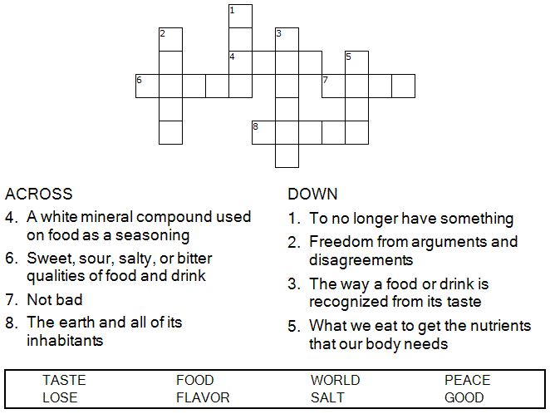

**

Copyright © Sermons4Kids, Inc.

May be reproduced for Ministry Use

Children’s Worship Bulletin



Mark 9:38-50

Word Search Puzzle

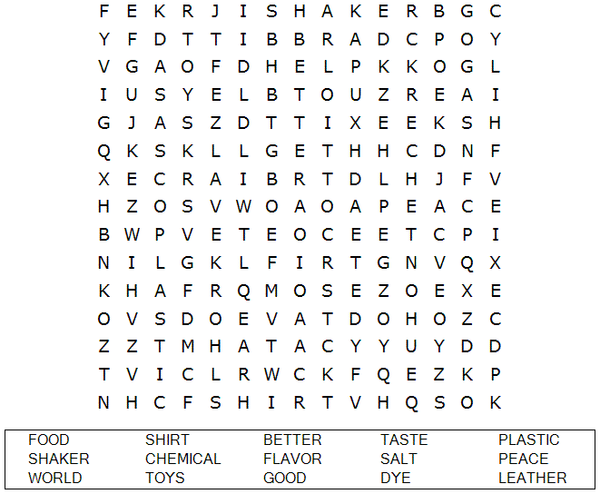

**Your Church Name Here**

Anytown, USA

Coloring Page



“Salt is good, but if it loses its saltiness, how can you  
make it salty again? Have salt among yourselves,  
and be at peace with each other.”  
Mark 9:50 (NIV)

Decoder Puzzle

Each number represents a letter of the alphabet. Substitute the correct letter for the numbers  
to reveal the coded words.

